Financial Stakeholders
The stakeholders in an organisation may be interested in financial aspects of an organisation’s performance and management. In particular, they will be interested in how an organisation’s performance is likely to impact upon them. Other people have a stake in and use for the financial information that results from what you and others do in your organisation. The way in which financial information is used and compiled into financial reports and statements is heavily influenced by perceptions of what these users need and expect. Table 2 summarises stakeholders’ main needs from and interests in an organisation’s financial information.

Types of Stakeholders
This guide will analyze the most common types of stakeholders and look at the unique needs that each of them typically has. The goal is to put yourself in the shoes of each type of stakeholder and see things from their point of view.

#1 Customers
Stake: Product/service quality and value
Many would argue that businesses exist to serve their customers. Customers are actually stakeholders of a business, in that they are impacted by the quality of service/products and their value. For example, passengers traveling on an airplane literally have their lives in the company’s hands when flying with the airline.

#2 Employees
Stake: Employment income and safety
Employees have a direct stake in the company in that they earn an income to support themselves, along with other benefits (both monetary and non-monetary). Depending on the nature of the business, employees may also have a health and safety interest (for example, in the industries of transportation, mining, oil and gas, construction, etc.).

#3 Investors
Stake: Financial returns
Investors include both shareholders and debtholders. Shareholders invest capital in the business and expect to earn a certain rate of return on that invested capital. Investors are commonly concerned with the concept of shareholder value. Lumped in with this group are all other providers of capital, such as lenders and potential acquirers. All shareholders are inherently stakeholders, but stakeholders are not inherently shareholders.

#4 Suppliers and Vendors
Stake: Revenues and safety
Suppliers and vendors sell goods and/or services to a business and rely on it for revenue generation and on-going income. In many industries, suppliers also have their health and safety on the line, as they may be directly involved in the company’s operations.

#5 Communities
Stake: Health, safety, economic development
Communities are major stakeholders in large businesses located in them. They are impacted by a wide range of things, including job creation, economic development, health, and safety. When a big company enters or exits a small community, there is an immediate and significant impact on employment, incomes, and spending in the area. With some industries, there is a potential health impact, too, as companies may alter the environment.

#6 Governments
Stake: Taxes and GDP
Governments can also be considered a major stakeholder in a business, as they collect taxes from the company (corporate income taxes), as well as from all the people it employs (payroll taxes) and from other spending the company incurs (sales taxes). Governments benefit from the overall Gross Domestic Product (GDP) that companies contribute to
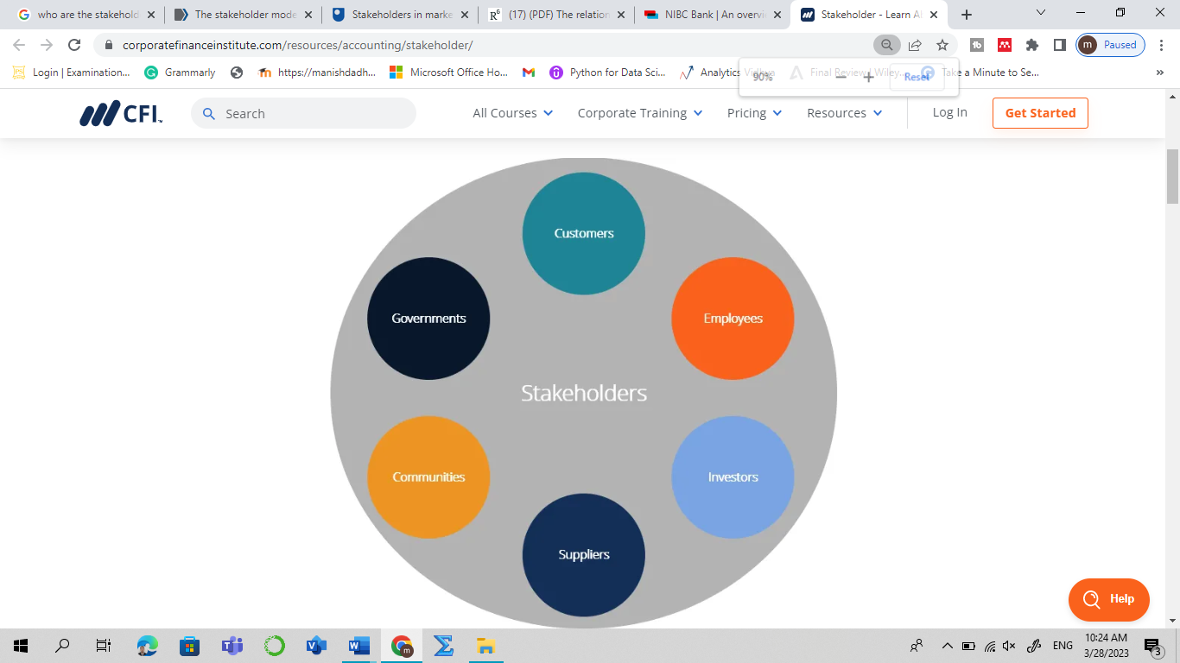
Table 2 Stakeholders' financial information needs and reasons for them
Internal | Main external | Other external
Managers | Owners/shareholders | Government agencies
Planning, controlling, decision-making and stewardship (safeguarding assets) | Calculating returns if investing capital | Taxation
Internal controls | Holding managers to account for financial (and/or other) performance | Informing regional and national economic development, competition, regulation and/or employment policies
Context for their own remuneration
Employees | Lenders/financiers | Local communities
Future job prospects | Repayments and interest on loans or investment* | Source of local employment, or of local pollution or congestion
Comparison with conditions in other organizations
Management board/governors | Suppliers | The general public
Responsibility and accountability to stakeholders for financial performance | Likelihood of being paid | Context of employment or environmental concerns
 | Future growth/survival prospects | Public sector organisations’ use of tax
 | Customers/clients | Competitors
 | Prospects for the organisation remaining a supplier | Knowledge to inform their own strategies
 | Donors
 | Cost-effectiveness

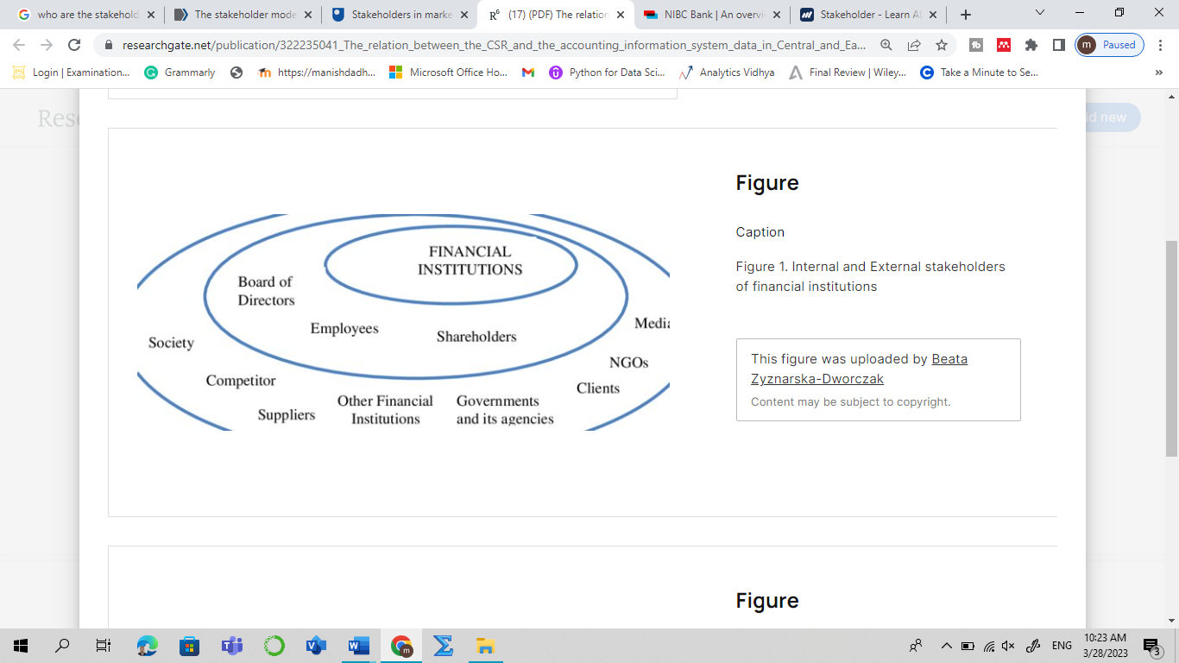

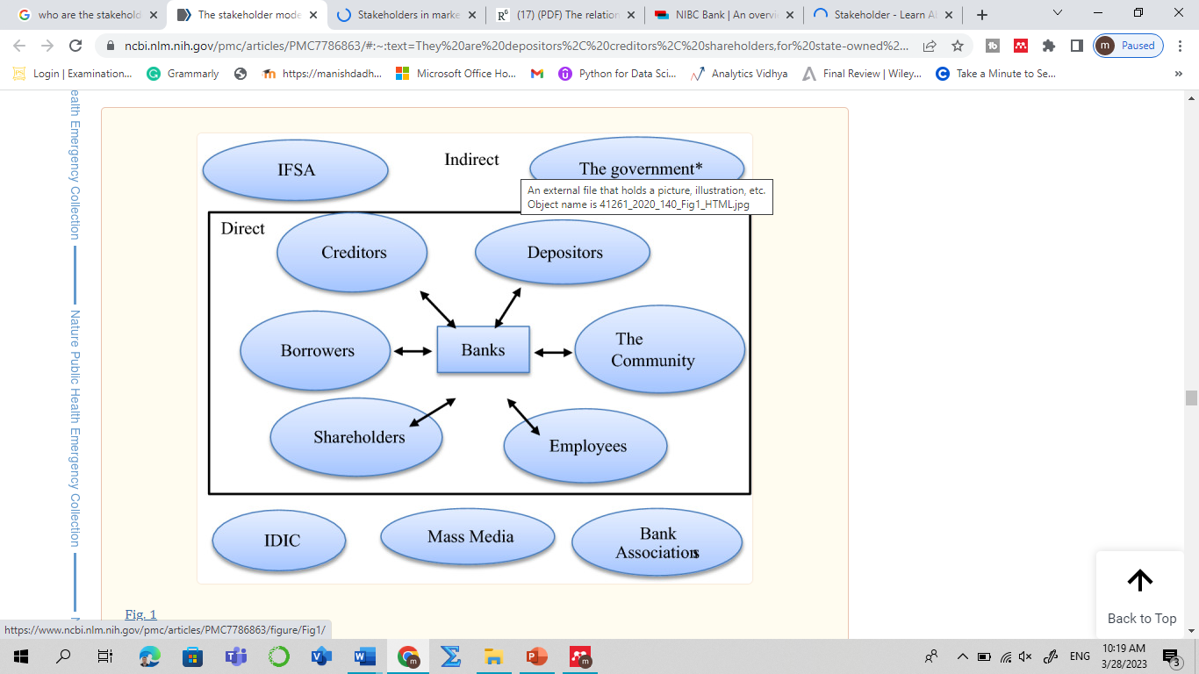

Stakeholder Conflict
Stakeholder conflict occurs when different stakeholders have different objectives. Firms may have to choose between maximizing one objective and satisfactorily meeting several stakeholder objectives, so called satisficing.
Reasons for conflict among stakeholders
Examples of stakeholders in a company are shareholders, employees, customers, suppliers, creditors, stock investors, local communities, and governments. Which are the primary stakeholders? It depends on the business model and industry in which the company operates. But, for sure, they have different interests towards the company, for example:

Shareholders are interested in dividends. They also have the potential to obtain capital gains by investing in the company. They want the company to continue growing and generating more profits, positively affecting dividends distributed and capital gains.
Employees and management are interested in high salaries and benefits. In addition, they are also interested in a healthy work environment, promising career paths, and adequate training and development programs. They affect the company with their performance. And, for management, the decisions they make have a significant impact on the company’s success.
Customers have an interest in the company’s products, customer service, and privacy protection. They want the company to offer quality but cheap products. Another aspect is business ethics, which is getting more and more popular and attention lately. They like it when companies are socially and environmentally responsible, not just for profit.
Suppliers have an interest in the purchase of inputs by the company. They want companies to pay on time, keep ordering from them, and buy in bulk. They don’t like it when companies switch to other suppliers, reducing their revenue.
The government has an interest in companies paying taxes on time and complying with regulations. The government also requires companies to run environmentally responsible businesses, refrain from anti-competitive behavior, and adopt fair employment practices. Another interest is the jobs, and income businesses create in the economy.
Creditors want the company to pay principal and interest on time. They don’t want the company to default on its debt. Therefore, they pay attention to aspects such as the company’s liquidity and solvency. Credit rating is another indicator to look at to determine the default rate. If the company’s repayment capacity is good, they also want to sign new contracts for loans.
Local communities are concerned about the jobs created by the company. They want the company to recruit local workers. On the other hand, they also want the company to carry out environmentally responsible business practices, not generate negative externalities, and support local community programs.
Each stakeholder seeks to protect their own interests. They want to make sure their interests are met, and their goals are achieved. However, for companies, fulfilling all their wishes is impossible. They often have to make priorities; which interests should come first?
Examples of stakeholder conflicts
Conflicts often arise because stakeholders have different and often conflicting interests. It often makes companies face a dilemma when making decisions. They must prioritize and make choices that some stakeholders may not like. In the following, we present some examples.
Higher wages vs. Higher dividends. Shareholders generally want the company’s profits to increase because it affects the dividends and capital gains. So, they are reluctant to see businesses pay high wages to employees.

