Behavioral Finance Concepts
Behavioral finance typically encompasses five main concepts:
Mental accounting: Mental accounting refers to the propensity for people to allocate money for specific purposes.
Herd behavior: Herd behavior states that people tend to mimic the financial behaviors of the majority of the herd. Herding is notorious in the stock market as the cause behind dramatic rallies and sell-offs.
Emotional gap: The emotional gap refers to decision-making based on extreme emotions or emotional strains such as anxiety, anger, fear, or excitement. Oftentimes, emotions are a key reason why people do not make rational choices.
Anchoring: Anchoring refers to attaching a spending level to a certain reference. Examples may include spending consistently based on a budget level or rationalizing spending based on different satisfaction utilities.
Self-attribution: Self-attribution refers to a tendency to make choices based on overconfidence in one's own knowledge or skill. Self-attribution usually stems from an intrinsic knack in a particular area. Within this category, individuals tend to rank their knowledge higher than others, even when it objectively falls short.
Behavioral finance is exploited through credit card rewards, as consumers are more likely to be willing to spend points, rewards, or miles as opposed to paying for transactions with direct cash.
====
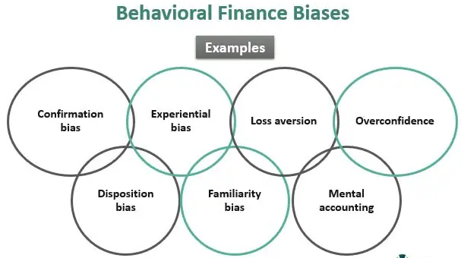
Confirmation bias: The confirmation bias occurs when the investors align to the information that matches with their beliefs. The data could be wrong, but as long as it fits with their views, they end up relying on it.
Experiential bias: It occurs when an investor’s memories or experiences from past events make them choose sides even when such a decision is not rational. For instance, previous or current bad experience leads them to avoid similar positions.
Loss aversion: Loss aversion makes investors avoid taking a risk even if it earns high returns. They give priority to restraining from experiencing losses rather than experiencing high returns.
Overconfidence: Overconfidence reflects when investors overestimate their abilities or trading skills and make decisions forgoing factual evidences.
Disposition bias: It explains the propensity of investors to hold on to the stocks even if the prices are declining, believing that the prices will appreciate in the future and, at the same time, sell the well-performing stocks. Such investors tend to hold on to a stock losing money, hoping that the price will soon increase. In their minds, it’s only a matter of time before the tides change for them, and they can then make profits on all their positions in a market.
Familiarity bias: The familiarity bias is reflected when investors place their investment in the stocks from the industry they know and understand rather than going after securities from an unrelated field. In this process, they may lose new or innovative opportunities that are revolutionary.
Mental accounting: People’s budgeting process or spending habits may vary based on circumstances. That is, they don’t maintain a consistent pace. For instance, people may spend for luxury in a mall or while on vacation, and they also possess a modest lifestyle at home or when they are back from vacation.
Many academics have portrayed various biases, classifications, and how the human brain functions in irrational ways. It is evident in many behavioral finance books and behavioral finance journals, which helps researchers understand the impact of human psychology in the financial decision-making process.
==

