**R&D Expense and Earnings Volatility**

R&D spending can vary widely from one year to another, which has a significant impact on a company’s profitability. Many businesses in the technology, healthcare, [consumer discretionary](https://www.bloomberg.com/research/sectorandindustry/sectors/sectordetail.asp?code=25&region=US), energy, and industrial sectors experience this problem.

If a company doesn’t capitalize research and development, its net income can be significantly higher or lower because of the timing of R&D spending. It’s important to note that net income doesn’t include the significant investments in R&D under its [cash flow from investing activities](https://corporatefinanceinstitute.com/resources/knowledge/accounting/cash-flow-from-investing-activities/). Additionally, this issue seems to contradict one of the main [accounting principles](https://corporatefinanceinstitute.com/resources/ebooks/investment-banking/ib-manual-accounting-principles/), which is that expenses should be matched to the same period when the corresponding revenue is generated.

Research and development is a long-term investment for most companies resulting in many years of revenue, [cash flow,](https://corporatefinanceinstitute.com/resources/knowledge/finance/cash-flow/) and profit, and, thus, should theoretically be capitalized as an asset, not expensed. Without the capitalization of R&D spending, it is more challenging to compare companies in the same industry, as the timing of their research spending can have a big impact on their bottom line in a given year.

**The Process of R&D Capitalization vs Expense**

From an economic perspective, it seems reasonable that research and development costs should be capitalized, even though it’s unclear how much future benefit they will create. To capitalize and estimate the value of these assets, an analyst needs to estimate how many years a product or technology will generate benefit for (its economic life), and use that as an assumption for the amortization period.

The amortizable life will differ from asset to asset and reflects the economic life of the various products. For example, R&D products developed by a pharmaceutical company would likely last many years (and thus have a long amortization period), since it takes a long time for patents to be approved and there is also some patent protection they can enjoy for several years. R&D amortization for a mobile phone company, however, should be much faster (a smaller number of years) since new phones tend to emerge much more quickly and, thus, have shorter lives.

After estimating the amortization life of R&D expenses, an analyst should gather information on the expenses over past years that related to the research and development of that asset.  For example, if the asset is given a commercial life of seven years, then the R&D expense in each of those seven years must be obtained. In the example below, we will assume the amortization of the asset uses the [straight-line approach](https://corporatefinanceinstitute.com/resources/knowledge/accounting/straight-line-depreciation/).

Therefore, if the asset has a life of seven years, an analyst would add up all expenses related to researching the asset, and then amortize the value of the asset equally over the seven-year life.

**R&D Capitalization Example**

Below is an example of the R&D capitalization and amortization calculations in an Excel spreadsheet.  The key assumptions are that a total of $100,000 has been spent on research and development, there is a $20,000 residual value, the product developed has a commercial life of 5 years, and the amortization expense uses the straight-line method.

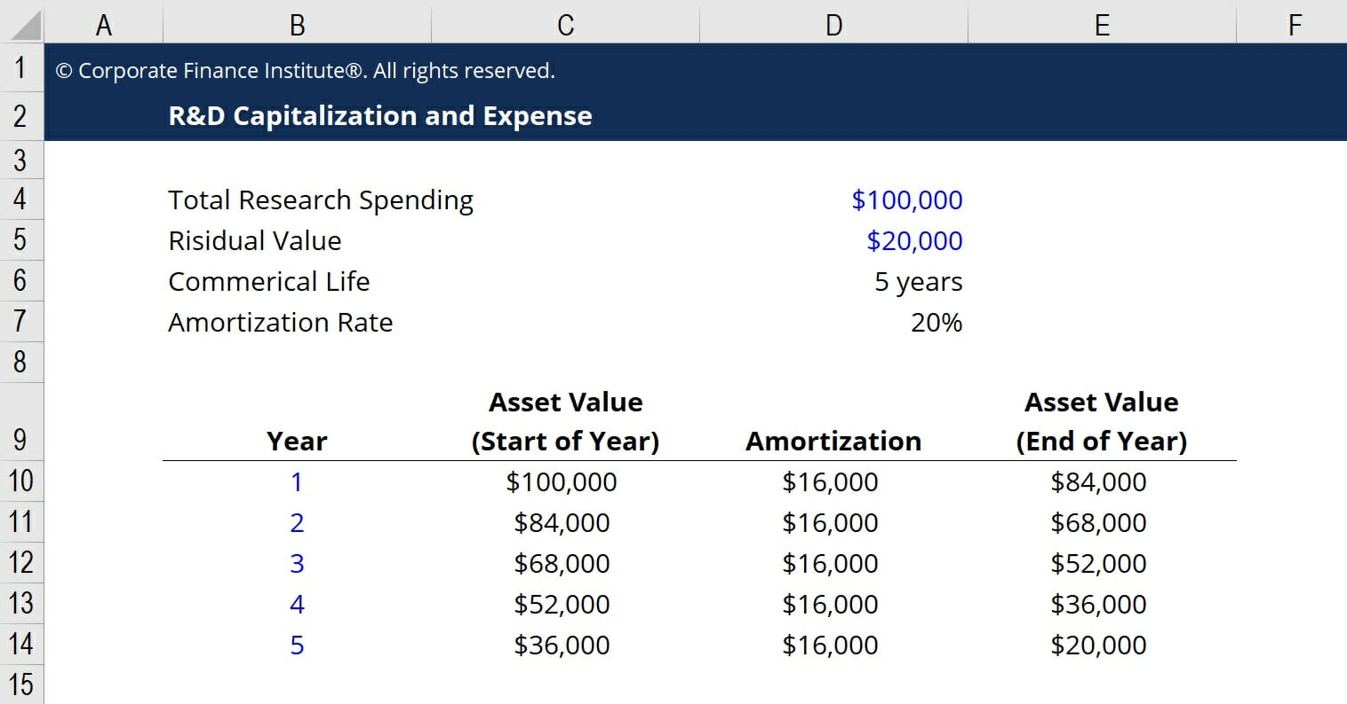

Based on these assumptions, the company would have a $16,000 amortization expense each year, for five years, until it reaches the residual value of $20,000. By amortizing the cost over five years, the net income of the business is smoothed out and expenses are more closely matched to revenues.