**Depreciation Schedule**

Depreciation is a term used to describe the reduction in the value of as asset over a number of years. A Depreciation Schedule is a table that shows the depreciation amount over the span of the asset's life. For accounting and tax purposes, the depreciation expense is calculated and used to "write-off" the cost of purchasing high-value assets over time. Usually a company will want to write-off the asset (meaning turn the cost into an expense) as soon as possible in order to increase the after-tax present worth, or profitability, of an asset.

## What Does Depreciation Schedule Mean?

A depreciation schedule enables firms to keep track of their long-term assets and see how these are going to depreciate over time. Usually, the information that a depreciation schedule includes is a description of the asset, the date of purchase, how much it costs, how long the firm estimates to use the asset (life), and the value of the asset when the firm decides to replace it (salvage value).

Furthermore, the depreciation schedule presents information on the depreciation method, the depreciation of the current year, the cumulative depreciation from the date the firm purchased the asset until today, and the net book value.

## Example

Rajesh is working at a firm’s accounting department. He is asked to create a schedule using the straight-line depreciation method and present the results to his manager.

He knows that depreciation can be claimed for assets with a useful life of at least one year, can become obsolete and are used for business purposes. Such assets are computers, equipment, vehicles, office furniture, and buildings.

He decides to use the straight-line method, which spreads the expenses of an asset evenly over its useful life after subtracting the asset’s salvage value.

Therefore, straight-line depreciation method = (Cost – Salvage Value) // Life. Furthermore, the straight-line depreciation method allows Rajesh to make an approximate estimate of the expected economic benefits over an asset’s useful life.

Based on the above, Theo creates the depreciation schedule by including the following information:

* Description of asset
* Date of purchase
* Cost
* Expected life
* Depreciation method
* Salvage value
* Current year depreciation
* Cumulative depreciation
* Net book value = Cost – Cumulative Depreciation

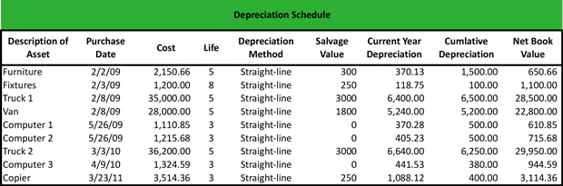

**Example:**

Your party business buys a bouncy castle for 10,000. Its salvage value is 500, and the asset has a useful life of 10 years.

We plug those numbers into the equation:

Formula: (asset cost – salvage value) / useful life

(10,000 – 500) / 10 = 950

So, you’ll write off 950 from the bouncy castle’s value each year for 10 years.