**What Is Valuation? Approaches of Valuation**

Valuation is the analytical process of determining the current (or projected) worth of an asset or a company. There are many techniques used for doing a valuation. An analyst placing a value on a company looks at the business's management, the composition of its [capital structure](https://www.investopedia.com/terms/c/capitalstructure.asp), the prospect of future earnings, and the [market value](https://www.investopedia.com/terms/m/marketvalue.asp) of its assets, among other metrics.

[Fundamental analysis](https://www.investopedia.com/terms/f/fundamentalanalysis.asp) is often employed in valuation, although several other methods may be employed such as the capital asset pricing model ([CAPM](https://www.investopedia.com/terms/c/capm.asp)) or the dividend discount model ([DDM](https://www.investopedia.com/terms/d/ddm.asp)).

## What Does Valuation Tell You?

A valuation can be useful when trying to determine the [fair value](https://www.investopedia.com/terms/f/fairvalue.asp) of a security, which is determined by what a buyer is willing to pay a seller, assuming both parties enter the transaction willingly. When a security trades on an exchange, buyers and sellers determine the [market value](https://www.investopedia.com/ask/answers/111414/whats-difference-between-enterprise-value-and-market-capitalization.asp) of a stock or bond.

The concept of [intrinsic value](https://www.investopedia.com/terms/i/intrinsicvalue.asp), however, refers to the perceived value of a security based on future earnings or some other company attribute unrelated to the market price of a security. That's where valuation comes into play. Analysts do a valuation to determine whether a company or asset is [overvalued or undervalued by the market](https://www.investopedia.com/articles/investing/101316/how-tell-if-stock-overvalued-or-undervalued.asp).

### The Two Main Categories of Valuation Methods

[**Absolute valuation**](https://www.investopedia.com/terms/a/absolute-value.asp)**models**attempt to find the intrinsic or "true" value of an investment based only on fundamentals. Looking at fundamentals simply means you would only focus on such things as dividends, cash flow, and the growth rate for a single company, and not worry about any other companies. Valuation models that fall into this category include the dividend discount model, discounted cash flow model, residual income model, and asset-based model.

[**Relative valuation**](https://www.investopedia.com/terms/r/relative-valuation-model.asp)**models,** in contrast, operate by comparing the company in question to other similar companies. These methods involve calculating multiples and ratios, such as the price-to-earnings multiple, and comparing them to the multiples of similar companies.

### Discounted Cash Flow Valuation

Analysts also place a value on an asset or investment using the cash inflows and outflows generated by the asset, called a [discounted cash flow](https://www.investopedia.com/terms/d/dcf.asp) (DCF) analysis. These cash flows are discounted into a current value using a discount rate, which is an assumption about interest rates or a minimum rate of return assumed by the investor.

If a company is buying a piece of machinery, the firm analyzes the cash outflow for the purchase and the additional cash inflows generated by the new asset. All the cash flows are discounted to a present value, and the business determines the [net present value](https://www.investopedia.com/terms/n/npv.asp) (NPV). If the NPV is a positive number, the company should make the investment and buy the asset.

## What are the Main Valuation Methods?

When valuing a company as a going concern, there are three main valuation methods used by industry practitioners:

(1) [DCF analysis](http://courses.corporatefinanceinstitute.com/collections/financial-modeling)

(2) comparable company analysis

(3) precedent transactions.

These are the most common methods of valuation used in [investment banking](https://corporatefinanceinstitute.com/resources/careers/jobs/investment-banking-overview/), equity research, private equity, corporate development, mergers & acquisitions ([M&A](https://corporatefinanceinstitute.com/resources/knowledge/valuation/mergers-acquisitions-ma-process/)), leveraged buyouts ([LBO](https://corporatefinanceinstitute.com/resources/knowledge/finance/leveraged-buyout-lbo/)), and most areas of finance.

[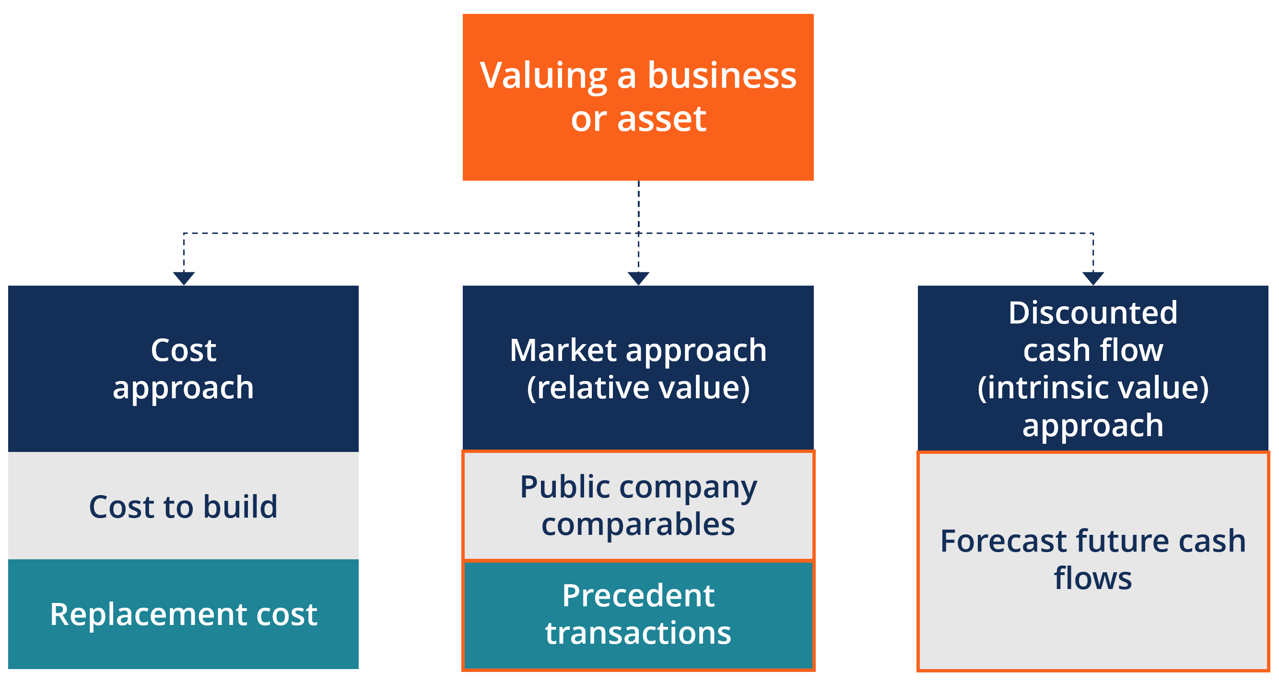](https://courses.corporatefinanceinstitute.com/courses/business-valuation-fundamentals-certificate-course)

As shown in the diagram above, when valuing a business or asset, there are three broad categories that each contain their own methods. The Cost Approach looks at what it costs to build something and this method is not frequently used by finance professionals to value a company as a going concern. Next is the Market Approach, this is a form of relative valuation and frequently used in the industry. It includes Comparable Analysis Precedent Transactions.  Finally, the discounted cash flow (DCF) approach is a form of intrinsic valuation and is the most detailed and thorough approach to valuation modeling.

### Method 1: Comparable Analysis (“Comps”)

[Comparable company analysis](https://corporatefinanceinstitute.com/resources/knowledge/valuation/comparable-company-analysis/) (also called “trading multiples” or “peer group analysis” or “equity comps” or “public market multiples”) is a relative [valuation method](http://courses.corporatefinanceinstitute.com/courses/business-valuation-fundamentals-certificate-course) in which you compare the current value of a business to other similar businesses by looking at trading multiples like P/E, [EV/EBITDA](https://corporatefinanceinstitute.com/ebitda-multiple), or other ratios. Multiples of [EBITDA](https://corporatefinanceinstitute.com/what-is-ebitda/) are the most common valuation method.

The “comps” valuation method provides an observable value for the business, based on what companies are currently worth. Comps are the most widely used approach, as they are easy to calculate and always current. The logic follows that, if company X trades at a 10-times P/E ratio, and company Y  has earnings of $2.50 per share, company Y’s stock must be worth $25.00 per share (assuming its perfectly comparable).

[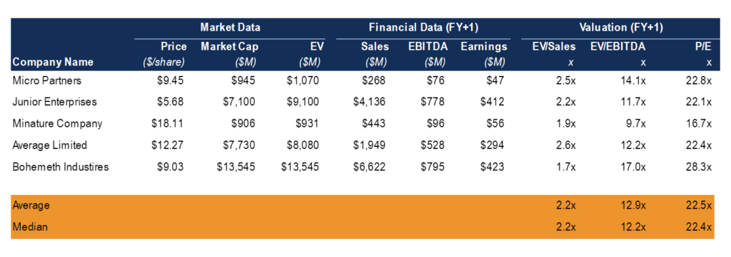](https://corporatefinanceinstitute.com/resources/knowledge/valuation/comparable-company-analysis/)Example Comps Table

### Method 2: Precedent Transactions

[Precedent transactions analysis](https://corporatefinanceinstitute.com/resources/knowledge/valuation/precedent-transaction-analysis/) is another form of relative valuation where you compare the company in question to other businesses that have recently been sold or acquired in the same industry. These transaction values include the take-over premium included in the price for which they were acquired.

These values represent the en bloc value of a business. They are useful for M&A transactions, but can easily become stale-dated and no longer reflective of the current market as time passes. They are less commonly used than Comps or market trading multiples.

[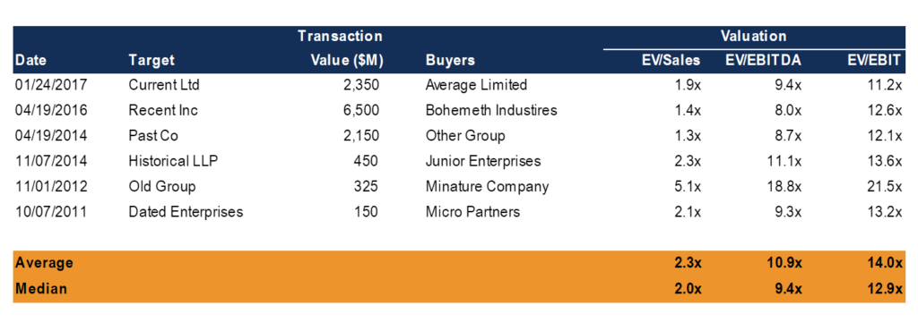](https://corporatefinanceinstitute.com/resources/knowledge/valuation/precedent-transaction-analysis/)Example Transaction Analysis

 Method 3: DCF Analysis

[Discounted Cash Flow (DCF)](https://corporatefinanceinstitute.com/resources/knowledge/modeling/dcf-model-training-free-guide/) analysis is an [intrinsic value](https://corporatefinanceinstitute.com/resources/knowledge/valuation/intrinsic-value-guide/) approach where an analyst forecasts the business’ unlevered [free cash flow](https://corporatefinanceinstitute.com/cash-flow/) into the future and discounts it back to today at the firm’s Weighted Average Cost of Capital ([WACC](https://corporatefinanceinstitute.com/what-is-wacc-formula)).

**How Discounted Cash Flow (DCF) Works**

The purpose of DCF analysis is to estimate the money an investor would receive from an investment, adjusted for the [time value of money](https://www.investopedia.com/terms/t/timevalueofmoney.asp). The time value of money assumes that a dollar today is worth more than a dollar tomorrow because it can be invested. As such, a DCF analysis is appropriate in any situation where a person is paying money in the present with expectations of receiving more money in the future.

For example, assuming a 5% annual interest rate, $1.00 in a savings account will be worth $1.05 in a year. Similarly, if a $1 payment is delayed for a year, its present value is $.95 because it cannot be put in your savings account to earn interest.

DCF analysis finds the [present value](https://www.investopedia.com/terms/p/presentvalue.asp) of expected future cash flows using a [discount rate](https://www.investopedia.com/terms/d/discountrate.asp). Investors can use the concept of the present value of money to determine whether future cash flows of an investment or project are equal to or greater than the value of the initial investment. If the value calculated through DCF is higher than the current cost of the investment, the opportunity should be considered.

In order to conduct a DCF analysis, an investor must make estimates about future cash flows and the ending value of the investment, equipment, or other asset. The investor must also determine an appropriate discount rate for the DCF model, which will vary depending on the project or investment under consideration. If the investor cannot access the future cash flows, or the project is very complex, DCF will not have much value and alternative models should be employed.

Discounted Cash Flow (DCF) Formula

**DCF = CF1/(1+r)1 + CF2/(1+r)2+ CFn/(1+r)n**

where:

* CF = the cash flow for the given year.
* CF1 is for year one,
* CF2 is for year two,
* CFnis for additional years
* r = the discount rate

Example of Discounted Cash Flow (DCF)

When a company looks to analyze whether it should invest in a certain project or purchase new equipment, it usually uses its [weighted average cost of capital](https://www.investopedia.com/terms/w/wacc.asp) (WACC) as the discount rate when evaluating the DCF. The WACC incorporates the average rate of return that shareholders in the firm are expecting for the given year.

You are looking to invest in a project and your company's WACC is 5%, so you will use 5% as your discount rate. The initial investment is $11 million and the project will last for five years, with the following estimated cash flows per year:

| **CASH FLOW** | |
| --- | --- |
| Year | Cash Flow |
| 1 | $1 million |
| 2 | $1 million |
| 3 | $4 million |
| 4 | $4 million |
| 5 | $6 million |

Therefore, the discounted cash flows for the project are:

| **DISCOUNTED CASH FLOW** | | |
| --- | --- | --- |
| Year | Cash Flow | Discounted Cash Flow |
| 1 | $1 million | $952,380 |
| 2 | $1 million | $907,029 |
| 3 | $4 million | $3,455,425 |
| 4 | $4 million | $3,290,826 |
| 5 | $6 million | $4,701,089 |

If we sum up all of the discounted cash flows, we get a value of $13,306,749. Subtracting the initial investment of $11 million, we get a [net present value](https://www.investopedia.com/terms/n/npv.asp) (NPV) of $2,306,749. Because this is a positive number, the cost of the investment today is worth it as the project will generate positive discounted cash flows above the initial cost. If the project had cost $14 million, the NPV would have been -$693,251, indicating that the cost of the investment would not be worth it.

**The 3 primary valuation approaches**   
ET Online

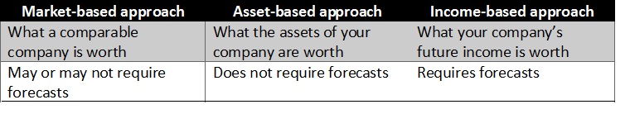

**1. Market-based approach**   
Under this approach you:   
1. identify a comparable firm (same industry, similar business and markets)   
2. identify the suitable multiple to be used (detailed below)   
3. choose the correct variable and multiply   
  
**Some of the most popular multiples are:**   
**a. Price/Earnings (P/E):** Under this method, the Profit After Tax is multiplied to arrive at an estimate of equity value. While it is the most easily understood and widely used, the main issue is using Profit After Tax, which is affected by a number of ..   
**b. Price/Sales (P/S):** Compared to P/E, P/S is less distorted, easier to calculate, and not affected by capital structure. Moreover, it is useful for firms that do not have consistent profits, and more appropriate for certain sectors like retail.   
**c. Price/Book Value (P/BV):** This method uses a multiple applied to the book or accounting value of net assets of the company. P/BV is particularly relevant for sectors where income (and thus, value) is entirely dependent on the value of assets, such as banking.   
**d. EV/EBITDA:**EBITDA, or Earnings Before Interest, Taxes, Depreciation, and Amortisation is widely regarded by analysts as more reliable since it removes distortions like effect of capital structure, varying tax rates, and non-operating income. Since EBITDA is the earnings before interest, the appropriate value in the numerator is taken as the Enterprise Value, or value of debt plus value of equity, plus cash balance. 

**2. Asset based approach**   
The Net Asset Value (NAV) is the easiest to understand. It is calculated simply as fair value of the assets of the business less the external liabilities owed. The key here is determining fair value, especially of assets since fair value may differ significantly from acquisition value (for non-depreciating assets) and recorded value (for depreciating assets). 

**3. Income based approach**   
This primarily involves calculating the value of the company using Discounted Cash Flow (DCF). In short and very simply, this means calculating the present value of the future cash flows of the company. The discounting to present value is done using the cost of capital of the company. Depending on the objective, cash flows to the firm (that is, before debt obligations) or cash flows to shareholders may be used.