**World Bank, Objective, function and structure**

The International Bank for Reconstruction and Development (IBRD) was created in 1944 to help Europe rebuild after World War II. Today, IBRD provides loans and other assistance primarily to middle income countries. IBRD is the original World Bank institution. It works closely with the rest of the World Bank Group (IBRD, IDA, IFC, MIGA) to help developing countries reduce poverty, promote economic growth, and build prosperity. IBRD is owned by the governments of its 188 member countries.

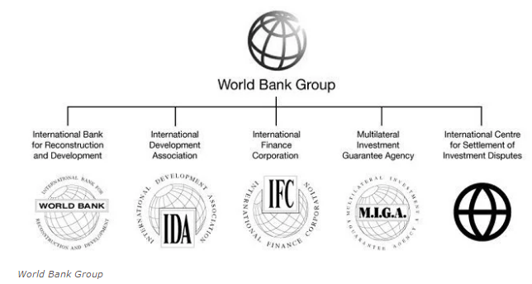

MAR 29, 2019

*World Bank Group:*

➢ International Development Association (IDA)

➢ International Finance Corporation (IFC)

➢ Multilateral Investment Guarantee Agency (MIGA)

➢ International Centre for settlement of Investment Disputes (ICSID)

WORLD Bank is also known as The International Bank for Reconstruction and Development (IBRD). The Second World War damages the economies of the world. So in 1945 it was realized to concentrate on the reconstruction of that war damaged economies. The IBRD was established in Dec. 1945 with the IMF on the basis of recommendations of the Bretton woods conference that is reason why IMF and World Bank are called Bretton woods twin. IBRD started working in June 1946. **As on April 2019; the World Bank of 189 members.**

* World Bank was formed on **July 1944** at the **Bretton Woods Conference.**
* Headquarter of World Bank is located at **Washington D.C. (U.S.A.)**
* The main purpose of the world bank is**''Reduction of Poverty''.**
* Current member nations of world bank are **188.**
* Now the president of the World Bank is **Jim Yong Kim.**

## Objectives/ Goals of World Bank:

The following are the important objectives of the World Bank:

1. To assist in the reconstruction and development of the territories of its members by facilitating the investment of capital for productive purposes.

2. To promote foreign private investment by means of (a) guarantees of or through participation in loans and other investments made by private investors; and (b) where private capital is not available on reasonable terms, to make loans for productive purposes out of its own resources or out of the funds borrowed by it.

3. To promote the long range balanced growth of international trade and the maintenance of equilibrium in balance of payments by encouraging international investment thereby assisting in raising productivity, the standard of living and condition of labour in the territories of the member countries.

4. To encourage loans made or guaranteed so that more useful and urgent projects, large and small alike will be dealt with first.

5. To conduct its operations so as to bring about a smooth transition from a war-time economy to a peace-time economy.

6. **World Bank supports special programmes related to the development of the country** e.g. forest development, port development, agricultural development, urban services, housing projects, sewerage development or underground railways.

### Functions of World Bank:

World Bank is playing main role of providing loans for development works to member countries, especially to underdeveloped countries. The World Bank provides long-term loans for various development projects of 5 to 20 years duration.

**The main functions can be explained with the help of the following points:**

1. **Specific Investment Loan (SIL):** Creation of new productive assets, establishment of social, economic and institutional infrastructure, etc. are the primary objectives of the SIL.

2. **Sector Investment and Maintenance Loan (SIML):** The purpose of SIML is to encourage investments, policies, and performance in specific sector(s) in accordance with National goods.

3. **Financial Intermediary Loan (FIL):** The FIL support financial development and provide finances in the

nature of general purpose credit. The credit or loan maybe for certain main sector or sub-sectors.

4. **Emergency Recover Loan (ERL):** This credit is given for restoration of assets and productivity of a member country. This is after situations like war or natural disaster

5. **Technical Assistance Loan (TAL):** This loan is given particularly to strengthen entities concerned with:

a. Policies, strategies and institutional reforms that promote further development in a sector or in the economy as a whole.

b. This is meant for public sector undertaking , so that they can smoothly carry out activities and investment.

c. It can also be used for Budgetary management.

6. **Structural Adjustment Loan (SAL):** The objective of the SAL is to support specific policy changes and institutional reforms pertaining to:

a. Efficient utilization of resources

b. Meeting balance of payments needs and

c. Mitigating social costs.

7. **Sector Adjustment Loan (SEAL):** The SEAL is meant to help in Government policy reform for the private productive sector where foreign exchange is required for urgent rehabilitation of key infrastructure and productive facilities. This loan is used when SAL is not available.

### Organizational Structure of World Bank:

The organizational structure of the World Bank consists of Board of Governors, Executive Directors and a president. All the powers of the bank are entrusted to the Board of Directors. Each member country has one governor and one alternate governor and their term is for five years. The Board of Governors meets once a year. The governors have delegated their powers to a Board of Executive Directors in order to carry on the day-to-day functions of the bank. At present, there are 25 executive directors.

The president of World Bank is also the chairman of the Board of Executive Directors. The meeting of the Board of Executive Directors is held once a month. They formulate the policy of the bank within the framework of the articles of agreement. They also decide over the loan and credit proposals made by the president. They submit to the Board of Governors the audited accounts and administrative budget and an annual report on the operation and policies of the bank at its annual meeting. The World Bank has about 6500 staff members in Washington in addition to about 1200 consultants. A number of vice presidents and directors of various departments and regions also assist the president of the World Bank in his functions.

**Summary**

1. The World Bank is one of four institutions created at the Bretton Woods Conference in 1944. It is an international financial institution which acts as a vital source of financial and technical assistance to developing countries around the world.

2. Some of its objectives are reconstruction and development, balanced growth, giving loans and advances and promoting foreign private investment.

3. World Bank has membership strength of 185 countries. All the 185 member countries of the World Bank are its shareholders who are generally represented by the board of governors. Governors in the member countries are mainly finance ministers or development ministers. Board of Governors in the World Bank group and IMF meet once in a year.

4. The IMF and the World Bank are institutions in the United Nations system. They share the same goal of raising living standards in their member countries. Their approaches to this goal are complementary, with the IMF focusing on macroeconomic issues and the World Bank concentrating on long-term economic development and poverty reduction.

5. The World Bank's (the IBRD and IDA's) activities are focused on developing countries, in fields such as human development (e.g. education, health), agriculture and rural development (e.g. irrigation and rural services), environmental protection (e.g. pollution reduction, establishing and enforcing regulations), infrastructure (e.g. roads, urban regeneration, and electricity), large industrial construction projects, and governance (e.g. anti-corruption, legal institutions development).