**Optimal Capital Structure and its determinants**

Capital Structure is referred to as the ratio of different kinds of securities raised by a firm as long-term finance. The capital structure involves two decisions-

1. Type of securities to be issued are equity shares, preference shares and long term borrowings (Debentures).
2. Relative ratio of securities can be determined by process of capital gearing. On this basis, the companies are divided into two-
   1. Highly geared companies - Those companies whose proportion of equity capitalization is small.
   2. Low geared companies - Those companies whose equity capital dominates total capitalization.

For instance - There are two companies A and B. Total capitalization amounts to be USD 200,000 in each case. The ratio of equity capital to total capitalization in company A is USD 50,000, while in company B, ratio of equity capital is USD 150,000 to total capitalization, i.e, in Company A, proportion is 25% and in company B, proportion is 75%. In such cases, company A is considered to be a highly geared company and company B is low geared company.

**From the following information, determine the optimal capital structure of the company:**

**[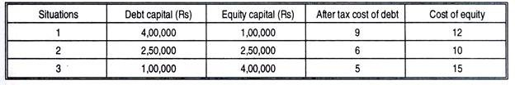](http://cdn.yourarticlelibrary.com/wp-content/uploads/2015/11/clip_image00225.jpg)**

**[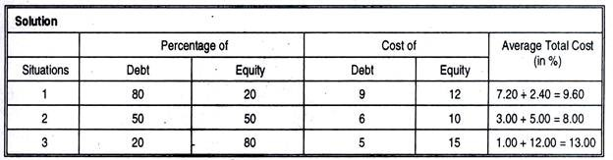](http://cdn.yourarticlelibrary.com/wp-content/uploads/2015/11/clip_image00418.jpg)**

So the optimal capital structure for the company is in Situation 2, where it uses 50% debt and 50% equity. At this level its combined average cost of capital is the minimum.

**Factors Determining Capital Structure**

1. **Trading on Equity-** The word “equity” denotes the ownership of the company. Trading on equity means taking advantage of equity share capital to borrowed funds on reasonable basis. It refers to additional profits that equity shareholders earn because of issuance of debentures and preference shares. It is based on the thought that if the rate of dividend on preference capital and the rate of interest on borrowed capital is lower than the general rate of company’s earnings, equity shareholders are at advantage which means a company should go for a judicious blend of preference shares, equity shares as well as debentures. Trading on equity becomes more important when expectations of shareholders are high.
2. **Degree of control-** In a company, it is the directors who are so called elected representatives of equity shareholders. These members have got maximum voting rights in a concern as compared to the preference shareholders and debenture holders. Preference shareholders have reasonably less voting rights while debenture holders have no voting rights. If the company’s management policies are such that they want to retain their voting rights in their hands, the capital structure consists of debenture holders and loans rather than equity shares.
3. **Flexibility of financial plan-** In an enterprise, the capital structure should be such that there is both contractions as well as relaxation in plans. Debentures and loans can be refunded back as the time requires. While equity capital cannot be refunded at any point which provides rigidity to plans. Therefore, in order to make the capital structure possible, the company should go for issue of debentures and other loans.
4. **Choice of investors-** The company’s policy generally is to have different categories of investors for securities. Therefore, a capital structure should give enough choice to all kind of investors to invest. Bold and adventurous investors generally go for equity shares and loans and debentures are generally raised keeping into mind conscious investors.
5. **Capital market condition-** In the lifetime of the company, the market price of the shares has got an important influence. During the depression period, the company’s capital structure generally consists of debentures and loans. While in period of boons and inflation, the company’s capital should consist of share capital generally equity shares.
6. **Period of financing-** When company wants to raise finance for short period, it goes for loans from banks and other institutions; while for long period it goes for issue of shares and debentures.
7. **Cost of financing-** In a capital structure, the company has to look to the factor of cost when securities are raised. It is seen that debentures at the time of profit earning of company prove to be a cheaper source of finance as compared to equity shares where equity shareholders demand an extra share in profits.
8. **Stability of sales-** An established business which has a growing market and high sales turnover, the company is in position to meet fixed commitments. Interest on debentures has to be paid regardless of profit. Therefore, when sales are high, thereby the profits are high and company is in better position to meet such fixed commitments like interest on debentures and dividends on preference shares. If company is having unstable sales, then the company is not in position to meet fixed obligations. So, equity capital proves to be safe in such cases.
9. **Sizes of a company-** Small size business firms capital structure generally consists of loans from banks and retained profits. While on the other hand, big companies having goodwill, stability and an established profit can easily go for issuance of shares and debentures as well as loans and borrowings from financial institutions. The bigger the size, the wider is total capitalization.