**Trade Theories**

Adam Smith and David Ricardo gave the classical theories of international trade. According to the theories given by them, when a country enters in foreign trade, it benefits from specialization and efficient resource allocation.

The foreign trade also helps in bringing new technologies and skills that lead to higher productivity.

**The assumptions taken under this theory’ are as follows:**

a. There are two countries producing two goods.

b. The size of economies of these countries is equal

c. There is perfect mobility of factors of production within countries

d. Transportation cost is ignored

e. Before specialization, country’s resources are equally divided to produce each good

**The classical theories are divided into three theories, as shown in Figure-3:**

**[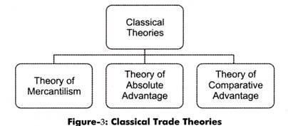](http://cdn.economicsdiscussion.net/wp-content/uploads/2015/01/clip_image00287.jpg)**

**1. Theory of Mercantilism:**

Mercantilism is the term that was popularized by Adam Smith, Father of Economics, in his book, The Wealth of Nations. Western European economic policies were greatly dominated by this theory. The theory of mercantilism holds that countries should encourage export and discourage import.

It states that a country’s wealth depends on the balance of export minus import. According to this theory, government should play an important role in the economy for encouraging export and discouraging import by using subsidies and taxes, respectively. In those days, gold was used for trading goods between countries.

Thus, export was treated as good as it helped in earning gold, whereas, import was treated as bad as it led to the outflow of gold. If a nation has abundant gold, then it is considered to be a wealthy nation. If all the countries follow this policy, there may be conflicts, as no one would promote import. The theory of mercantilism believed in selfish trade that is a one-way transaction and ignored enhancing the world trade. Mercantilism was called as a zero-sum game as only one country benefitted from it.

**2. Theory of Absolute Advantage:**

Given by Adam Smith in 1776, the theory of absolute advantage stated that a country should specialize in those products, which it can produce efficiently. This theory assumes that there is only one factor of production that is labor.

Adam Smith stated that under mercantilism, it was impossible for nations to become rich simultaneously. He also stated that wealth of the countries does not depend upon the gold reserves, but upon the goods and services available to their citizens.

Adam Smith wrote in The Wealth of Nations, ”If a foreign country can supply us with a commodity cheaper than we ourselves can make it, better buy it of them with some part of the produce of our own industry, employed in a way in which we have some advantage”.

He stated that trade would be beneficial for both the countries if country A exports the goods, which it can produce with lower cost than country B and import the goods, which country B can produce with lower cost than it.

An example can be used to prove this theory. Suppose there are two countries A and B, which produce tea and coffee with equal amount of resources that is 200 laborers. Country A uses 10 laborers to produce 1 ton of tea and 20 laborers to produce 1 ton of coffee. Country B uses 25 units of laborers to produce tea and 5 units of laborers to produce 1 ton of coffee.

**This is shown in Table- 1:**

**[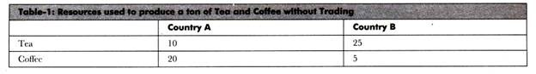](http://cdn.economicsdiscussion.net/wp-content/uploads/2015/01/clip_image00438.jpg)**

It can be seen from Table-2 that country A has absolute advantage in producing tea as it can produce 1 ton of tea by using less laborers as compared to country B. On the other hand, country B has absolute advantage in producing coffee as it can produce 1 ton of coffee by employing less laborers in comparison to country A.

Now, if there is no trade between these countries and resources (in this case there are total 200 laborers) are being used equally to produce tea and coffee, country A would produce 10 tons of tea and 5 tons of coffee and country B would produce 4 tons of tea and 20 tons of coffee. Thus, total production without trade is 39 tons (14 tons of tea and 25 tons of coffee).

**Table-2 shows the production without the trade between country A and country B:**

**[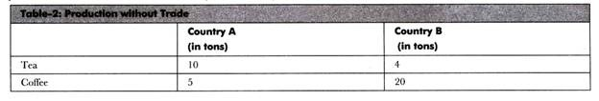](http://cdn.economicsdiscussion.net/wp-content/uploads/2015/01/clip_image00624.jpg)**

If both the countries trade with each other and specialize in goods in which they have absolute advantage, the total production would be higher. Country A would produce 20 tons of tea with 200 units of laborers; whereas, country B would produce 40 tons of coffee with 200 units of laborers. Thus, total production would be 60 units (20 tons of tea and 40 tons of coffee).

**The production of tea and coffee after trade is shown in Table-3:**

**[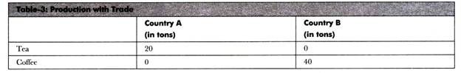](http://cdn.economicsdiscussion.net/wp-content/uploads/2015/01/clip_image00716.jpg)**

Without specialization, total production of countries was 39 tons, which becomes 60 tons after specialization. Therefore, the theory of absolute advantages shows that trade would be beneficial for both the countries.

**3. Theory of Comparative Advantage:**

Many questions may come in mind after reading the absolute advantage theory that what would happen if a country has absolute advantage in all the products or no absolute advantage in any of the product. How such a country would benefit from trade? The answers of these questions was given by David Ricardo in his theory of comparative advantage, which states that trade can be beneficial for two countries if one country has absolute advantage in all the products and the other country has no absolute advantage in any of the products.

According to Ricardo, “…a nation, like a person, gains from the trade by exporting the goods or services in which it has its greatest comparative advantage in productivity and importing those in which it has the least comparative advantage. ”

This theory assumes that labor as the only factor of production in two countries, zero transport cost, and no trade barriers within the countries. Let us understand this theory with the help of an example.

Suppose there are two countries A and B, producing two commodities wheat and wine with labor as the only factor of production. Now assume that both the countries have 200 laborers and they use 100 laborers to produce wheat and 100 laborers to produce wine.

**Table-4 shows the production of wheat and wine in Country X and Country Y before trade:**

**[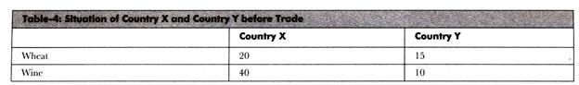](http://cdn.economicsdiscussion.net/wp-content/uploads/2015/01/clip_image00912.jpg)**

Table-4 depicts that country X can produce 20 units; whereas, country Y can produce 15 units of wheat by using 100 laborers. In addition, country X can produce 40 units; whereas, country’ Y can produce 10 units of wine by employing 100 laborers.

Thus, country X has absolute advantage in producing both the products. As already discussed, country X employs same number of laborers (100 laborers in production of each good) in producing both wine and wheat; however, the production of wine is more than the production of wheat.

It shows that country’ X has comparative advantage in producing wine. Similarly, country Y also employs same number of laborers (100 laborers in production of each good) in manufacturing wheat and wine; however, its production of wheat is more than the wine. It indicates that country Y has comparative advantage in manufacturing wheat.

For example, country X has decided to produce 60 units of wine by employing 150 laborers. It uses 50 laborers to produce 10 units of wheat. On the other hand, country Y has decided to use all the 200 laborers to produce 30 units of wheat. It would not produce any unit of wine.

**This data is represented in Table-5:**

**[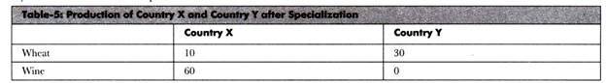](http://cdn.economicsdiscussion.net/wp-content/uploads/2015/01/clip_image01111.jpg)**

Now, country X exchanges 14 units of wine with 14 units of wheat produced by country Y.

**The situation of both the countries after trade is shown in Table-6:**

**[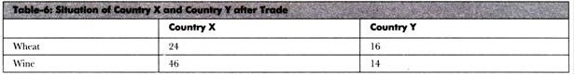](http://cdn.economicsdiscussion.net/wp-content/uploads/2015/01/clip_image0127.jpg)**

It can be observed from Table-6 that both the countries have gained from trade. Before trade, country X has 20 units of wheat and 40 units of wine; however, after trade, country Y has 24 units of wheat and 46 units of wine.

On the other hand, country Y has 15 units of wheat and 10 units of wine before trade; however, it has 16 units of wheat and 14 units of wine after trade. Therefore, comparative advantage explains that trade can create benefit for both the countries even if one country has absolute advantage in the production of both the goods.

**Porter’s Diamond Theory of National Advantage**

Micheal Porter gave the diamond theory of national advantage, which states that the features of home country are crucial for the success of an organization in the international markets.

This theory is called the diamond theory, as it is depicted in the shape of a diamond framework.

It describes the factors that contribute to the success of organizations in global industries. These factors are called the determinants of the national advantage.

**Figure-4 depicts these determinants:**

**[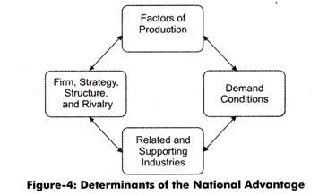](http://cdn.economicsdiscussion.net/wp-content/uploads/2015/01/clip_image00286.jpg)**

**The discussion of these determinants is as follows:**

**(a) Factors of Production:**

Include the inputs necessary for producing goods and services. The basic factors to carry out a business include natural resources and labor; whereas, advanced factors include infrastructure, such as communication systems.

The skilled personnel form the part of specialized factors. If a country is endowed with all these factors of production, it would be successful in the global market. However, there may be countries that have advanced and specialized factors but lack in the basic factors.

For example, South Korea lacks natural resources, but have specialized engineers. Thus, it can be said that the countries that lack in natural resources develop new methods or processes that lead to a national comparative advantage.

**(b) Demand Conditions:**

Refer to the nature and size of the customers of the products in the home market. The strong demand conditions in the home country persuade the domestic organizations to constantly improve the product. If the demand of a product is more in the domestic market then it can influence the demand of customers in the foreign market.

**(c) Related and Supporting Industries:**

Involve industries in the country that are considered as the leader of a particular product. These industries help in innovation that helps organization under them to produce at low cost.

In addition, the growth of one industry influences the growth of other industries. For instance, the growth and development of the automobile industry would enhance the growth opportunities of the steel industry.

**(d) Organizational Strategy, Structure, and Rivalry:**

Varies from country to country. The strategies, structures, and rivalry are very important for the success of an organization. The strategies help in setting new goals, the structure helps in managing operations, and rivalry helps in generating innovative ideas in organizations.

These four determinants can also be called as the dimensions of the diamond model that help in contributing to the national advantage. According to Porter, these dimensions interact with each other and help in increasing the competitiveness of the organizations.