**What Is Fintech?**

Fintech, a combination of the terms “financial” and “technology,” refers to businesses that use technology to enhance or automate financial services and processes.

Fintech refers to the application of software and hardware to financial services and processes, making them faster, easier to use and more secure. The fintech industry includes everything from payment processing solutions to mobile banking apps.

The term encompasses a [rapidly growing industry](https://builtin.com/fintech/fintech-companies-startups-to-know) that serves the interests of both consumers and businesses in multiple ways. From mobile banking and insurance to cryptocurrency and investment apps, fintech has a seemingly endless array of applications.

Fintech (financial technologies) is a business direction that uses new technologies and innovations in the financial services market, which involves such advanced areas as digital, mobile payments and transfers, e-wallets, online lending, P2P platforms, crowdfunding, online funds, online insurance, etc.

* The first meaning of fintech is presented as a new branch of the economy, consisting of young companies that provide improved products and services to the financial market.
* The second meaning of this concept is expressed in the aggregate of new technology companies that, on the basis of their own funds, are developing mechanisms for introducing innovative technologies into the traditional financial sector of the economy.
* The third understanding of the essence of fintech lies in the practical activity based on the use of software to meet the demand for products of the financial market.

Having decided on an understanding of the essence of fintech, it is advisable to study the history of its development for a deeper analysis of this phenomenon. The evolution of [fintech development](https://geniusee.com/fintech) can be conditionally divided into 3 stages, which are clearly shown in the image below.

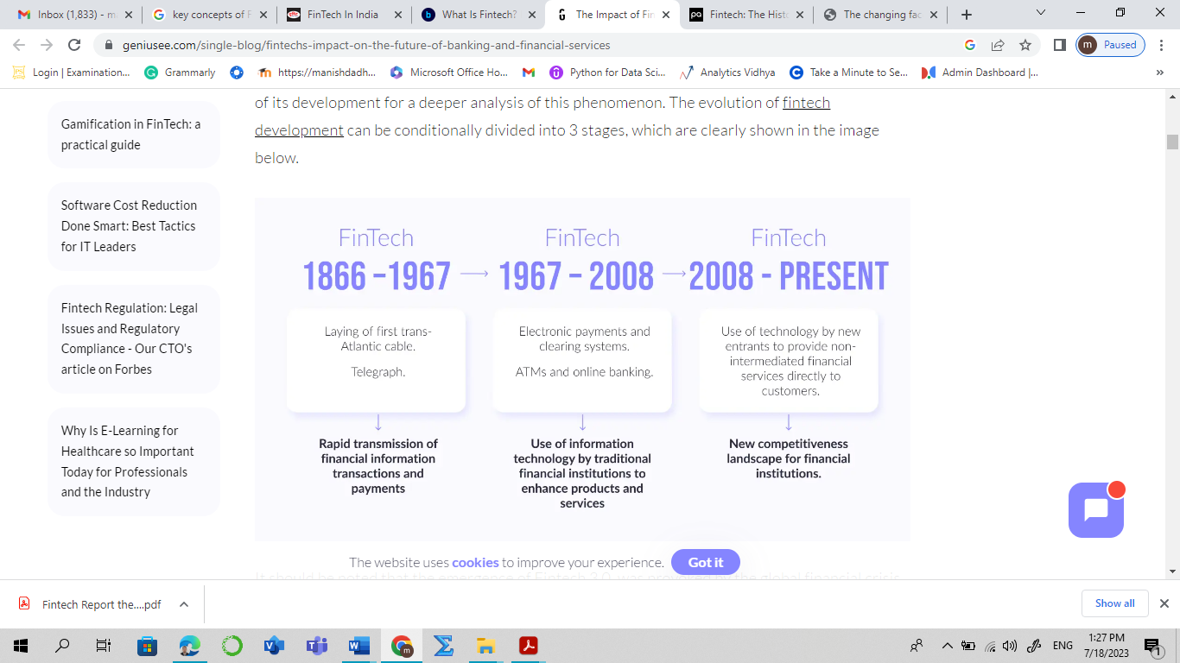

## The History of Fintech

According to a paper by [Arneris, Barberis & Ross](https://www.researchgate.net/publication/313365410_The_Evolution_of_Fintech_A_New_Post-Crisis_Paradigm), fintech can be split into a number of different eras. Each of these three (and a half…) eras saw a distinct level of differentiation in the market that led to changes in the way consumers interacted with their money. Let’s take a look at these eras:

### **Fintech 1.0 (1886 – 1967)**

This stage involves **building the infrastructure that will support globalized financial services**. The first transatlantic cable (1866) and Fedwire (1918) in the USA enabled the first electronic fund transfer system using technologies such as telegraph and Morse code. It was basic by today’s standards, but at a time of developing infrastructure and transportation, the ability to make financial transactions over a more considerable distance was revolutionary.

### **Fintech 2.0 (1967 – 2008)**

The start of this phase is marked by the installation of the first ATM by Barclays in 1967, and is characterised by the **switch from analogue to the digitalization of finances**. The 1970s saw the establishment of NASDAQ, the world’s first digital stock exchange and SWIFT (Society For Worldwide Interbank Financial Telecommunications), a communication protocol between financial institutions facilitating the large volume of cross-border payments.

This era continued through the 1980s with the rise of bank mainframe computers (and a “Gordon Gecko” sense of Wall Street style…) and the growth of online banking through the 1980s saw the way people do business change, with the **online revolution** leading to a shift in how people perceived financial institutions.

The 1990s saw the **first movements towards digital banking**, with connected customers starting to manage their money in different ways. PayPal was launched in 1998 which would hint towards the new payment systems that would come as the world increasingly went online.

### **Fintech 3.0 (2008-Current)**

Post-financial crisis, lack of trust in banks aligned with **regulatory change opens up the market to new providers**. Bitcoin is born in 2009 followed by other cryptocurrencies using blockchain technology. Smartphone adoption means that **mobile devices become the primary means** by which people access the web and other financial services. It’s become the **era of the start-up**,

## A majority of the Indian FinTech start-ups are not even a decade old but the progress and growth shown by them has been exponential over the past few years.15 As of December 2021, there are more than 2,100 FinTechs in India. The Indian FinTech market is expected to reach USD 150 billion in valuation by 2025.17 Indian FinTech start-ups have raised USD 10.6 billion in 2021.18 As of 2022, India minted 100 unicorn start-ups across sectors with a total valuation of over USD 333 billion, out of which 21 are FinTech unicorns.[1]

## Types of Fintech Companies

**Mobile Banking and Neobanks**

Mobile banking is the central focus of many finance technology companies. In the world of personal finance, consumers have increasingly demanded easy access to their bank accounts, especially on a mobile device. Most major banks now offer some kind of mobile banking feature, especially with the rise of digital-first banks, or neobanks. Neobanks are essentially banks without any physical branch locations, serving customers with checking, savings, payment services and loans on completely mobile and digital infrastructure. Some banks also allow third-party software applications to access a user’s financial information, which is called open banking. Some examples of fintech banks or neobanks are Chime, Current, Aspiration and Varo.

**Cryptocurrency Fintech**

Cryptocurrency and blockchain intersect with fintech in a number of ways. For starters, several crypto trading platforms have emerged in recent years that allow users to trade different kinds of cryptocurrencies and take advantage of decentralized exchanges. And to keep people’s digital currency safe, a number of crypto wallets have sprung up as well. In addition, several fintech companies use blockchain technology for payment processing, money transfer and secure digital identity management. Some examples of cryptocurrency fintech companies include Coinbase, Blockfi and SALT.

**Fintech Investment and Savings**

Fintech has caused an explosion in the number of investing and savings apps in recent years. More than ever, the barriers to investing are being broken down by companies like Robinhood, Stash and Acorns. While these apps differ in approach, each uses a combination of savings and automated small-dollar investing methods, such as instant round-up deposits on purchases, to introduce consumers to the markets.

**Machine Learning and Trading**

Being able to predict where markets are headed is the Holy Grail of finance. With billions of dollars to be made, it’s no surprise that machine learning has played an increasingly important role in fintech — and in trading specifically. The power of this AI subset in finance lies in its ability to run massive amounts of data through algorithms designed to spot trends and risks, allowing consumers, companies, banks and additional organizations to have a more informed understanding of investment and purchasing risks earlier on in the process.

**Payment Fintech**

Moving money around is something fintech is very good at. The phrase “I’ll Venmo you” or “I’ll CashApp you” is now a replacement for “I’ll pay you later.” These are, of course, go-to mobile payment platforms. Payment companies have changed the way we all do business. It’s easier than ever to send money digitally anywhere in the world. In addition to Venmo and Cash App, popular payment companies include Zelle, Paypal, Stripe and Square.

**Fintech Lending**

Fintech is also overhauling credit by streamlining risk assessment, speeding up approval processes and making access easier. Billions of people around the world can now apply for a loan on their mobile devices, and new data points and risk modeling capabilities are expanding credit to underserved populations. Additionally, consumers can request credit reports multiple times a year without dinging their score, making the entire backend of the lending world more transparent for everyone. Within the fintech lending space, some companies worth noting include Tala, Petal and Credit Karma.

**Insurtech — Insurance Fintech**

While insurtech is quickly becoming its own industry, it still falls under the umbrella of fintech. Insurance is a somewhat slow adopter of technology, and many fintech startups are partnering with traditional insurance companies to help automate processes and expand coverage. From mobile car insurance to wearables for health insurance, the industry is staring down tons of innovation. Some insurtech companies to keep an eye on include Lemonade, Kin and Insurify.

**Fintech Trends**

Fintech is not a new industry, it’s just one that has evolved very quickly. Technology has, to some degree, always been part of the financial world — whether it’s the introduction of credit cards or ATMs, electronic trading floors, personal finance apps and high-frequency trading in the decades that followed. Over the past decade, though, the fintech industry has seen accelerated growth — and fintech innovations are likely to only advance from here.

Some fintech trends to keep an eye on include:

**Digital Wallets**

Digital wallets, like Apple Pay and Google Pay, allows people to store their payment information in a mobile app, and then use that app when it comes time to pay for something. While digital wallets have been around for years, their usage is still on the rise.

**Blockchain in Fintech**

Blockchain — a public ledger capable of recording the ownership, origin and movement of digital assets — will continue to impact the financial industry. For starters, the ledger technology and proliferation of smart contracts will greatly help with making the industry more secure and efficient.

**Embedded Finance**

Embedded finance is the term for when a non-financial business integrates fintech tools into its point of service. Examples include payment processing terminals at coffee shops and buy-now-pay-later buttons on e-commerce store checkouts. This integrated finance stack makes for a smoother, more-flexible experience for customers — and we’re likely to see it more and more in the days ahead.

1. https://www.pwc.in/assets/pdfs/consulting/financial-services/fintech/publications/the-changing-face-of-financial-services-growth-of-fintech-in-india-v2.pdf