**Consumer Finance**

 The term ‘[Consumer Financing](https://www.jifiti.com/consumer-financing/)’ is when a business or retailer offers customer financing options to its customers using either their own funds or the funds of a lending company or bank. This allows the consumer to be able to purchase an item that they would otherwise not be able to, or may not want to pay for using immediate funds. The term is typically used to describe debt for everyday goods and services.

  Additional points:

* ‘Consumer financing’ covers all point-of-sale finance, including credit cards and installment loans.
* Businesses of all sizes benefit greatly from offering consumer financing.
* Also referred to as ‘Customer financing

**1. Why should I offer consumer financing?**

For a retailer, offering consumer financing at the point of purchase can be crucial in converting passive browsers into active buyers. Therefore, it can boost sales and conversion rates. At the same time, it can promote customer loyalty and repeat business. Consumer financing encourages a customer to increase their order spend, allowing them the opportunity to spend more than they would be able to if they had to pay the balance upfront.

Key benefits:

* Boosts sales and conversion rates
* Promotes customer loyalty and repeat business
* Increases average spend

**2.** **Sources of Consumer Finance**

•         **Traders:** The predominant agencies that are involved in consumer finance are traders. They include sales finance companies, hire purchase and other such financial institutions.

•         **Commercial Banks:** Commercial Banks provide finance for consumer durables. Banks lend large sum of money at wholesale rate to commercial or sales finance companies, hire purchase concerns and other such finance companies. Banks also provide consumers personal loans meant for purchasing consumer durable goods.

•         **Credit Card Institutions:** These institutions arrange for credit purchase of consumer goods through respective banks which issue the credit cards. The credit card system enables a person to buy credit card services on credit. On presentation of credit card by the buyer, the seller prepares 3 copies of the sales voucher, one for seller, bank/credit card company and 3rd for the buyer. The seller forwards a copy to the bank for collection. The seller’s bank forwards company. The bank debits the amount buyer to receives monthly statement from the card issuing bank or company and the amount is to be paid within a period of 20 to 45 days without any additional charges.

* (NBFC‘s): Non-banking Financial companies constitute an important source of consumer finance. Consumer finance companies also known as small loan companies or personal finance companies are non-saving institutions whose prime assets constitute sale finance receivables, personal cash loans, short- and medium-term receivables. These companies charge substantially higher rate of interest than the market rates.

•         **Credit Unions:** A credit union is an association of people who agree to save their money together and in turn provide loans to each other at a relatively lower rate of interest. These are caller co-operative credit societies. They are nonprofit deposit taking and low cost credit institutions.

**3. Categories of Loans**

**a.** **Open-end loan**

An open-end consumer loan, also known as revolving credit, is a loan in that the borrower can use for any type of purchases but must pay back a minimum amount of the loan, plus interest, before a specified date. Open-end loans are generally unsecured. If a consumer is unable to pay off the loan in full before the specified date, interest is charged.

A credit card is an example of an open-end consumer loan. The consumer is able to make purchases on a credit card but must pay the outstanding amount when it becomes due. If the consumer fails to settle the outstanding amount on the credit card, he/she would be charged interest until the amount is paid off.

**b. Closed-end loan**

A closed-end consumer loan, also known as installment credit, is used to finance specific purchases. In closed-end loans, the consumer makes equal monthly payments over a period of time. Such loans are generally secured. If a consumer is unable to pay the installment amounts, the lender can seize the assets that were used as collateral.

**4. Types of Products**

**a. Mortgage**

Mortgage is a long-term, secured loan, whereas you can buy, build or repair immobile property, like apartment, cottage house, parcel of land. Securing of mortgage with immobile property means that if you fail to fulfill the taken liabilities during the loan period, Bank is entitled to realize the immobile property.

**b. Auto Loan**

Auto Loan is a determined type of loan, whereas consumer is allowed to purchase desirable car, new or secondary one. Generally, loan is secured by the purchased vehicle and until full coverage of the loan, bank keeps it under security. Insurance of the vehicle is a must, insurance fee is based on vehicle price and purchased package. In case of Auto loan, one can secure immobile property, instead of the vehicle.

**c. Installment**

Installment is a consumer kind of loan, aimed for purchasing specific item or service from the shop/shopping center. Unlike the consumer loan, installment has specific purpose, for example, purchasing of domestic appliances, vehicle. As a rule, installment is an instant, directly in the shop or shopping center. Please consider that in some cases, price of the item/service purchased via installment is higher than the price purchased directly with own existing funds. For example, if you buy a domestic appliance via installment, in amount of 550 Gels and in case of your direct purchase, shop would have provided 30 Gels discount, the said positive difference refers to the expenditure.

**d. Overdraft**

Overdraft is a short term loan, allowed on the card account of the costumer. Sometimes, overdraft is called thirteenth salary and is launched corresponding to the salary (as a rule, amount of overdraft is 90% of the salary, though in some banks it could be more than salary). Usually, overdraft term is 1 year, only accrued interest rate is cut off from monthly transferred salary and principle sum is covered at the end of the term**.**

**e. Credit Card**

Credit Card is the hybrid creature of the two bank products - plastic card and consumer loan. This is bank product allowing the customers to purchase item or service, including via internet and/or withdraw cash from the ATM. Credit limit or maximum amount of loan, is verified individually, based on the credit history and income of the customer.

**5.** **Consumer Finance Practice in India**

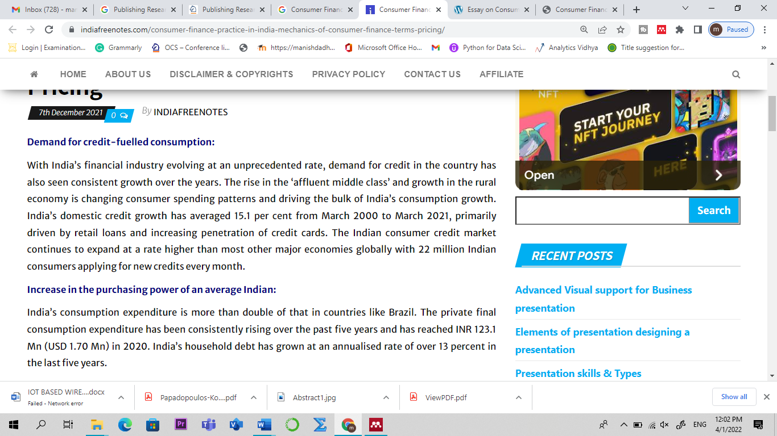

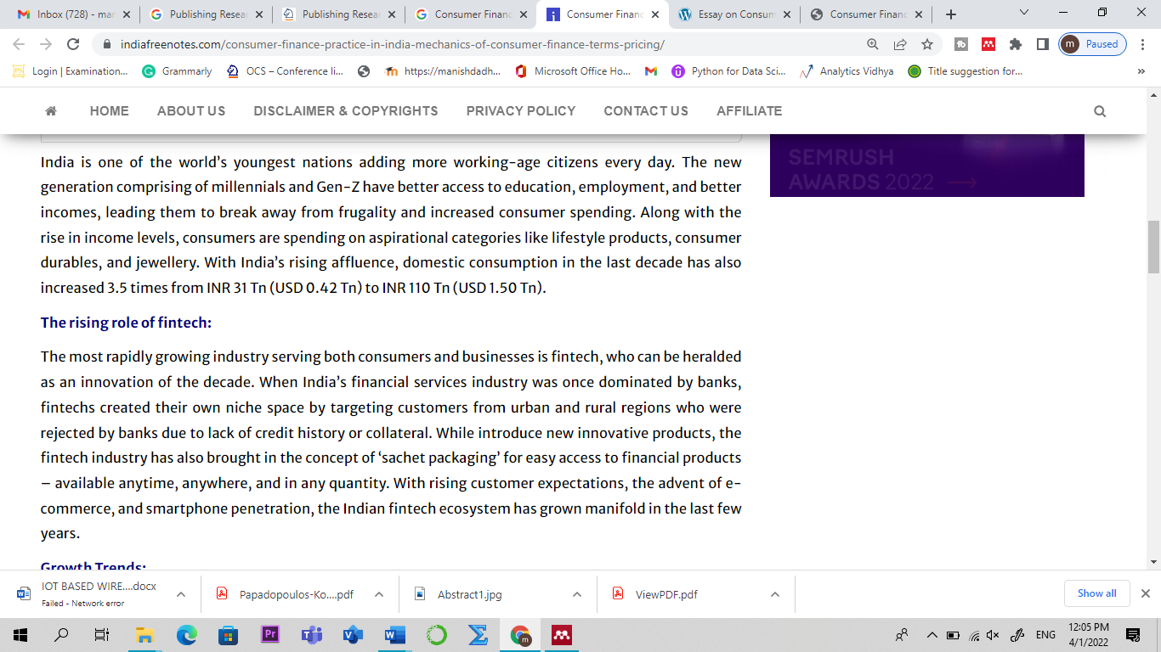

**Types of Credit Insurance**

There are five types of credit insurance. Four are designed to protect consumers. The fifth type is for businesses.

**Credit Life Insurance**

Credit life insurance pays off your credit card balance if you die. This prevents your loved ones from having to pay your balance out of your estate.

**Credit Disability Insurance**

This coverage pays your minimum payment to your credit card issuer if you become disabled. You may have to be disabled for a certain amount of time before the insurance will kick in. There may be a waiting period before the benefit pays out. You can't add this insurance and make a claim on the same day.

**Credit Unemployment Insurance**

Credit unemployment insurance makes your minimum payment for you if you lose your job through no fault of your own. The benefit doesn't kick in if you quit or you're fired. You may have to be out of work for a certain amount of time before the insurance takes over your payments.

**Credit Property Insurance**

This protects any personal property you've used to secure a loan if that property is destroyed or lost due to theft, accident, or a natural disaster.

**Trade Credit Insurance**

Trade credit insurance protects businesses that sell goods and services on credit. It shields them against the risk that clients won't pay what they owe due to insolvency. A few other events may also be covered. Most consumers won't need this type of insurance.