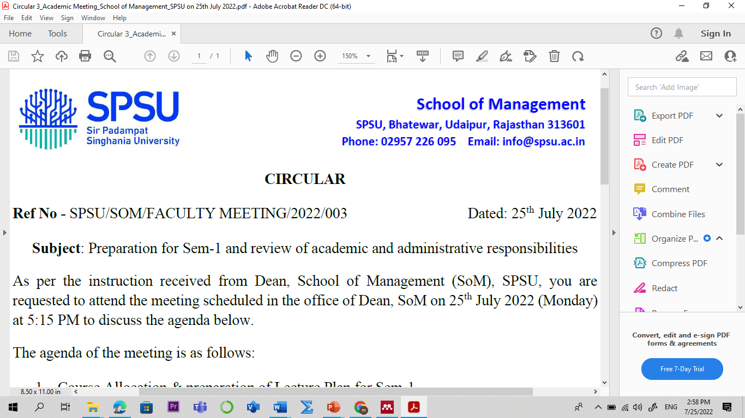

Lecture Plan

Program: BBA

Name of the Course: Investment Management L-P-T-C
Credit: 02 0-0-2-0
Sem: IV Academic Year: 2025-26
Faculty Member: Manish Dadhich, PhD Code: VAM2401
Contact No.: 9828142616 E-mail: manish.dadhich@spsu.ac.in

Introduction /Course Description:
This course provides a comprehensive introduction to the principles and practices of investment management, equipping students with the knowledge and skills to navigate the financial landscape. It begins with an overview of wealth management, investment attributes, and the investment process, distinguishing between economic and financial investments and investment and speculation. Students will explore financial instruments, including money and capital market instruments, derivatives, and mutual funds, alongside their functions and classifications. The course delves into investment theories such as portfolio theory, the capital asset pricing model, and arbitrage pricing theory, providing a strong theoretical foundation. Additionally, it covers the structure and dynamics of primary and secondary markets, emphasizing the roles of market players, stock exchanges, trading, and settlement procedures, preparing students for practical engagement in the financial markets.

Course Objective:
To provide knowledge about the objectives, scope, and how financial Management has evolved over a period of time.
- Understand the basics of wealth management, investment attributes, and processes.
- Explore financial instruments, including money markets, capital markets, derivatives, and mutual funds.
- Classify and evaluate investment companies and mutual funds using performance metrics.
- Apply investment theories like CAPM and portfolio management strategies.
- Learn the functioning of primary and secondary markets, including trading and settlement.

Course Outcomes (COs) & Bloom's Taxonomy:

Course Outcomes | Bloom's Taxonomy
CO1: Understand wealth management and key investment concepts. | - Remembering (K1)
CO2: Identify and assess financial instruments and mutual funds. | - Remembering (K1)  - Knowledge (K2)
CO3: Analyze and assess mutual fund performance using key metrics. | - Remembering (K2)  - Knowledge (K3)
CO4: Apply investment theories to create effective strategies. | - Apply (K3)  - Analyze (K4)
CO5: Navigate primary and secondary markets, including trading and settlement. | - Apply (K3)  - Analyze (K4)
*Level of Learning- Use the number from 1 to 5 for indicating the level. Level 1- Remember & Understand, Level 2- Apply, Level 3- Analyse, Level 4- Evaluate, Level 5- Create. Mention the highest level that will be attained in the particular Course Outcome.
Course Outcome (CO) - Program Outcome (PO)/ Program Specific Outcome (PSO) Mapping
Sem | Course | CO-PO/PSO Mapping | PO1 | PO2 | PO3 | PO4 | PO5 | PO6 | PO7 | PO8 | PSO1 | PSO2 | PSO3
 | Investment | CO1 |  |  |  | 1 | 1
 | Management
 |  | CO2 | 1 |  |  |  |  |  |  | 2
I
 |  | CO3 | 1 |  |  | 1 |  | 1 |  |  | 2
 |  | CO4 |  | 2 |  | 1 | 1 |  |  | 1 |  | 2
 | (VAM2401)
 |  | CO5 |  | 3 |  | 2 | 2 |  |  |  | 3
Note: 1 for “Low”, 2 for “Medium” and 3 for “High”

Pedagogy
The course employs a blended learning approach, combining theoretical instruction with practical application. Interactive lectures provide foundational knowledge, while case studies and real-world examples illustrate key concepts. Hands-on exercises enhance analytical skills, including portfolio analysis and mutual fund evaluation. Group discussions and projects encourage collaboration and critical thinking, while guest lectures from industry professionals offer insights into current market practices. Assessments are designed to reinforce learning through quizzes, assignments, and practical simulations, ensuring a comprehensive understanding of investment management.

Employability Skills Measuring Tools:
- Critical Thinking and Problem Solving
- Managerial competitive skill (assignment on contemporary issues).
- Portfolio Assessment

Suggested Readings:
Textbook/ Reference Books:
- Vishwanath S R, Krishnamurti C. Investment Management. Springer, 11th Edition. 2023.
- Sandeep Kour Tandon. Investment Management. Directorate of Distance Education University of Jammu, 14th Edition. 2021.
- Kishore, Ravi M. Financial Management. Taxman’s, 8th Edition, 2022.

Important Websites:
- Investopedia: www.investopedia.com
- Yahoo Finance: finance.yahoo.com
- Morningstar: www.morningstar.com
- SEC EDGAR: www.sec.gov/edgar.shtml
- Wall Street Journal: www.wsj.com
- Morningstar: https://www.morningstar.com
- Fidelity Investments: https://www.fidelity.com
- Investing.com: https://www.investing.com
- BlackRock: https://www.blackrock.com
- Morgan Stanley Wealth Management: https://www.morganstanley.com/what-we-do/wealth-managementHarvard Business Review - Finance: hbr.org/topic/financeESG Investing and Analysis (cfainstitute.org)

Scheme of Evaluation

Assessment
Continuous Internal Assessment
Assessment Task | Frequency * Marks = Total Marks (100)
Quiz | 3*20 = 60
Assignments (Class Assignment /Home Assignments)/Case Study/ Case Discussions/ Project Work. | 1*20 = 20
Assignments (Class Assignment /Home Assignments) | 1*20 = 20

Detailed Lecture Plan:

Session No | Topics | Reading/Reference | Learning Outcome & Course Outcome (CO)
UNIT-I: Introduction to Investment
1 | Overview of Wealth Management and Investment | Textbook, Chapter 1, pp. 1-4 (Investment Management,  by S. R. Vishwanath ² C. Krishnamurti) Springer | Understand the basics of wealth management and investment attributes. (CO1, K1, K2)
2 | Economic vs. Financial Investment | Textbook, Chapter 1, pp. 5-10 (Investment Management,  by S. R. Vishwanath ² C. Krishnamurti) Springer | Differentiate between economic and financial investments. (CO1, K2)
3 | Investment vs. Speculation | Textbook, Chapter 1, pp. 10-20 (Investment Management,  by S. R. Vishwanath ² C. Krishnamurti) Springer | Analyze the differences between investment and speculation. (CO1, K2)
4 | Features of a Good Investment | Textbook, Chapter 2, pp. 25-30 (Investment Management,  by S. R. Vishwanath ² C. Krishnamurti) Springer | Identify the features of a good investment. (CO1, K2)
5 | Investment Process | Textbook, Chapter 3, pp. 35-45 (Investment Management,  by S. R. Vishwanath ² C. Krishnamurti) Springer | Understand the steps involved in the investment process. (CO1, K2)
UNIT-II: Financial Instruments
6 | Overview of Financial Instruments | Textbook, Investment Management, Chapter 2, Prof. Sandeep kour tandon, Further: https://manishdadhich.gnomio.com | Gain knowledge of various financial instruments. (CO2, K1)
7 | Money Market Instruments | Textbook, Investment Management, Chapter 3, Prof. Sandeep kour tandon, Further: https://manishdadhich.gnomio.com | Understand money market instruments and their functions. (CO2, K2)
8 | Capital Market Instruments | Textbook, Investment Management, Chapter 3, Prof. Sandeep kour tandon, Further: https://manishdadhich.gnomio.com | Understand capital market instruments and their functions. (CO2, K2)
9 | Derivatives | Textbook, Investment Management, Chapter 4, Prof. Sandeep kour tandon, Further: https://manishdadhich.gnomio.com | Learn the basics of derivatives and their applications. (CO2, K2)
10 | Mutual Funds | Textbook, Investment Management, Chapter 4, Prof. Sandeep kour tandon, Further: https://manishdadhich.gnomio.com | Understand the concept of mutual funds and their types. (CO2, K2)
UNIT-III: Classification of Investments
11 | Types of Investment Companies | Textbook, Investment Management, Prof. Sandeep kour tandon,  Further: https://manishdadhich.gnomio.com, 232-328 | Classify different types of investment companies. (CO3, K2)
12 | Mutual Fund Types | Textbook, Investment Management, Prof. Sandeep kour tandon,  Further: https://manishdadhich.gnomio.com, 232-328 | Learn about various mutual fund types. (CO3, K2)
13 | Performance of Mutual Funds | Textbook, Investment Management, Prof. Sandeep kour tandon,  Further: https://manishdadhich.gnomio.com, 232-328 | Analyze the performance of mutual funds. (CO3, K2)
14 | NAV Analysis | Textbook, Investment Management, Prof. Sandeep kour tandon,  Further: https://manishdadhich.gnomio.com, 232-328 | Understand and analyze NAV calculations. (CO3, K2)
15 | Fund Performance Analysis | Textbook, Investment Management, Prof. Sandeep kour tandon,  Further: https://manishdadhich.gnomio.com, 232-328 | Evaluate mutual fund performance using key metrics. (CO3, K3)
16 | Quiz and analysis | Further: https://manishdadhich.gnomio.com | Understand and analyze capital budgeting, TVM and applications.  (CO2, K3, K4)
UNIT-IV: Investment Theories
17 | Introduction to Portfolio Theory | Textbook, Investment Management, Prof. Sandeep kour tandon, Further: https://manishdadhich.gnomio.com329-398 | Learn the fundamentals of portfolio theory. (CO4, K2)
18 | Risk and Return Concepts | Textbook, Investment Management, Prof. Sandeep kour tandon, Further: https://manishdadhich.gnomio.com329-398 | Understand the concepts of risk and return in investments. (CO4, K2)
19 | Capital Asset Pricing Model (CAPM) | Textbook, Investment Management, Prof. Sandeep kour tandon, Further: https://manishdadhich.gnomio.com329-398 | Apply CAPM to evaluate investments. (CO4, K3)
20 | Arbitrage Pricing Theory (APT) | Textbook, Investment Management, Prof. Sandeep kour tandon, Further: https://manishdadhich.gnomio.com329-398 | Understand the principles of APT and its application. (CO4, K3)
21 | Portfolio Optimization | Textbook, Investment Management, Prof. Sandeep kour tandon, Further: https://manishdadhich.gnomio.com329-398 | Learn techniques for optimizing investment portfolios. (CO4, K3)
UNIT-V: Primary and Secondary Markets
22 | Primary Market Overview | Textbook, Investment Management, Prof. Sandeep kour tandon, Further: https://manishdadhich.gnomio.com | Understand the role and functions of the primary market. (CO5, K2)
23 | Factors to Enter the Primary Market | Textbook, Investment Management, Prof. Sandeep kour tandon, Further: https://manishdadhich.gnomio.com | Identify factors to consider when entering the primary market. (CO5, K3)
24 | Modes of Raising Funds | Textbook, Investment Management, Prof. Sandeep kour tandon, Further: https://manishdadhich.gnomio.com | Understand different modes of raising funds in the primary market. (CO5, K2)
25 | Secondary Market Overview | Textbook, Investment Management, Prof. Sandeep kour tandon, Further: https://manishdadhich.gnomio.com | Learn the structure and functioning of the secondary market. (CO5, K2)
26 | Major Players in the Secondary Market | Textbook, Investment Management, Prof. Sandeep kour tandon, Further: https://manishdadhich.gnomio.com | Identify the key players and their roles in the secondary market. (CO5, K2)
27 | Functioning of Stock Exchanges | Textbook, Investment Management, Prof. Sandeep kour tandon, Further: https://manishdadhich.gnomio.com | Understand how stock exchanges operate.  (CO5, K2)
28 | Final Discussion and Q&A | N/A | Review and clarify all concepts discussed in the course.
29 | Recapitulation/Seminar/ presentation | Further: https://manishdadhich.gnomio.com | -
30 | Recapitulation/Seminar/ presentation | Further: https://manishdadhich.gnomio.com | -

Students' Interaction Time: Friday (04:30 PM – 05:30 PM)
Thursday (04:30 PM – 05:30 PM)

