**FinTech Transformation: FinTech Evolution 1.0: Infrastructure. FinTech Evolution 2.0, FinTech Evolution 3.0.**

**Introduction**

FinTech transformation refers to the comprehensive and fundamental changes that occur within the financial industry as a result of the integration and adoption of innovative technologies. It involves the application of cutting-edge digital solutions to reimagine and revolutionize traditional financial processes, products, services, and customer experiences. This transformation impacts various aspects of finance, ranging from banking and payments to investments, insurance, and regulatory compliance. The key elements of FinTech transformation are as follows:

Technological Integration

The integration of advanced technologies into financial processes enhances efficiency and accuracy. Blockchain, for instance, improves transparency in transactions and reduces fraud by creating tamper-resistant records. AI-driven chatbots enhance customer service by providing instant assistance, while machine learning algorithms analyze data to tailor financial products and services to individual needs.

Digital Customer Experience

FinTech transformation places customer-centricity at the forefront. User-friendly mobile apps, intuitive online platforms, and personalized recommendations create a seamless and convenient experience. Customers can conduct transactions, manage investments, and track their financial health conveniently.

Innovation in Services

FinTech solutions bring innovative services to the forefront. Robo-advisors offer automated investment management based on personalized risk profiles. Peer-to-peer lending platforms allow individuals to directly lend to borrowers or invest in loans. Digital wallets enable contactless payments and simplified fund transfers.

Cost Efficiency

Automation and digitization reduce the need for manual processes, cutting operational costs for financial institutions. Digital platforms require fewer physical resources, leading to cost savings that can be passed on to customers through competitive pricing and reduced fees.

Financial Inclusion

FinTech transformation extends financial services to underserved populations. Mobile banking and digital wallets allow individuals without traditional bank accounts to access funds, make payments, and save money. This contributes to economic growth by empowering more people to participate in the formal financial system.

Regulatory Compliance

Regulatory Technology (RegTech) tools streamline compliance processes by using automation and data analytics to monitor and report on regulatory requirements. This not only reduces the risk of non-compliance but also saves time and resources for financial institutions.

Data-driven Insights

Data analytics tools analyze vast datasets to extract valuable insights. This can include identifying customer behaviors and preferences, enabling financial institutions to offer more targeted and relevant products and services.

Collaboration

Traditional financial institutions collaborate with FinTech startups to tap into specialized expertise and technological innovations. These partnerships lead to the creation of hybrid solutions that combine the stability of established institutions with the agility of startups.

Cybersecurity and Privacy

As FinTech solutions handle sensitive financial information, robust cybersecurity measures are paramount. Technologies such as encryption, biometric authentication, and secure cloud storage are essential to safeguard customer data and prevent breaches.

Ecosystem Evolution

FinTech transformation is not confined to individual institutions but extends to the broader financial ecosystem. It influences regulatory discussions, shapes industry standards, and encourages traditional players to innovate to stay competitive in the evolving landscape.

FinTech transformation is a multifaceted process that embraces technology to reshape financial services, enhance customer experiences, and drive innovation across the financial ecosystem. It represents a shift towards a digital, interconnected, and inclusive financial future.

**FinTech Evolution Stages**

The evolution of FinTech can be divided into several stages or phases, each marked by significant technological advancements and changes in the financial landscape. In contrast, the exact categorization may vary depending on sources and perspectives. There is a generalized overview of the FinTech evolution stages:

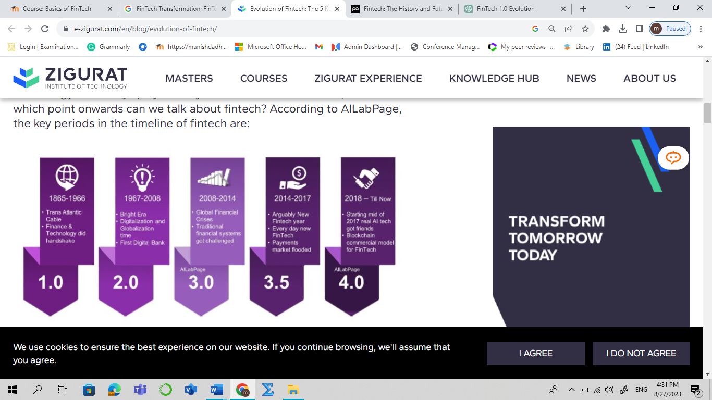

Fig. 1: FinTech Evolution Stages

**Fintech 1.0 (1886-1967): Laying the Foundation for Digital Finance**

Fintech 1.0 marks the inception of technological advancements in the financial industry, setting the stage for future digital transformations. This era, which emerged in the late 20th century and early 21st century, witnessed the initial steps towards digitizing financial processes. Key developments included the introduction of automated teller machines (ATMs), which provided customers with the convenience of accessing their funds beyond traditional banking hours. The birth of online banking platforms enabled customers to perform basic transactions and view account information through digital interfaces.

The late 1990s and early 2000s witnessed significant strides in digital payments and e-commerce, with the advent of online payment systems and the rise of platforms like Amazon and eBay. The introduction of these technologies laid the groundwork for the transition from cash-based transactions to digital methods, paving the way for the reshaping of consumer behaviors and business models. Additionally, this era saw the inception of peer-to-peer lending platforms, a precursor to the disruption that fintech would bring to traditional lending models.

Fintech 1.0, while relatively basic compared to later phases, laid the foundation for the subsequent waves of fintech innovation. It introduced consumers to the possibilities of digital financial services and planted the seeds for the more advanced technological developments that would follow. This era sparked the initial shifts towards convenience, accessibility, and efficiency in finance, setting the tone for the rapid evolution that the fintech industry would undergo in the years to come.

**Fintech 2.0 (1967-2008): Navigating Digital Horizons**

Fintech 2.0 signifies a critical juncture in the evolution of financial technology, characterized by a shift towards more sophisticated digital innovations. This era witnesses the expansion of online banking beyond basic transactions, with financial institutions embracing web-based platforms to offer a broader range of services. The integration of internet technologies allows customers to access account information, manage investments, and conduct transactions from the comfort of their devices. Furthermore, the proliferation of e-commerce ushers in secure digital payment methods, setting the stage for the transformation of consumer purchasing behaviors.

Central to Fintech 2.0 is the advent of robo-advisors, a groundbreaking development that revolutionizes investment advisory services. These algorithm-driven platforms leverage data analytics to formulate personalized investment strategies, catering to individuals with varying risk appetites and financial goals. The democratization of wealth management becomes evident as robo-advisors provide affordable and accessible investment solutions, challenging the traditional model dominated by human financial advisors.

Additionally, Fintech 2.0 introduces the concept of alternative lending models. Peer-to-peer lending platforms emerge, connecting borrowers directly with lenders through online marketplaces. This innovation simplifies borrowing, offers competitive interest rates, and expands credit access for individuals and small businesses. Fintech 2.0 encapsulates a phase of increased digitalization, expanded financial services, and the emergence of tech-driven financial intermediaries that pave the way for further advancements in the fintech landscape.

**Fintech 3.0 (2008-2014):** Shaping the Digital Financial Landscape

Fintech 3.0 ushers in a new era of financial transformation, marked by the convergence of advanced technologies and the financial industry. This phase witnesses the maturation of concepts introduced in previous iterations, coupled with a renewed focus on enhancing user experiences and expanding financial inclusion. Central to Fintech 3.0 is the rise of neobanks, disruptors that challenge the status quo by offering simplified, digital-centric banking experiences while fostering trust through transparent fee structures and personalized services. These digital-first banks are reshaping customer expectations and driving traditional banks to innovate.

Machine Learning (ML) takes center stage in Fintech 3.0, revolutionizing customer engagement and financial services. ML-powered algorithms analyze vast datasets to provide tailored financial products, predictive insights, and risk assessments. This era also witnesses the integration of ML in security applications, where AI-driven fraud detection and risk management systems bolster consumer trust in digital transactions. Moreover, the proliferation of AI chatbots enhances customer support and expedites query resolutions.

Another pivotal aspect of Fintech 3.0 is the emergence of personalized financial platforms. These platforms leverage user data to offer hyper-customized solutions, spanning investment advice, insurance coverage, and budgeting strategies. The advent of open banking further catalyzes innovation, as it encourages collaboration between established financial institutions and agile fintech startups, creating innovative cross-platform services. Fintech 3.0 paints a landscape where technology-driven personalization, streamlined processes, and expanded access converge to redefine the financial experience.

**Fintech 3.5 (2014-2017)**: **Catalyzing Inclusive Innovation**

Fintech 3.5 emerges as a pivotal juncture in the evolution of financial technology, marked by a profound shift towards inclusive innovation. This phase transcends geographic boundaries and extends its transformative impact to traditionally underserved regions. The standout feature of Fintech 3.5 is the empowerment of countries like China and India, which have harnessed the potential of technology to revolutionize financial services for their massive populations. With the burden of legacy infrastructure absent, these nations have embraced novel solutions with agility, fostering a new wave of accessibility and convenience.

The defining aspects of Fintech 3.5 reach far beyond the Western-centric financial landscape. The rise of integrated payment providers stands as a testament to the era's dynamic nature, enabling businesses to seamlessly integrate payment functionalities into their comprehensive management systems. Furthermore, the mainstream adoption of non-fungible tokens (NFTs) introduces novel use cases beyond conventional financial realms. NFTs empower creators to monetize their digital creations, provide artists with a fairer distribution of royalties, and offer unique applications such as digital event tickets and membership cards.

Fintech 3.5 encapsulates a broader, more encompassing perspective, breaking away from the confines of earlier phases. Its hallmark is the recognition of technology's potential to bridge global disparities and enhance financial well-being, thereby setting the stage for a more inclusive and interconnected financial future.

**Fintech 4.0 (2018-today):** Navigating the Digital Frontier

Fintech 4.0 emerges as a trailblazing era at the convergence of cutting-edge technologies and financial services. This phase encompasses a sophisticated interplay of artificial intelligence (AI), blockchain, quantum computing, and augmented reality, reshaping the financial landscape in profound ways. One of the defining features of Fintech 4.0 is the enhanced personalization of financial offerings through AI-driven insights. Customers experience tailored solutions and predictive recommendations, enabling smarter financial decisions. In Fintech 4.0, blockchain technology transcends its role as a mere transaction ledger, evolving into a cornerstone of decentralized finance (DeFi) ecosystems. The concept of programmable money gains traction, allowing the automated execution of complex financial agreements without intermediaries. Quantum computing, with its exponential processing power, introduces novel dimensions to risk assessment, fraud detection, and portfolio optimization. Augmented reality interfaces transform user engagement, enabling immersive experiences for investment analysis, virtual branch visits, and interactive financial education.

As Fintech 4.0 unfurls, collaborations between traditional financial institutions and agile fintech startups become pivotal. The era's innovation revolves around co-created solutions that leverage established infrastructures and nimble digital advancements. Fintech 4.0 navigates the digital frontier, fusing technological prowess with financial acumen to usher in a new era of personalized, secure, and dynamic financial services.