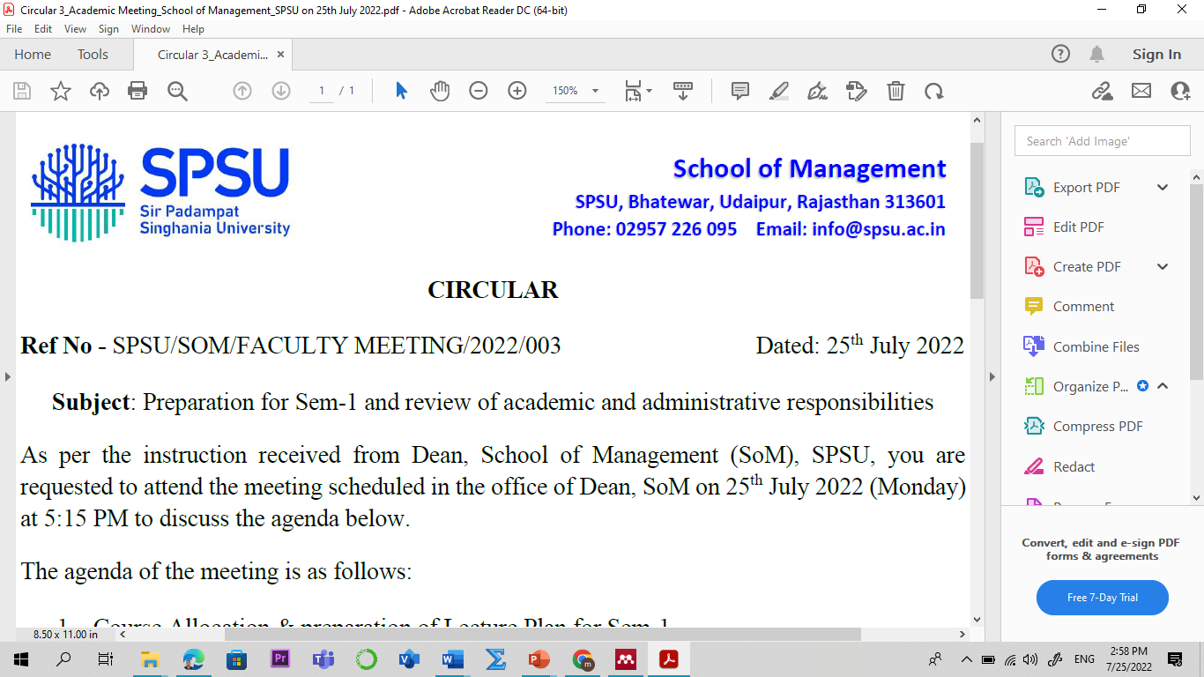

Course Plan
Program: MBA

Name of the Course: Basics of FinTech L-P-T-C
Credit: 03 2-0-1-3
Sem: III Academic Year: 2025-26
Faculty Member: Manish Dadhich, PhD Code: MGM4341
Contact No.: 9828142616
E-mail: manish.dadhich@spsu.ac.in

Introduction /Course Description:
The course Basics of FinTech provides a foundational understanding of the rapidly evolving financial technology landscape that is reshaping the global financial ecosystem. It introduces students to the core concepts, key innovations, and emerging trends in FinTech, including digital payments, blockchain, robo-advisory services, peer-to-peer lending, and digital banking. This course aims to equip learners with essential knowledge of how technology is driving financial inclusion, improving operational efficiency, and fostering innovation in financial services. Through real-world case studies and practical insights, students will gain a comprehensive view of the opportunities and challenges within the FinTech domain, preparing them for future roles in finance, technology, and entrepreneurship.

Course Objectives:
- Understand the key concepts of FinTech and services in the present context.
- Understand the technologies that empower FinTech, and FinTech skills in the new age market.
- Gain a basic knowledge of the FinTech landscape, FinTech Architecture, and FinTech Technologies.
- Improve FinTech knowledge of current and future issues in cutting-edge developments in banking, financial markets, and entrepreneurial fields.
- Assess business and regulatory implications, RegTech, FinTech Payments, and Regulations, CBDC.

Course Outcomes (COs) & Bloom's Taxonomy:
Course Outcomes | Bloom's Taxonomy
CO1: Understand the meaning, definition, and categories of FinTech companies and their role in the modern economy. | - Remembering (K1)  - Knowledge (K2)
CO2: Analyze the future scope and opportunities of FinTech in enhancing financial services and inclusion. | - Remembering (K1)  - Knowledge (K2)
CO3: Analyze the future scope and opportunities of FinTech in enhancing financial services and inclusion. | - Remembering (K1)  - Knowledge (K2)
CO4: Identify and discuss recent trends and developments in the global FinTech industry. | - Apply (K3)  - Analyze (K4)
CO5: Evaluate the three phases of FinTech evolution and their impact on financial infrastructure. | - Apply (K3)  - Analyze (K4)
*Level of Learning- Use the number from 1 to 5 for indicating the level. Level 1- Remember & Understand, Level 2- Apply, Level 3- Analyse, Level 4- Evaluate, Level 5- Create. Mention the highest level that will be attained in the particular Course Outcome.
Course Outcome (CO) - Program Outcome (PO)/ Program Specific Outcome (PSO) Mapping
Sem | Course | CO-PO/PSO Mapping | PO1 | PO2 | PO3 | PO4 | PO5 | PO6 | PO7 | PO8 | PSO1 | PSO2 | PSO3
 | Basics of | CO1 |  |  | 1 | 1 | 1
 | FinTech
 |  | CO2 | 1 | 1 |  |  | 2 |  |  | 2
I
 |  | CO3 | 1 |  | 2 | 1 |  | 1 |  |  | 2
 |  | CO4 |  | 2 |  | 1 | 1 |  |  | 1 |  | 2
 | (MGM4341)
 |  | CO5 |  | 3 |  | 4 | 4 |  |  |  | 3
Note: 1 for “Low”, 2 for “Medium”, and 3 for “High”
Pedagogy
The pedagogy for the Basics of FinTech course is designed to blend theoretical understanding with real-world application through a combination of interactive lectures, case study analysis, group discussions, and hands-on activities. Emphasis will be placed on experiential learning, where students explore current trends and technologies in FinTech through live examples, simulations, and digital tools. Industry insights will be integrated through guest lectures, webinars, and video documentaries to expose learners to the practical challenges and innovations in the FinTech ecosystem. Students will also engage in mini-projects and presentations to critically analyze FinTech models, payment systems, and the transformation of financial services.
Employability Skills Measuring Tools:
- Assesses practical understanding of FinTech concepts.
- Critical Thinking and Problem Solving:
- Managerial competitive skills (assignment on contemporary issues).

Suggested Readings:

Text & Reference Books:
- Chishti S, The FinTech Book - The Financial Technology Handbook for Investors, Entrepreneurs, and Visionaries, John Wiley & Sons Inc., 2022.
- H B, Jaspal Singh, N C, Financial Technology (FinTech ) and Digital Banking in India, Publisher, Delhi. 2021.
- Agustin Rubini, FinTech in a Flash: Financial Technology, Zaccheus Entertainment; 3rd edition (1 January 2018).
- Steven O' Hanlon, Susanne Chishti, FinTech For Dummies, Wiley. 2021.
- Khan, M.Y., & Jain, P.K. Financial Management: Text, Problems and Cases McGraw-Hill Publication, 8th Edition. 2021.
- Maheshwari S.N. Financial Management: Principles and Practice Sultan Chand and Sons, 5th Edition. 2019.
Important Websites:
- https://bootcamp.cvn.columbia.edu/blog/what-is-FinTech /
- https://www.cfainstitute.org/en/research/FinTech
- Investopedia: www.investopedia.com
- Financial Times: www.ft.com
- Bloomberg: www.bloomberg.com
- Yahoo Finance: finance.yahoo.com
- Morningstar: www.morningstar.com

Scheme of Evaluation
Assessment |  | Weightage (in %)
Continuous Internal Assessment |  | 40
Assessment Task | Frequency * Marks = Total Marks (100) | Weightage for individual Component
Mid-Term Examination – I and II | 2*20 = 40 | 16
Quiz | 3*10 = 30 | 12
Assignments (Class Assignment /Home Assignments)/Case Study/ Case Discussions/ Project Work. | 1*10 = 10 | 4
Assignments (Class Assignment /Home Assignments) | 1*10 = 10 | 4
Attendance | 10 | 4
External Assessment |  | 60
End Term Examination | 1*60 | 60

Detailed Lecture Plan:
LN | Topic | Reading/Reference | Learning Outcome & Course Outcome (CO) with Bloom’s Taxonomy
Module-I: Introduction to FinTech
1 | Concept, FinTech : meaning, definition. | Textbook, FinTech and the future of finance,  Chapter 1, pp.13 | Explain the basic concept of FinTech .  (CO1; K1 & K2)
2 | Types of FinTech Companies. Scope of FinTech in future. | Textbook, FinTech and the future of finance,  Chapter 1, pp.20 | To understand various types of FinTech companies and know the scope of FinTech in the future.  (CO1; K1 & K2)
3 | Overview of E-wallets and payment system. | Textbook, FinTech and the future of finance, Chapter 2, pp.26 | To get an overview of E-wallets and payment systems.  (CO1; K1 & K2)
4 | Discussion on the Recent Trends in FinTech . | Textbook, FinTech and the future of finance,  Chapter 2, pp.30 | To know the recent trends in FinTech .  (CO1; K1 & K2)
5 | FinTech Transformation: FinTech Evolution 1.0: Infrastructure. | Textbook, FinTech and the future of finance,  Chapter 3, pp.34 | To understand FinTech transformation, including FinTech 1.0.  (CO1; K1 & K2)
6 | FinTech Evolution 2.0: Banks, FinTech Evolution 3.0. | Textbook, FinTech and the future of finance,  Chapter 3, pp. 40 | To know FinTech Evolution 2.0, FinTech Evolution 3.0.  (CO1; K1 & K2)
7 | Quiz 1 on FinTech and modern world | Textbook, FinTech and the future of finance,  Chapter 3, pp. 40 | To know FinTech and modern world.  (CO1; K1 & K2)
Module-II: History of Financial Innovation
8 | A brief history of financial innovation. | Textbook, FinTech and the future of finance,  Chapter 4, pp. 45 | To understand the brief history of financial innovation.  (CO2; K2)
9 | Digitization of financial services | Textbook, FinTech and the future of finance,  Chapter 4, pp. 50 | To understand the digitization of financial services.  (CO2; K2)
10 | FinTech & Funds. How AI is Transforming the Future of FinTech . | Textbook, FinTech and the future of finance,  Chapter 4, pp. 55 | To acquaint with AI and transforming the future of FinTech .  (CO2; K2)
11 | Technologies that power FinTech | Textbook, FinTech and the future of finance,  Chapter 5, pp. 60 | To know technologies that power FinTech .  (CO2; K2 & K3)
12 | Essential of FinTech in the present era | Textbook, FinTech and the future of finance,  Chapter 5, pp. 65 | To remember the essential of FinTech . (CO2; K2)
13 | Skills required in the new age market. | Textbook, FinTech and the future of finance,  Chapter 5, pp.70 | To know about the skills required in the new age market.  (CO2; K2)
14 | Mini-Case: FinTech and banking system | Textbook, FinTech and the future of finance,  Chapter 5, pp.85 | To participate in FinTech and the banking system.  (CO2; K3)
15 | Quiz 2 on FinTech Innovation | Textbook, FinTech and the future of finance,  Chapter 5, pp.85 | To become acquaint with FinTech and innovation system.  (CO2; K3)
16 | Revision on FinTech for Mid Term-I, Classroom presentation | Textbook, FinTech and the future of finance,  Chapter 5, pp.90 | To understand the overview of FinTech .  (CO2; K2 & K4)
Module-III: FinTech landscape
17 | Introduction to the FinTech landscape. | Textbook, FinTech and the future of finance,  Chapter 5, pp.95 | To understand the concept of FinTech landscape.  (CO3; K2)
18 | Overview of FinTech Architecture | https://www.cambridge.org/core/books/abs/digital-entrepreneurship/FinTech /3705D69FE896063E6DFF11A5C1863220 | To know about FinTech architecture.  (CO3; K2)
19 | FinTech Technologies, future of FinTech . | https://www.cambridge.org/core/books/abs/digital-entrepreneurship/FinTech /3705D69FE896063E6DFF11A5C1863220 | To understand FinTech Technologies, the future of FinTech .  (CO3; K3 & K4)
20 | Applications of FinTech , Use cases of FinTech in banks | https://www.cambridge.org/core/books/abs/digital-entrepreneurship/FinTech /3705D69FE896063E6DFF11A5C1863220 | To know the applications of FinTech , use cases of FinTech in banks.  (CO3; K3 & K4)
21 | Overview of FinTech startups, FinTech unicorns and business models. | https://www.cambridge.org/core/books/abs/digital-entrepreneurship/FinTech /3705D69FE896063E6DFF11A5C1863220 | To know FinTech startups, FinTech unicorns, and business models.  (CO3; K3 & K4)
22 | Quiz 3 on FinTech landscape | Textbook, FinTech and the future of finance,  Chapter 5, pp.95 | To analyze FinTech landscape and business models.  (CO3; K3 & K4)
23 | Case study: FinTech and expansion, tutorial | Textbook, FinTech and the future of finance,  Chapter 5, pp.95 | To analyze FinTech and its relevance in the present scenario.  (CO3; K3 & K4)
24 | Case study: teaching analysis and presentation | Textbook, FinTech and the future of finance,  Chapter 5, pp.95 | To analyze FinTech and its relevance in the present scenario.  (CO3; K3 & K4)
Module-IV: FinTech and BFSI
25 | Banking, Financial Services & Insurance (BFSI) | https://www.cambridge.org/core/books/abs/digital-entrepreneurship/FinTech /3705D69FE896063E6DFF11A5C1863220 | To know Banking, Financial Services & Insurance (BFSI).  (CO3; K3 & K4)
26 | Conducted Presentation on practical exercise on behavior finance | Further: https://manishdadhich.gnomio.com | To evaluate behavior finance, FinTech aspects.
27 | Value chain, the role of Financial Analyst. | https://media.neliti.com/media/publications/73390-EN-the-FinTech -book-the-financial-technolog.pdf | To understand value chain, the role of a financial analyst.  (CO3; K2)
28 | How FinTech changed BFSI. | https://media.neliti.com/media/publications/73390-EN-the-FinTech -book-the-financial-technolog.pdf | To understand how FinTech changed BFSI.  (CO3; K2)
29 | Modern Banking Landscape | https://media.neliti.com/media/publications/73390-EN-the-FinTech -book-the-financial-technolog.pdf | To know the modern banking landscape.  (CO3; K3 & K4)
30 | Introduction to BankTech | https://media.neliti.com/media/publications/73390-EN-the-FinTech -book-the-financial-technolog.pdf | To understand and remember BankTech. (CO3; K4 )
31 | Central Bank Digital Currency (CBDC). Introduction to InsureTech | https://www.nbc.gov.kh/download_files/others/1_Igor_Pesin_may.pdf | To remember Central Bank Digital Currency (CBDC), InsureTech.  (CO3; K4 )
32 | Relevance and current trends of CBDC. tutorial | https://www.nbc.gov.kh/download_files/others/1_Igor_Pesin_may.pdf | To analyze CBDC and its relevance, and the recent trends.  (CO3; K4 )
33 | Class test and assignment evaluation on FinTech and BFSI | Further: https://manishdadhich.gnomio.com | To analyze and evaluate FinTech and BFSI.  (CO3; K4 )
Module-V: FinTech in Wealth Management
34 | FinTech Big Trends - Looking Forward | https://www.nbc.gov.kh/download_files/others/1_Igor_Pesin_may.pdf | To understand different FinTech Big Trends.  (CO4; K3)
35 | FinTech Regulations, Evolution of RegTech. | https://www.nbc.gov.kh/download_files/others/1_Igor_Pesin_may.pdf | To know FinTech regulations, the evolution of RegTech.  (CO4; K3 & K4)
36 | RegTech Ecosystem: Financial Institutions. | https://www.nbc.gov.kh/download_files/others/1_Igor_Pesin_may.pdf | To acquaint oneself with RegTech Ecosystem and Financial Institutions.  (CO4; K3)
37 | FinTech in Wealth Management | https://assets.kpmg.com/content/dam/kpmg/tr/pdf/2020/01/2019-FinTech -100.pdf | To understand & evaluate FinTech in Wealth Management.  (CO4; K3 & K4)
38 | Technology Disruptions in FinTech . | https://assets.kpmg.com/content/dam/kpmg/tr/pdf/2020/01/2019-FinTech -100.pdf | To know about technology disruptions in FinTech .  (CO4; K3 & K4)
39 | Sustainable Finance and FinTech, tutorial | https://assets.kpmg.com/content/dam/kpmg/tr/pdf/2020/01/2019-FinTech -100.pdf | To analyze various sustainable finance and FinTech .  (CO4; K3, K4)
40 | Class test and discussion on technological disruption, FinTech and its impact on investment in stock market. | Further: https://manishdadhich.gnomio.com | To analyze technological disruption, FinTech , and its impact on investment in the stock market.  (CO4; K3, K4)
41 | Scenario of Financial Markets, and Services. | https://assets.kpmg.com/content/dam/kpmg/tr/pdf/2020/01/2019-FinTech -100.pdf | To understand the scenario of financial markets, and services.  (CO4; K3)
42 | Present scenario of FinTech in Wealth Management | https://assets.kpmg.com/content/dam/kpmg/tr/pdf/2020/01/2019-FinTech -100.pdf | To understand & evaluate the present scenario of FinTech in wealth management.  (CO4; K3 & K4)
43 | Recapitulation of various types of FinTech in the present era. | Further: https://manishdadhich.gnomio.com | To analyze, revise, and evaluate various aspects of FinTech .  (CO4; K3, K4)
44 | Recapitulation of BFSI, the FinTech landscape and wealth management. | Further: https://manishdadhich.gnomio.com | To analyze, revise evaluate the various landscape of FinTech and wealth management.  (CO4; K3, K4)
45 | Recapitulation/Seminar/ presentation | Further: https://manishdadhich.gnomio.com | To analyze, revise, evaluate various FinTech issues.  (CO4; K3, K4)
Students’ Interaction Time:
Wednesday (04:30 pm – 05:30 pm)

