## What is the Private Sector?

The private [sector](https://www.investopedia.com/terms/s/sector.asp) is the part of the economy that is run by individuals and companies for profit and is not state controlled. Therefore, it encompasses all for-profit businesses that are not owned or operated by the government. Companies and corporations that are government run are part of what is known as the public sector, while charities and other [nonprofit organizations](https://www.investopedia.com/terms/n/non-profitorganization.asp) are part of the voluntary sector. **Private** undertakings are owned, controlled and financed by private businessmen. There is no government participation in them. The main motive of private sector undertakings is to earn profits. **Their main characteristics are as under:**

**(a) Private Ownership and Control:**

A private sector undertaking is fully owned and controlled by the private entrepreneurs. It may be owned by one individual or by a group of individuals jointly. When owned by one person, it is called Sole Proprietor­ship. A group of persons may jointly own the firm in the form of joint Hindu family business, partnership, Joint Stock Company or cooperative society.

**(b) Profit Motive:**

The main objective of private sector undertakings is earning profits. Profits provide the reward for the risk assumed and the required return on capital.

**(c) No State Participation:**

There is no participation by the Central or State Governments in the ownership and control of a private sector undertaking.

**(d) Private Finance:**

The capital of a private sector undertaking is arranged by its owners. The sole trader contributes the capital of a sole proprietorship. In case of partnership, capital is invested by the partners. A joint stock company raises capital by the issue of shares and debentures. A private sector undertaking can also raise loans to meet its long-term and short-term needs for funds.

**(e) Independent Management:**

A private sector undertaking is managed by its owners. In case of sole proprietorship and partnership, the owners directly manage the firm. The management of a joint stock company lies in the hands of directors who are the elected representatives of the shareholders.

**Role of Private Sector in the Economic Development of India**

#### 1. Most Important Sector:

In-spite of huge progress of the public sector during the plan period, the importance of private sector is tremendous in the India economy.

#### 2. Employment Generation:

Private sector plays a dominant role for generating employment opportunities inside the country. A huge number of large scale, small scale, cottage scale units are under the control of private sector. It proves that small scale and cottage scale industries contribute four times more employment in compare to large scale industries. According to 2017-18 statistics, as far as employment is concerned, the share of private sector was 60.2% against 40.3% of the public sector.

**3. Helpful for Development:**

According to Schumpeter peter private sector plays a dominant role in economic development. It enhances the process of industrialisation. All the private entrepreneurs are worked for profit motive. They actually played a leading role for the introduction of new commodities, new techniques of production, new plants equipment’s and machineries. Private entrepreneur has innovative ideas and always modifies the total method of production. After the introduction of new industrial policy in 1991, private sector leads a vital role in country’s industrial development.

#### 4. Contribution to Agriculture:

India is an agro based economy. The share of agriculture and its allied activities like fishing, poultry, cattle rearing, animal husbandry, dairy farming etc. to the national income is nearly 22%. On the other hand, about 60% of the total working population is engaged in this area. Hence, this large agriculture sector is controlled by the private sector.

#### 5. Contribution to Industry:

According to 1956 resolution, “industries producing intermediate goods and machines can be set up in the private sector.” A good number of ultra modern industries are constructed under the control of private sector. This includes several consumers’ good industries like sugar industry, edible oil industry, textile industry, paper industry, spice industry and fast food or semi-finished food industries.

Even in the sphere of capital goods, iron and steel heavy engineering, chemical, motors etc. private sector plays a dominant role for their development. In the post liberalisation phase (after introduction of New Industrial Policy, 1991), the working of few private industries became huge.

#### 6. High Potentiality:

Most of the small scale and cottage scale industries are using labour intersine technologies, they create huge employment opportunities. These industries are owned by private sector. About 80% of the total working forces are employed in either organized or unorganized private sector units. Private sector contributes about three-forth of the country’s national income. Moreover, this sector also plays a vital role to increase gross domestic saving (CDS) and gross domestic capital formation'(GDCF) within the economy.

#### ****Relative Role of Public Sector in India:****

Public sector occupied a worthy place for achieving systematic and planned development in a developing country like India. In a country like India suffering from multi-dimensional problems, private sector is not in a position to make necessary effort for the development of its various sectors simultaneously. Thus, in order to provide the necessary support to the development strategy of the country, the public sector offers the necessary minimum push for bringing the economy to a path of self sustained growth. Thus it is now well recognised that public sector plays a positive role in the industrial development of the country by laying down a sound foundation of industrial structure in the initial stage of its development.

**Following are some of the important relative roles of the public sector in the economic development of a country like India:**

(a) Promoting economic development at a rapid pace by filling gaps in the industrial structure;

(b) Promoting adequate infrastructural facilities for the growth of the economy;

(c) Undertaking economic activity in those strategically significant development areas, where private sector may distort the spirit of national objective;

(d) Checking monopolies and concentration of power in the hands of few;

(e) Promoting balanced regional development and diversifying natural resources and other infrastructural facilities in those less developed areas of the country;

(f) Reducing the disparities in the distribution of income and wealth by bridging the gap between the rich and the poor;

(g) Creating and enhancing sufficient employment opportunities in different sectors by making heavy investments;

(h) Attaining self-reliance in different technologies as per requirement;

(i) Eliminating dependence on foreign aid and foreign technology;

(f) Exercising social control and regulation through various public finance institutions;

(k) Controlling the sensitive sectors such as distribution system, allocating the scarce imported goods rationally etc.; and

(l) Reducing the pressure of balance of payments by promoting export and reducing imports.

**Sun-rise Sectors of Indian Economy**

Introduction

India is the fastest growing large economy in the world, with an enormous population, favourable demographics and high catch-up potential due to low initial GDP per head.

As per the World Bank data, in 2017, India became the sixth largest economy with a GDP of USD 2.59 trillion, relegating France to the seventh position.

India is likely to surpass the United Kingdom in the world's largest economy rankings in 2019, according to a report by global consultancy firm PwC.

[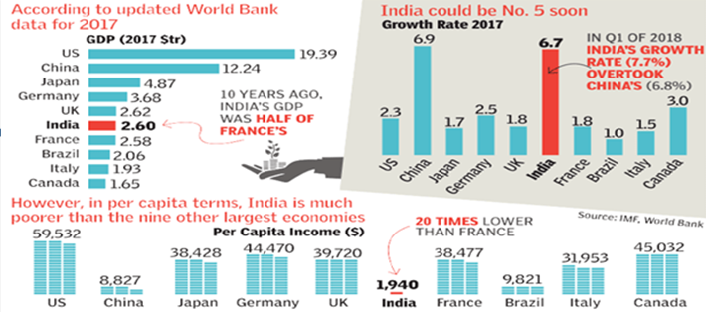](https://www.drishtiias.com/images/uploads/1578483675_image49.png)

1. According to World Economic Outlook report of IMF, India's economy is expected to grow by 7.5 per cent in the 2019-20 fiscal year, keeping an upward trajectory as the rest of the world slumps.
2. According to report "India's economy is poised to pick up in 2019, benefiting from lower oil prices and a slower pace of monetary tightening than previously expected, as inflation pressures ease," the report said.
3. As per Central Statistics Office (CSO), Ministry of Statistics and Programme Implementation (MOSPI), the growth in GDP during 2018-19 is estimated at 7.2 percent as compared to the growth rate of 6.7 per cent in 2017-18.

Economic Sectors

* Economic activities result in the production of goods and services while sectors are the group of economic activities classified on the basis of some criteria.
* The Indian economy can be classified into various sectors on the basis of ownership, working conditions and the nature of the activities.
* All economic activity was in the primary sector during early civilisation. After the surplus production of food, people’s need for other products increased which led to the development of the secondary sector.
* The growth of secondary sector spread its influence during the industrial revolution in the nineteenth century.
* A support system was needed to facilitate the industrial activity. Certain sectors like transport and finance played an important role in supporting the industrial activity.

[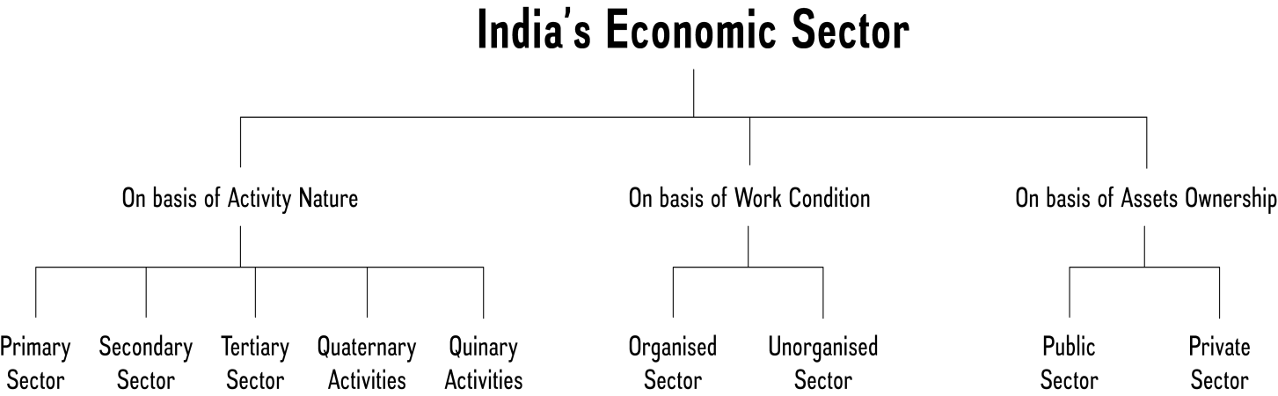](https://www.drishtiias.com/images/uploads/1578483780_image15.png)

**Primary Sector**

In Primary sector of economy, activities are undertaken by directly using natural resources. Agriculture, Mining, Fishing, Forestry, Dairy etc. are some examples of this sector. It is called so because it forms the base for all other products. Since most of the natural products we get are from agriculture, dairy, forestry, fishing, it is also called Agriculture and allied sector. People engaged in primary activities are called red-collar workers due to the outdoor nature of their work.

**Secondary Sector**

It includes the industries where finished products are made from natural materials produced in the primary sector. Industrial production, cotton fabric, sugar cane production etc. activities comes under this sector.

Hence its the part of a country's economy that manufactures goods, rather than producing raw materials Since this sector is associated with different kinds of industries, it is also called industrial sector.

People engaged in secondary activities are called blue collar workers.

**Examples of manufacturing sector:**

Small workshops producing pots, artisan production.

Mills producing textiles,

Factories producing steel, chemicals, plastic, car.

Food production such as brewing plants, and food processing.

Oil refinery.

Core Industries

Eight Core Industries are Electricity, steel, refinery products, crude oil, coal, cement, natural gas and fertilizers. The Index of Eight Core Industries is a monthly production index, which is also considered as a lead indicator of the monthly industrial performance. The Index of Eight Core Industries is compiled based on the monthly production information received from the Source Agencies.

**Tertiary Sector/Service Sector**

This sector’s activities help in the development of the primary and secondary sectors. By itself, economic activities in tertiary sector do not produce a goods but they are an aid or a support for the production.

Goods transported by trucks or trains, banking, insurance, finance etc. come under the sector. It provides the value addition to a product same as secondary sector.

This sector jobs are called white collar jobs.

**Pink Collar Worker**

Pink-collar worker is one who is employed in a job that is traditionally considered to be women's work. The term pink-collar worker was used to distinguish female-orientated jobs from the blue-collar worker, a worker in manual labor, and the white-collar worker, a professional or educated worker in office positions.

A pink collar worker need not require as much professional training as white-collar professions. They do not get equal pay or prestige.

A pink collar worker is usually a woman. Men rarely work in pink collar jobs. Some examples of pink collar occupations are baby sitter, florist, day care worker, nurses etc.

Lately, the pink collar worker is educated or trained. Pink collar workers are educated through training seminars or classes and they have to continue to strive for advancement in their careers.

**Sunrise Industry**

Sunrise industry is a term used for a sector that is just in its infancy but shows promise of a rapid boom.The industry is typically characterized by high growth rates, high degree of innovation and generally has plenty of public awareness about the sector and investors get attracted to its long-term growth prospects.

On the other hand Sunrise industry rapid emergence may threaten a competing industry sector that is already in decline. Because of its dim long-term prospects, such an industry is referred to as a sunset industry.

**Existing Indian sectors that can be termed as Sunrise sectors and likely to hold us in good stead in the future in terms of employment generation and business growth are:**

**Information Technology**

**Telecom Sector**

**Healthcare**

**Infrastructure Sector**

**Retail Sector**

**Food Processing Industries**

**Fisheries**

**Why did India shift from primary sector to services sector and not secondary sector?**

The natural economic movement of a country goes from agrarian economy to an industrial economy to a service economy but India has leapfrogged from an agrarian economy to a service economy.

One remarkable feature of India’s recent growth is diversification into services, with the services sector dominating GDP. India’s success in software and IT-enables serviced (ITeS) exports, has made it a significant services exporter with its share in world services exports rising from 0.6 per cent in 1990 to 3.3 per cent in 2013.

human resources, Fluency in English and availability of cheap labour are other reasons for rapid growth of service sector in the country. On the other hand low growth in Secondary sector can be attributed to:

The license Raj

**Restrictions on foreign investment**

Lack of measures to promote private industry

Power Deficit

Stringent Labour laws

Lack of skilled labour

Delays in Land Acquisition and environmental clearances

Import of cheap manufactured goods etc.

Though India ranks low in terms of per capita income, its share of services in GDP is approaching the global average. Interestingly, however, the contribution of services to employment was significantly lower than the world average.

The manufacturing sector tends to be labour intensive, hence renewed emphasis on the manufacturing through programmes like ‘Make in India’ will serve to correct this anomaly and raise employment in proportion with growth in GDP.

**Quaternary Activities**

These are specialized tertiary activities in the ‘Knowledge Sector’ which demands a separate classification.

The quaternary sector is the intellectual aspect of the economy. It is the process which enables entrepreneurs to innovate and improve the quality of services offered in the economy.

Personnel working in office buildings, elementary schools and university classrooms, hospitals and doctors’ offices, theatres, accounting and brokerage firms all belong to this category of services.

Like other tertiary functions, quaternary activities can also be outsourced.

**Quinary Activities**

The quinary sector is the part of the economy where the top-level decisions are made. This includes the government which passes legislation. It also comprises the top decision-makers in industry, commerce and also the education sector.

These are services that focus on the creation, re-arrangement and interpretation of new and existing ideas; data interpretation and the use and evaluation of new technologies.

Profession under this category often referred as 'gold collar' professions, they represent another subdivision of the tertiary sector representing special and highly paid skills of senior business executives, government officials, research scientists, financial and legal consultants, etc.

**Organised Sector**

In this sector, employment terms are fixed and regular, and the employees get assured work and social security.

It can also be defined as a sector, which is registered with the government and a number of acts apply to the enterprises. Schools and hospitals are covered under the organised sector.

Workers in the organised sector enjoy security of employment. They are expected to work only a fixed number of hours. If they work more, they have to be paid overtime by the employer.

**Unorganised Sector**

An unorganised worker is a home-based worker or a self-employed worker or a wage worker in the unorganized sector and includes a worker in the organized sector who is not covered by any of the Acts pertaining to welfare Schemes as mentioned in Schedule-II of Unorganized Workers Social Security Act, 2008.

In this sector wage-paid labour is largely non-unionised due to casual and seasonal nature of employment and scattered location of enterprises.

The sector is marked by low incomes, unstable and irregular employment, and lack of protection either from legislation or trade unions.

**The Public Sector**

In the sector, government owns most of the assets and it is the part of the economy concerned with providing various governmental services.

The purpose of the public sector is not just to earn profits. Governments raise money through taxes and other ways to meet expenses on the services rendered by it.

**Classification of Central Public Sector Enterprises (CPSEs)**

**CPSEs are classified into 3 categories- Maharatna, Navratna and Miniratna. Presently, there are 7 Maharatna, 16 Navratna and 71 Miniratna CPSEs.**

**Maharatna Scheme was introduced for Central Public Sector Enterprises (CPSEs), with effect from 19th May, 2010, in order to empower mega CPSEs to expand their operations and emerge as global giants.**

**Presently there are seven ‘Maharatna’ CPSEs, viz. (i) Bharat Heavy Electricals Limited, (ii) Coal India Limited, (iii) GAIL (India) Limited, (iv) Indian Oil Corporation Limited, (v) NTPC Limited, (vi) Oil & Natural Gas Corporation Limited and (vii)Steel Authority of India Limited.**

**CPSEs fulfilling the following criteria are eligible to be considered for grant of Maharatna status:**

**Having Navratna status.**

1. Listed on Indian stock exchange with minimum prescribed public shareholding under SEBI regulations.
2. Average annual turnover of more than Rs. 25,000 crore, during the last 3 years.
3. Average annual net worth of more than Rs. 15,000 crore, during the last 3 years.
4. Average annual net profit after tax of more than Rs. 5,000 crore, during the last 3 years.
5. Should have significant global presence/international operations.