**Investment Function**

The investment function refers to investment -interest rate relationship. There is a functional and inverse relationship between rate of interest and investment. The investment function slopes downward.

**I = f (r)**

I= Investment (Dependent variable)

r = Rate of interest (Independent variable)

**1. Meaning of investment**

The term investment means purchase of stocks and shares, debentures, government bonds and equities. According to Keynes, it is only financial investment and not real investment. This type of investment does result in an addition to the stock of real capital of the nation.

In the views of **Keynes**, Investment includes expenditure on capital investment.

**2. Types of investment**

**Autonomous Investment and Induced Investment**

**Autonomous Investment**

1. Investment that is not dependent on the national income
2. Mainly done with the welfare motive and not for making profits
3. Examples: Construction of road, bridges, School, Charitable houses
4. Not affected by rise in raw materials or wages of workers
5. Essential to development of nation and out of depression

**i) Autonomous investment:**Autonomousinvestment is the expenditure on capital formation, which is independent of the change in income, rate of interest or rate of profit.

This investment is independent of economic activity. Autonomous investment is income-inelastic, the volume of autonomous investment is the same at all levels.

The autonomous investment curve is horizontal, parallel to X axis.

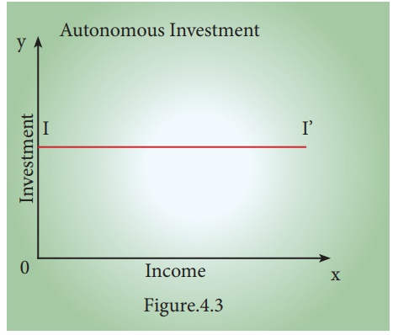

*In the times of economic depression, the governments try to boost the autonomous investment. Thus, autonomous investment is one of the key concepts in welfare economics.*

Generally, Government makes autonomous investment because of the welfare consideration.

**ii) Induced** **investment:**

Induced investment is the expenditure on fixed assets and stocks which are required when level of income and demand in an economy goes up.

Induced investment is profit motivated. It is related to the changes of national income. The relationship between the national income and induced investment is positive; decreases in national income leads to decrease in induced investment and vice versa. Induced investment is income elastic. It is positively sloped as shown here.

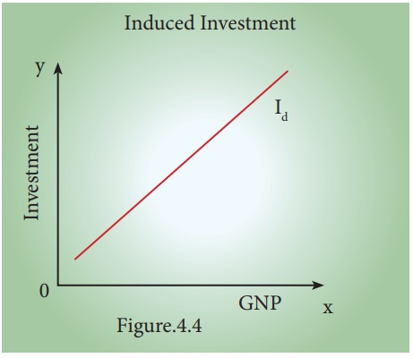

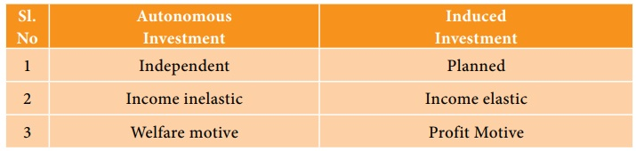

**3.  Determinants of Investment Function**

The classical economists believed that investment depended exclusively on rate of interest. In reality investment decision depends on a number of factors. They are as follows:

1.        Rate of interest

2.        Level of uncertainty

3.        Political environment

4.        Rate of growth of population

5.        Stock of capital goods

6.        Necessity of new products

7.        Level of income of investors

8.        Inventions and innovations

9.        Consumer demand

10.   Policy of the state

11.   Availability of capital

12.   Liquid assets of the investors

However, **Keynes** contended that business expectations and profits are more important in deciding investment. He also pointed out that investment depends on MEC (Marginal Efficiency of Capital) and rate of interest.

i. Private investment is an increase in the capital stock such as buying a factory or machine.

The marginal efficiency of capital (MEC) states the rate of return on an investment project. Specifically, it refers to the annual percentage yield (output) earned by the last additional unit of capital.

ii. If the marginal efficiency of capital is 5% and interest rates is 4%, then it is worth borrowing at 4% to get an expected increase in output of 5%.

**4.  Relationship between rate of interest and Investment:**

An explanation of how the rate of interest influences the level of investment in the economy. Typically, higher interest rates reduce investment, because higher rates increase the cost of borrowing and require investment to have a higher rate of return to be profitable.

**Interest rates and investment**

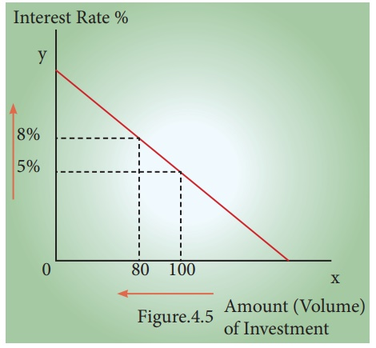

As the real cost of borrowing rises, fewer investment projects are profitable.

If interest rates rise from 5% to 8 %, then we get a fall in the amount of investment from ₹ 100 cr to ₹ 80 cr.

If interest rates are increased then it will tend to discourage investment because investment has a higher opportunity cost.

1. With higher rates, it is more expensive to borrow money from a bank.

2. Saving money in a bank gives a higher rate of return. Therefore, using savings to finance investment has an opportunity cost of lower interest payments.

If interest rates rise, firms will need to gain a better rate of return to justify the cost of borrowing using savings.

**5. Marginal Efficiency of Capital.**

MEC was first introduced by J.M Keynes in 1936 as an important determinant of autonomous investment. The MEC is the expected profitability of an additional capital asset. It may be defined as the highest rate of return over cost expected from the additional unit of capital asset.

**Meaning of Marginal Efficiency of Capital**(MEC) is the rate of discountwhich makes the discounted present value of expected income stream equal to the cost of capital.

**MEC depends on two factors:**

1. The prospective yield from a capital asset.

2. The supply price of a capital asset.

**Factors Affecting MEC:**

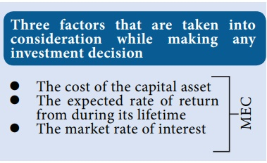

The marginal efficiency of capital is influenced by short - run as well as long-run factors. These factors are discussed in brief:

**a) Short - Run Factors**

**(i) Demand for the product:**If the marketfor a particular good is expected to grow and its costs are likely to fall, the rate of return from investment will be high. If entrepreneurs expect a fall in demand for goods and a rise in cost, the investment will decline.

**(ii) Liquid assets:**If the entrepreneursare holding large volume of working capital, they can take advantage of the investment opportunities that come in their way. The MEC will be high.

**(iii) Sudden changes in income:**The MECis also influenced by sudden changes in income of the entrepreneurs. If the business community gets windfall profits, or tax concession the MEC will be high and hence investment in the country will go up. On the other hand, MEC falls with the decrease in income.

**(iv) Current rate of investment:**Anotherfactor which influences MEC is the current rate of investment in a particular industry. If in a particular industry, much investment has already taken place and the rate of investment currently going on in that industry is also very large, then the marginal efficiency of capital will be low.

**(v) Waves of optimism and pessimism:**The marginal efficiency of capital is also affected by waves of optimism and pessimism in the business cycle. If businessmen are optimistic about future, the MEC will be likely to be high. During periods of pessimism the MEC is underestimated and so will be low.

**b) Long - Run Factors**

The long run factors which influence the marginal efficiency of capital are as follows:

**(i) Rate of growth of population:** Marginal efficiency of capital is also influenced by the rate of growth of population. If population is growing at a rapid speed, it is usually believed that the demand of various types of  goods will increase. So a rapid rise in the growth of population will increase the marginal efficiency of capital and a slowing down in its rate of growth will discourage investment and thus reduce marginal efficiency of capital.

**(ii) Technological progress:** If investment and technological development take place in the industry, the prospects of increase in the net yield brightens up. For example, the development of automobiles in the 20th  century has greatly stimulated the rubber industry, the steel and oil industry etc. So we can say that inventions and technological  improvements encourage investment in  various  projects and increase marginal efficiency of capital.

**(iii) Monetary and Fiscal policies:** Cheap money policy and liberal tax policy pave the way for greater profit margin and so MEC is likely to be high.

**(iv) Political environment:** Political stability, smooth administration, maintenance of law and order help to improve MEC.

**(v) Resource availability:** Cheap  and abundant supply of natural resources, efficient labour and stock of capital enhance the MEC.

**6.  Marginal Efficiency of Investment**

MEI is the expected rate of return on  investment  as  additional  units  of investment  are  made  under  specified conditions and over a period of time. When cost of borrowing is high, businesses are less motivated to borrow money and make investment on different projects because high  cost  of  borrowing  reduces  profit margin of the business firms;

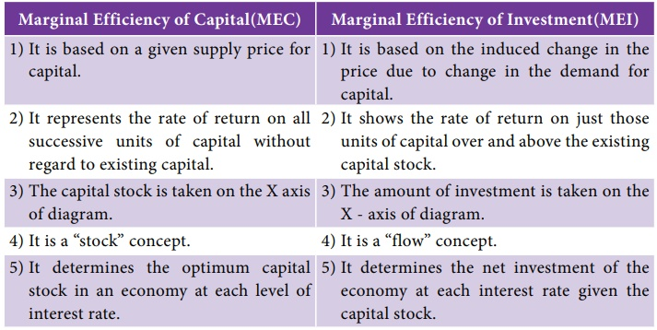

**Calculating the Keynesian Multiplier**

The value of the multiplier depends on the marginal propensity to consume and the marginal propensity to save.

**1. Marginal Propensity to Save**

The change in total savings as a result of a change in total income is known as the marginal propensity to save. When an individual’s income increases, the marginal propensity to save (MPS) measures the proportion of income the person saves rather than spend on goods and services. It is calculated as MPS = ΔS / ΔY.

Suppose an individual receives a year-end bonus of $600 and spends $300 on goods and services. The MPS is (600 – 300) / 600 = 0.5.

**2. Marginal Propensity to Consume**

The change in total consumption as a result of a change in total income is known as the marginal propensity to consume. The marginal propensity to consume (MPC) measures how consumer spending changes with a change in income. Using the figures above, the MPC is ΔC / ΔY = 300/600 = 0.5.

The Keynesian Theory states that an increase in production leads to an increase in the level of income and therefore, an increase in spending. The value of MPC allows us to calculate the size of the **multiplier** using the formula:

1 / (1 – MPC) = 1 / (1 – 0.5) = 2

This means that every $1 of new income will generate $2 of extra income.

**Expenditure Multiplier Work?**

It’s easiest to see how the multiplier works with an increase in expenditure. Suppose government spontaneously purchase $100 billion worth of goods and services, perhaps because they feel optimistic about the future. The producers of those goods and services see an increase in income by that amount. They use that income to pay their bills, paying wages and salaries to their workers, rent to their landlords, payments for the raw materials they use. Any income left over is profit, which becomes income to their stockholders. Each of these economic agents takes their new income and spend some of it. Those purchases then become new income to the sellers, who then turn around and spend a portion of it. That spending becomes someone else’s income. The process continues, though because economic agents spend only part of their income, the numbers get smaller in each round. When the dust settles the amount of new income generated is multiple times the initial increase in spending–hence, the name the spending multiplier. The table below gives an example of how this could work with an increase in government spending. Note that the multiplier works the same way in reverse with a decrease in spending.

Table 1. Calculating the Multiplier Effect

1. Original increase in aggregate expenditure from government spending 100.
2. Save 10% of income. Spend 90% of income. Second-round increase of… 100 – 10 = 90
3. $90 of income to people through the economy: Save 10% of income. Spend 90% of income. Third-round increase of… 90 – 9 = 81
4. $81 of income to people through the economy: Save 10% of income. Spend 90% of income. Fourth-round increase of… 81 – 8.1 = 72.10

Table 1 works through the process of the multiplier. Over the first four rounds of aggregate expenditures, the impact of the original increase in government spending of $100 creates a rise in aggregate expenditures of $100 + $90 + $81 + $72.10 = $343.10, which is larger than the initial increase in spending. And the process isn’t finished yet.