***__***

**Socio-Cultural Environment**

**TABLE OF CONTENTS**

***__***

## Learning Outcomes

1. **Introduction**
2. **Socio-Cultural Environment & Business: Relationship**
3. **Critical Element of Socio-Cultural Environment**
4. **Impact of Culture on Organizational Behaviour**
5. **Conclusion**
6. **Summary**

# Introduction

***__***

The term social-cultural environment of a country refers to surroundings consists of societal preferences, values, behaviour, customs and beliefs etc. Every society constructs its own environment. Each country develops its own environment in terms of food, drink or language. For example India had 200 different dialects, more the 179 different languages. Business need to understand that it can’t exist in vacuum. Business operates in the society only and should be aware of changes that are occurring. For the existence and survival of business, business must adapt itself according to the dynamics of society and culture. It is essential for business to read the mind of consumer before the competitor to stay ahead in the market.

The socio-cultural environment of a country has influence of religion, family, educational background and the social system. Our world is a global village, where each country is connected to another in one or the other way. Each country has its own value system, beliefs, behaviour etc. All these factors pose different challenges for businesses. This chapter deals with the socio- cultural environment of business, its effects on business and how business deals with the challenges exposed by social-cultural environment.

# Socio-Cultural Environment & Business: Relationship

For business social and cultural environment is an external environment created by the society at large. Business environment is surrounded by multi-cultural society where lots of sub-populations with unique values. Beliefs and customs exist simultaneously.

Each business faces two types of social and cultural environment as explained in the following figure.

Internal Social-Cultural Environment: Each organization has its own social environment known as internal social environment. As time passes each organization develops its own customs, beliefs, practices and behaviour within the confines of organization.

External Social-Cultural Environment: Organizations work in a society and needs, customs, beliefs of society affects business and its survival is known as external socio-cultural environment.

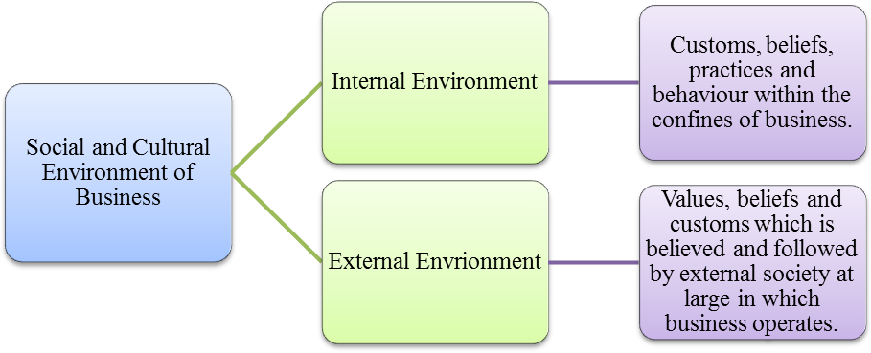Figure 1: Types of Social-Cultural Environment of Business

***__***

To survive in the market it is necessary to understand the implications of external socio-cultural environment on business. Business should be aware of social preferences, needs and wants of society in which it is operating because all these factors are influenced by population values, beliefs & practice. At the same in this dynamic world where each day new changes are occurring should keep itself updated with the changes occurring in external environment. If any business refuses to adapt to social-cultural environment or social changes that are occurring then in the long run sales would decline as a result of bad reputation.

For example, when McDonald entered in Indian market people didn’t accept it whole heartedly. Reason behind the skepticism was vast diversity in Indian religion and food habits. McDonald’s served beef in their burger but in India for Hindu cow is sacred and for Muslims beef meat was not acceptable. Keeping in mind religious sentiments of Indian connected with cow McDonald’s introduced their first vegetarian range in India. If McDonald’s had not adapted to the cultural environment of India, it would have failed in the Indian market.

The businessman cannot ignore the elements of social environment as these elements may look like not affecting business directly but in the long run the social environment has great impact on the business. For instance, PEPSI used the slogan of “Come Alive” in advertisement in all countries. But in China people misinterpreted the word as “Coming out of Graves”. Therefore, they condemned the use of product and the demand of PEPSI started falling rapidly. So, at the end company had to change its slogan because by overlooking the sentiments of people company cannot survive in the long run.

***__***

On the other hand when McDonald introduced its famous slogan “I’m lovin’ it” in Spain, they translated it into Spanish “Me encanta” i.e. I really like it. It was necessary to translate the slogan as in Spanish speaking countries love is considered a very strong word and is used only in certain situations.

Therefore, while designing business strategy social environment of the country should be crucially studied. One small mistake can lead to a great loss in the long run.

**Socio-cultural environment covers factors such as social customs, traditions, culture, lifestyle, attitude of people, saving & spending patterns, size of population, demographic profile, education level, occupational structure, trade unions, and a lot of factors that influence and describe the behavioural characteristics of the people. But also includes the Corporate Social Responsibility initiatives undertaken by companies.** CSR Initiatives CSR in India is in a nascent stage. It is still one of the least understood initiatives in the Indian development sector. A lack of understanding, inadequately trained personnel, non-availability of authentic data and specific information on the kinds of CSR activities, coverage, policy etc. further adds to the reach and effectiveness of CSR programmes. However the situation is changing as CSR is coming out of the purview of 'doing social good' and is becoming a 'business necessity'. The business case for CSR is gaining ground and corporate houses are realising that what is good for workers - their community, health and environment is also good for business.

It is true that social cultural environment of a country affects it business environment at large. But vice-versa situation is also true. Sometimes business also influences social values. Through marketing, advertising and public relations businesses can influence and change the social values of people. It has been proved that marketing strategies are used to create trends in markets. Public relational tools are also used to repair bad reputation of organizations. For example, as people are becoming more health conscious fast food is being criticized by the whole world for its zero nutritional values. Therefore, now fast food outlets are offering healthier options to consumers to indemnify the loss of reputation.

# Critical Elements of Socio-Cultural Environment

***__***

To generate revenue and maximization of profits, optimum utilization of available resources is a perquisite. But whether an organization would be able to utilize available resources depends on internal and external factors. Socio-cultural environment refers to surrounding in which an organization operates. Socio-cultural factors such as social attitude, belief system, education etc. have impact on business. If any business overlooks or fails to understand the impact of socio cultural factors on business, it creates a situation where people will not be able to relate themselves with their product. And in the long run organization may go out of business.

### Critical elements affecting socio-cultural environments are as follows:

### Social institutions and system:

Social institutions and system of a country has great impact on the socio-cultural environment. The Caste system, joint family system, child marriage, and religion etc. affects social environment and business. Religious beliefs and superstitions of the people are affected by their environment. In India for example religious sentiments of people have given birth to a new business and a source of income to people.

### Social values:

Social values of a society are not rigid anymore and keep on changing with time. Views towards authority, responsibility & delegation, attitudes of people towards different professions, role of ownership and management, are all undergoing rapid changes. Every business organization needs to adapt itself with the changes that are occurring in the social values or customs of an economy. At the same time a uniform business policy cannot be implemented throughout the world. Every country has its own social norms, values and customs and therefore it is a prerequisite for business to modify the business policies and strategy according to the social values of country in which business is operating.

### Education and Culture:

When level of education in a country increases its impact on business also increases. Spread of education and their impact on business ethics, business morality and organizational culture are one of the major elements of socio-cultural environment of business.

### Social Groups:

India is a dual economy where traditions and customs co-exist with the modern culture. India has a unique socio-economic order where there is a lot of differences exist in food, dress, language, religion and sub-culture. As time passes the order of socio-economic gets disturbed or needs modifications or alterations. Business needs to adapt itself with the changing.

### Changing Preferences:

Preferences of consumer keep on changing & affect business and its strategies. What was popular 15 years back may not be

***__***

in demand today and what is in demand today may not be desired by consumer tomorrow.

### Demographics:

Demographics have significant impact on business. If large proportion of population belongs to younger age group then demand of music, fashion items, education etc. will be higher. But as populations ages demand for luxury and healthy products may increase. Changes in the proportion of gender, age group, income etc. significantly impact on the way a company does business.

### Advertising Techniques:

Advertising agencies and marketers are required to judge the pulse of the people. Change in fashion, need, want of customers need to be tracked regularly because if changes in all these factors are not considered then business may fail.

Apart from the factors mentioned above quality of life, importance of women in workforce, birth & death rate, attitudes of consumers towards new products, education & literacy rates, size of population etc. can also have impact on social-cultural environment of a country.

Social environment of country is related to society but society ultimately comprises of consumers, investors, employees and the local community.

Some cultural variations around the world:

* + Numeric number 7 is considered bad luck in Kenya, good luck in Czech Republic and has magical connotations in Benin.
  + Red is a positive colour in Denmark but represents death in many African countries.
  + In Japan if you are visiting a home with a gift, it is considered good. But in case of Soviet Union the same is considered as bribe.
  + Pepsodent toothpaste was unsuccessful in Southeast Asia because it promised white teeth to a culture where black or yellow teeth are symbol of prestige.
  + Some cultural variations as mentioned above have great impact on business environment.

#### Impact of foreign culture on Indian business:

West has changed the Indian standard of living based on the deep sense of contentment and spiritualism. Hereditary occupations could no longer guarantee the individual subsistence or comfort. New types of employment and castes came into existence. The economic and industrial policy of the British destroyed the ancient village based indigenous industries of India. Her traditional economic structure in agriculture and industries fell to pieces. But on account of the increased population and absence of new large scale industries, agriculture could not be the sound means of livelihood for the people. Close contact with the western countries could make the Indians understand about the modern industrial way of life and the availability of minerals and raw materials in plenty to industrialize their country for the growth of their economy. Thus the economic life of the country was bound to be modernized. The new western ideology has changed our economic outlook, introduced a desire for liberty, a passion for social justice in the field of economy. A new demand for modernization for all avenues of progress in the field of industries and a different type of national sentiment based the economic growth thus came in the way of Indian life to regenerate the hope of economic prosperity in the modern time. The legacy of difficulties in the economic field reminds the exploitative character of Western culture.