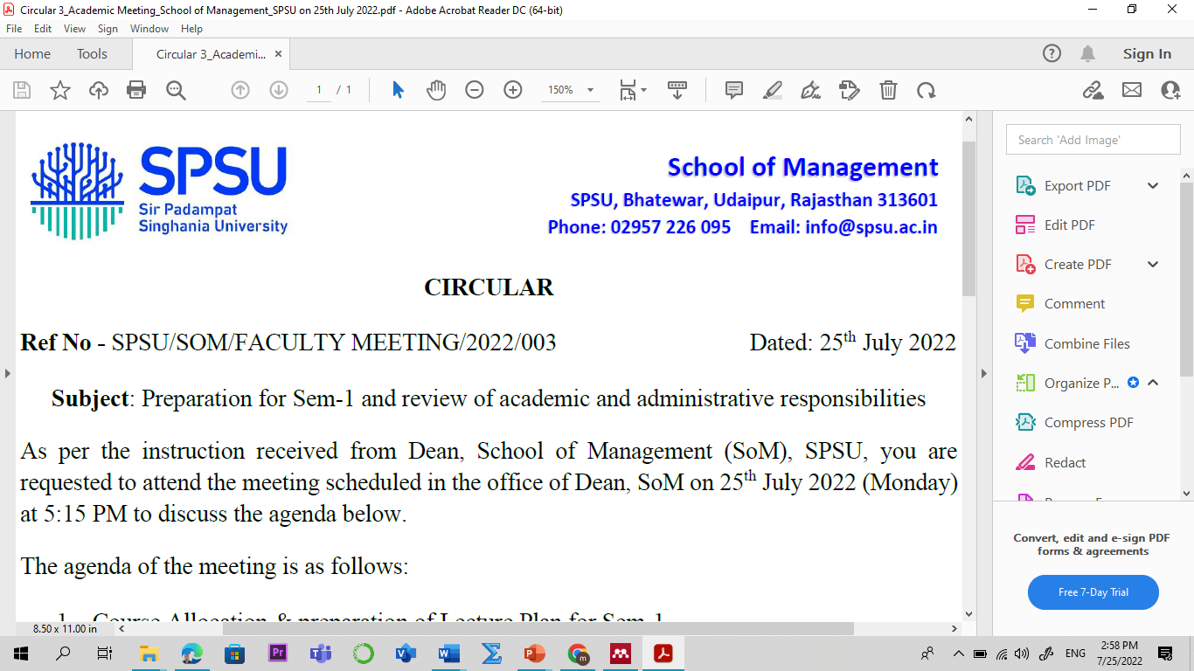

Lecture Plan

Program: MBA

Name of the Course: Environmental Social and Governance (ESG) L-P-T-C
Credit: 02 2-0-0-2
Sem: I Academic Year: 2024-25
Faculty Member: Manish Dadhich, PhD Code: VAE4101
Contact No.: 9828142616 E-mail: manish.dadhich@spsu.ac.in

Introduction /Course Description:

This course provides an in-depth exploration of Environmental, Social, and Governance (ESG) principles, emphasizing their significance in contemporary business and investment contexts. Students will thoroughly understand how ESG factors influence corporate strategies, investor decisions, and societal outcomes. The curriculum covers key topics such as climate change, sustainable resource use, human rights, corporate governance, ethical business practices, and ESG reporting standards. Through a blend of theoretical insights and practical applications, the course aims to equip students with the knowledge and skills to assess and implement effective ESG strategies.
Designed for business students, professionals, and individuals interested in ESG, the course employs various teaching methods, including lectures, interactive discussions, case studies, and guest speakers. Students will engage in group projects and presentations to enhance their collaborative and analytical skills. By the end of the course, participants will be able to evaluate corporate ESG practices critically, integrate ESG factors into investment decisions, and anticipate future trends in the evolving ESG landscape.
Course Objective:
- Recognize the importance of ESG in sustainable business practices.
- Understand key ESG issues in the financial sector, including regulatory and investment challenges.
- Identify ESG-related risks and opportunities within their organization.
- Effectively discuss the contemporary issue of ESG in the present context.
- Advocate for and implement ESG initiatives to drive positive change and improve corporate reputation.
Course Outcomes (COs) & Bloom's Taxonomy:

Course Outcomes | Bloom's Taxonomy
CO1: Learn to identify relevant ESG pathways for stakeholders, navigate materiality maps effectively, and prioritize stakeholder relations to enhance shareholder value. | - Remembering (K1)  - Knowledge (K2)
CO2: Explore ESG investing history, corporate responsibility, and methods to integrate ESG factors into investment strategies. | - Remembering (K1)  - Knowledge (K2)
CO3: Examine ESG data, compare provider approaches, and measure the impact of environmental, social, and governance factors on stakeholders. | - Remembering (K1)  - Knowledge (K2)
CO4: Analyze contemporary ESG issues with stakeholders. | - Apply (K3)  - Analyze (K4)
CO5: Analyze strategies to enhance stakeholder relations and integrate ESG risk assessments into broader corporate frameworks for optimized performance. | - Apply (K3)  - Analyze (K4)
*Level of Learning- Use the number from 1 to 5 for indicating the level. Level 1- Remember & Understand, Level 2- Apply, Level 3- Analyse, Level 4- Evaluate, Level 5- Create. Mention the highest level that will be attained in the particular Course Outcome.
Course Outcome (CO) - Program Outcome (PO)/ Program Specific Outcome (PSO) Mapping
Sem | Course | CO-PO/PSO Mapping | PO1 | PO2 | PO3 | PO4 | PO5 | PO6 | PO7 | PO8 | PSO1 | PSO2 | PSO3
 | ESG Management | CO1 |  |  | 1 | 1 | 1
 |  | CO2 | 1 |  | 1 |  | 2 |  |  | 2
I
 |  | CO3 | 1 |  | 2 | 1 |  | 1 |  |  | 2
 |  | CO4 |  | 2 |  | 1 | 1 |  |  | 1 |  | 2
 | (VAE4101)
 |  | CO5 |  | 3 |  | 4 | 4 |  |  |  | 3
Note: 1 for “Low”, 2 for “Medium” and 3 for “High”

Pedagogy
The Environmental, Social, and Governance (ESG) Principles and Practices course will utilize a diverse and interactive teaching methodology, including expert-led lectures, facilitated discussions, and real-world case studies to comprehensively understand ESG concepts. Participants will engage in collaborative group projects, practical assignments, and role-playing simulations to apply ESG principles to real-world scenarios. Insights from industry professionals and ESG experts through guest lectures and Q&A sessions will deepen practical knowledge. Interactive workshops and skill-building exercises will further enhance participants' ability to advocate for and implement effective ESG initiatives within their organizations.

Employability Skills Measuring Tools:
- Critical Thinking and Problem Solving:
- Managerial competitive skill (assignment on contemporary issues).
- Business insight (case studies).

Suggested Readings:
Textbook/ Reference Books:

- John Hill, Environmental, Social, and Governance (ESG) Investing: A Balanced Analysis of the Theory and Practice of a Sustainable Portfolio, Academic Press; 1st edition (February 13, 2020)
- CFA Institute, Certificate in ESG Investing Curriculum: ESG Investing Official Training Manual, CFA Institute (September 2, 2021).
- Nevena Kostić, Amina Hujdur, Building a Sustainable Future: ESG Business Handbook, the AIRE Centre, 2021.
- Sunny Revankar, Understanding ESG and Sustainability, Jec Publication, 2023.
- Garima Dadhich, Dr. Ravi Raj Atrey, Demystifying ESG, Taxmann Publications Private Limited, 2024
- S. Sarkar and Anil Kumar Singh. Environmental Impact Assessment: Theory and Practice, Butterworth-Heinemann, 2020.

Important Websites:
- Bloomberg ESG Data Services: www.bloomberg.com/professional/solution/esg-data/
- The Sustainability Consortium (TSC): www.sustainabilityconsortium.org
- CDP (formerly Carbon Disclosure Project): www.cdp.net
- Global Reporting Initiative (GRI): www.globalreporting.org
- Sustainability Accounting Standards Board (SASB): www.sasb.org
- Task Force on Climate-related Financial Disclosures (TCFD): www.fsb-tcfd.org
- ESG (Environmental, Social and Governance) - Turn ESG theory into action (pwc.com)
- ESG Investing and Analysis (cfainstitute.org)

Scheme of Evaluation

Assessment |  | Weightage (in %)
Continuous Internal Assessment |  | 40
Assessment Task | Frequency * Marks = Total Marks (100) | Weightage for individual Component
Mid-Term Examination – I and II | 2*20 = 40 | 16
Quiz | 3*10 = 30 | 12
Assignments (Class Assignment /Home Assignments)/Case Study/ Case Discussions/ Project Work. | 1*10 = 10 | 4
Assignments (Class Assignment /Home Assignments) | 1*10 = 10 | 4
Attendance | 10 | 4
External Assessment |  | 60
End Term Examination | 1*60 | 60

Detailed Lecture Plan:

Session No | Topics | Reading/Reference | Learning Outcome & Course Outcome (CO)
UNIT-I: Introduction to ESG Factors and Concepts
1 | Overview of ESG and its relevance | Textbook, Chapter 1, pp. 1-10 (Building a  Sustainable Future:  ESG Business Handbook by Nevena Kostić, Amina Hujdur, UNDP) | Remember and understand ESG and its relevance in the present context.  (CO1, K1, K2)
2 | Introduction to environmental, social, and governance (ESG) factors. | Textbook, Chapter 1, pp. 10-15. Further: https://manishdadhich.gnomio.com | Comprehend environmental, social, and governance (ESG) factors.  (CO1, K1 & K2)
3 | Importance of assessing stakeholder interest or salience in different ESG factors, limitations. | Textbook, Chapter 2, pp. 15-20. Further: https://manishdadhich.gnomio.com | Understand the importance of assessing stakeholder interest or salience in different ESG factors.  (CO1, K2)
4 | ESG factors and how they vary across industries. | Textbook, Chapter 3, pp. 15-20. Further: https://manishdadhich.gnomio.com | Comprehend ESG factors and how it vary across industries.  (CO1, K2)
5 | Five pathways of materiality through which ESG factors impact revenues, costs, or productivity. | Textbook, Chapter 4, pp. 20-25. Further: https://manishdadhich.gnomio.com | Know the concept of five pathways of materiality through which ESG factors impact revenues, costs, or productivity.  (CO1, K2)
6 | Conditions under which stakeholders are expected to activate these pathways. | Textbook, Chapter 5, pp. 25-30. Further: https://manishdadhich.gnomio.com | Discuss the conditions under which stakeholders are expected to activate these pathways.  (CO2, K1, K2)
7 | Highlighting the strategic and financial importance of stakeholder relations. (Case study: An ESG Puzzale) | https://hbsp.harvard.edu/download?url=%2Fcatalog%2Fsample%2FABC038-PDF-ENG%2Fcontent&metadata=e30%3D  Further: https://manishdadhich.gnomio.com | Comprehend the ESG concept and KPIs.  (CO2, K1, K2)
8 | Quiz 1: Introduction to ESG Factors and Concepts | Further: https://manishdadhich.gnomio.com | Understand and appraise ESG factors and their relevance.  (CO2, K1, K2)
UNIT-II: History and Flavors of ESG Investing
9 | Overview of the history of ESG investing. | Research Paper, an overview of environmental, social, and governance (ESG) and company performance, https://www.researchgate.net/publication/375665001_ | Discuss the history of ESG investing.  (CO3, K1, K2)
10 | Review the past and present ways investors have attempted to incorporate environmental, social, and governance factors into their strategies. | https://onlinelibrary.wiley.com/doi/10.1111/joes.12599, Further: https://manishdadhich.gnomio.com | Understand the past and present ways investors have attempted to incorporate environmental, social, and governance factors into their strategies.  (CO3, K1, K2)
11 | The relationships between social pressure, corporate responses, and financial performance. | https://onlinelibrary.wiley.com/doi/full/10.1002/csr.2446, Further: https://manishdadhich.gnomio.com | Understand the relationships between social pressure, corporate responses, and financial performance.  (CO3, K1, K2)
12 | Portfolio optimization and how to utilize ESG factors to maximize returns. | https://www.tandfonline.com/doi/full/10.1080/1331677X.2017.1313122, Further: https://manishdadhich.gnomio.com | Acquaint with portfolio optimization and how to utilize ESG factors to maximize returns.  (CO3, K1, K2)
13 | Various case studies look at different investment strategies. | https://onlinelibrary.wiley.com/doi/abs/10.1002/jsc.2594, Further: https://manishdadhich.gnomio.com | Discussion of case studies that look at different investment strategies.  (CO3, K1, K2)
14 | The case and their outcomes in terms of both ESG and financial performance. | https://onlinelibrary.wiley.com/doi/abs/10.1002/jsc.2594, Further: https://manishdadhich.gnomio.com | Discussion on outcomes in terms of both ESG and financial performance.  (CO2, K2)
15 | Quiz 2: History and Flavors of ESG Investing | Further: https://manishdadhich.gnomio.com | Understand and appraize History and Flavors of ESG Investing.  (CO2, K1, K2)
UNIT-III: ESG Data
16 | The importance of ESG data and financial analyses. | https://journals.sagepub.com/doi/10.1177/000765039903800105. Further: https://manishdadhich.gnomio.com | Understand the importance of ESG data and financial analyses.  (CO3, K1, K2)
17 | Different providers of ESG data. | Top 10 ESG Data Providers, https://www.esganalytics.io/insights/top-10-esg-data-providers | Understand the different providers of ESG data.  (CO3, K1, K2, K3)
18 | ESG factors and assessing this data. | ESG Risk Assessment: A Comprehensive Guide for Informed Decision-Making, https://esgresearch.pro/esg-risk-assessment/# | Understand ESG factors and assess this data.  (CO3, K1, K2, K3)
19 | Survey the tendency towards integrated reporting, whereby firms embed ESG data inside their financial reports. | Building a sustainable path to cleaner ESG data, https://www.pwc.com/us/en/services/esg/library/esg-data-collection-reporting.html Further: https://manishdadhich.gnomio.com | Acquainted with the survey the tendency towards integrated reporting, whereby firms embed ESG data inside their financial reports.  (CO3, K1, K2, K3)
20 | Examine ESG data that focuses on the financial impacts on a firm's stakeholders. | Building a sustainable path to cleaner ESG data, https://www.pwc.com/us/en/services/esg/library/esg-data-collection-reporting.html Further: https://manishdadhich.gnomio.com | Acquaint with ESG data that focuses on the financial impacts on a firm's stakeholders.  (CO3, K1, K2, K3)
21 | Determinants of creating financial benefits or harm for the firm. | The Determinants of ESG Rating in the Financial Industry: The Same Old Story or a Different Tale? doi:10.3390/su12166398 | Understand the determinants of creating financial benefits or harm for the firm.  (CO3, K1, K2, K3)
22 | Class assignment: ESG Data |  | Understand and appraise ESG data and its relevance.  (CO3, K1, K2, K3)
UNIT-IV: ESG Management at the Firm Level
23 | The specific cost and revenue variances associated with ESG issues. How stakeholder relations can mitigate some of these risks. | https://www.thomsonreuters.com/en-us/posts/esg/enterprise-risk-management/ | Understand the specific cost and revenue variances associated with ESG issues and how stakeholder relations can mitigate some risks.  (CO4, K2, K3)
24 | Examine cases from India, Peru, Ghana, and Brazil and assess how different ESG risk management strategies affected the performance of these projects. | https://www.sciencedirect.com/science/article/abs/pii/S0301479723016171 | Analyze various cases of ESG, performance, and strategy.  (CO4, K3, K4)
25 | Review participatory stakeholder processes and external value at stake (EVAS). | https://blogs.lse.ac.uk/businessreview/2019/01/10/a-new-measure-to-assess-companies-external-engagement/Further: https://manishdadhich.gnomio.com | Review participatory stakeholder processes external value at stake (EVAS).  (CO5, K3, K4)
26 | Transformative ways to implement ESG risk assessments into a broader risk management framework to maximize expected corporate performance. | ESG in Risk Management, doi.org/10.1007/978-3-031-52734-0_10  Further: https://manishdadhich.gnomio.com | Analyze the transformative ways to implement ESG risk assessments into broader risk management to maximize expected corporate performance.  (CO5, K3, K4)
27 | Case study: ESG: a case study in how responsible governance creates shareholder value. | Link:https://quantlegaltech.com/blog/esg-a-case-study-in-how-responsible-governance-creates-shareholder-value/ | Analyze and understand how responsible governance creates shareholder value.  (CO5, K3, K4)
28 | Case study: IMPAAKT: Crowdsourcing Better ESG Ratings | https://hbsp.harvard.edu/download?url=%2Fcatalog%2Fteaching-note%2FIM1151-PDF-ENG% | Analyze and understand how crowdsourcing better esg ratings.  (CO5, K3, K4)
29 | Seminar/ presentation on the cases | - | -
30 | Recapitulation | - | -

Students' Interaction Time: Friday (04:30 PM – 05:30 PM)
Thursday (04:30 PM – 05:30 PM)

