**Types of Fintech Companies**

Most people think that all fintech startups are the same. However, there are many differences between them. The types of fintech companies include the following:

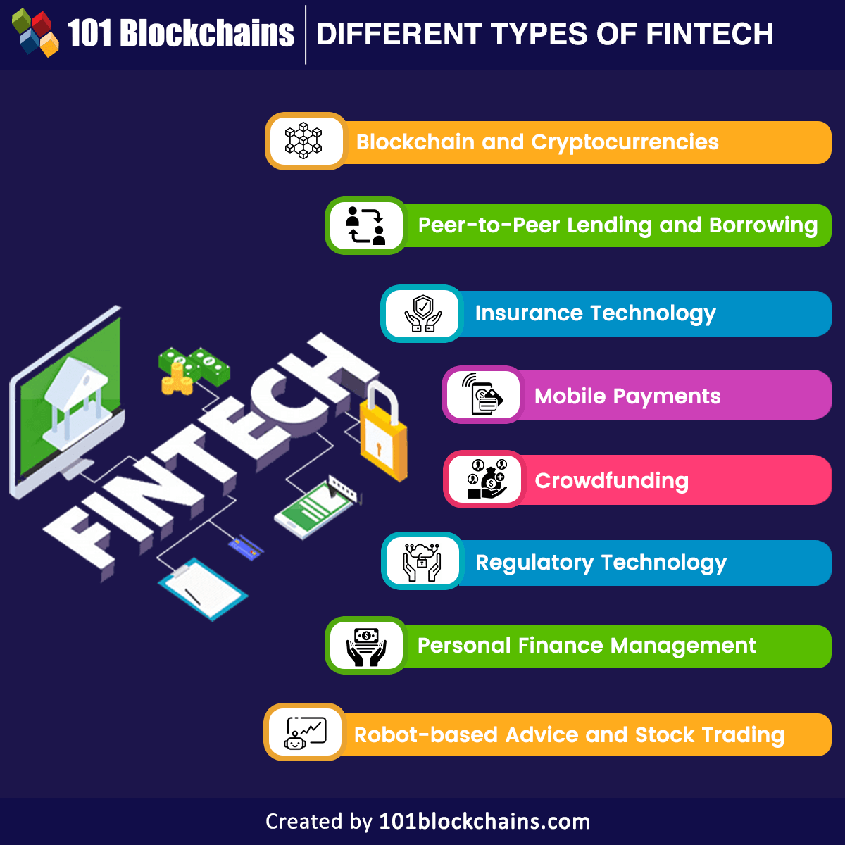

**Payment Processors:**

Payment processors act as intermediaries between merchants, consumers, and financial institutions. They facilitate electronic payment transactions, enabling businesses to accept payments from customers through various channels, such as credit cards, debit cards, digital wallets, and online bank transfers. Popular examples include Stripe, PayPal, Square, and Adyen.

**Digital Banking (Neobanks):**

Neobanks are fully digital banking platforms that operate without physical branches. They offer a range of financial services, including checking and savings accounts, debit cards, money transfers, and various other banking products. Their user-friendly mobile apps and streamlined processes appeal to customers seeking convenience and efficiency. Examples of neobanks include Revolut, Chime, N26, and Monzo.

**Peer-to-Peer Lending (P2P):**

P2P lending platforms connect individual lenders, often referred to as investors or peers, with borrowers. These platforms enable individuals and small businesses to access loans with potentially lower interest rates and more flexible terms than traditional banks offer. P2P lending cuts out the intermediaries, providing a more direct and accessible lending process. Notable P2P lending platforms include LendingClub, Prosper, and Funding Circle.

**Personal Finance Management**

Personal finance management companies develop apps and tools to help individuals manage their finances more effectively. These tools typically provide budgeting and expense tracking features, insights into spending patterns, and goal-setting capabilities. Examples include Mint, YNAB (You Need a Budget), and Personal Capital.

**Robo-Advisors:**

Robo-advisors offer automated investment advice and portfolio management services based on algorithms and artificial intelligence. They typically use clients' financial goals, risk tolerance, and other data to create and manage diversified investment portfolios. Robo-advisors often have lower fees compared to traditional human financial advisors. Some well-known robo-advisors are Betterment, Wealthfront, and Acorns.

**Insurtech:**

Insurtech companies leverage technology to improve the efficiency and accessibility of insurance services. They may offer online insurance policies, use data analytics to assess risk more accurately, and use innovative underwriting processes. Examples include Lemonade, Oscar Health, and Root Insurance.

**Cryptocurrency and Blockchain:**

Companies in this category deal with cryptocurrencies and blockchain technology. Cryptocurrency exchanges provide platforms for buying, selling, and trading digital assets. Digital wallets allow users to store and manage their cryptocurrencies securely. Blockchain development services build decentralized applications (DApps) and smart contracts. Notable names include Coinbase, Binance, Ledger, and ConsenSys.

**Regtech:**

Regtech companies focus on providing solutions to help financial institutions comply with regulations and streamline regulatory processes. They use technology to automate compliance tasks, monitor transactions for suspicious activities, and simplify reporting requirements. Examples include ComplyAdvantage, Onfido, and Trulioo.

**Crowdfunding Platforms**

Crowdfunding platforms enable individuals or businesses to raise funds from a large number of people (the "crowd") for projects, ventures, or charitable causes. There are different types of crowdfunding, including reward-based crowdfunding, equity crowdfunding, and donation-based crowdfunding. Notable platforms include Kickstarter, Indiegogo, GoFundMe, and Seedrs.

**Wealth Management Platforms**

Wealth management platforms offer digital tools and services to assist high-net-worth individuals and institutional clients in managing their investments and financial portfolios. These platforms often provide personalized investment advice and portfolio allocation based on the client's financial goals and risk tolerance. Examples include Betterment for Advisors, Charles Schwab Intelligent Portfolios, and Vanguard Personal Advisor Services.

**Trade Finance and Supply Chain:**

Companies in this category use technology to optimize trade finance processes and enhance supply chain management. They might offer solutions for digital trade finance, trade credit insurance, and supply chain visibility and efficiency. Notable names include TradeIX, Taulia, and Tradeshift.

**Real Estate FinTech**

Real estate FinTech companies use technology to disrupt and innovate the real estate industry. They offer online property listings, real estate crowdfunding platforms, digital mortgage lending services, and property management tools. These platforms aim to simplify real estate transactions, improve accessibility to investment opportunities, and enhance property management efficiency. Examples include Zillow, Fundrise, and Roofstock.

**Open Banking and APIs**

Open banking and API (Application Programming Interface) companies build platforms and APIs that enable different financial institutions and FinTechs to share data securely. These technologies facilitate data integration and allow for collaboration and innovation within the financial industry. Open banking APIs enable authorized third-party providers to access customer financial data, with user consent, to offer personalized financial services and solutions. Examples of companies in this space include Plaid, Yodlee, and TrueLayer.

These descriptions provide an overview of the various types of FinTech companies and their primary focus areas. However, it's worth noting that many companies may operate across multiple categories or have expanded their offerings beyond their initial scope. The boundaries between these categories can be fluid as companies continue to innovate and diversify within the FinTech industry.