**Heuristics Meaning**

Heuristics refers to a problem-solving and decision-making approach where individuals or entities consider past results or experiences and the minimal relevant details to reach a practical conclusion. These strategies utilize mental shortcuts and generalized concepts to find immediate, efficient, and short-term solutions.

A heuristic model acts as a rule of thumb in cases where there is no time for careful consideration of different aspects of a situation. Though this technique does not always give accurate, rational, or optimal results, it satisfies the requirements awaiting valid conclusions or decisions in complex scenarios. Its purpose is to solve a problem or achieve an outcome quickly with minimal mental effort and without analyzing everything thoroughly.

**Table of contents**

* [**Heuristics Meaning**](https://www.wallstreetmojo.com/heuristics/#h-heuristics-meaning)
  + [**How Does Heuristics Work?**](https://www.wallstreetmojo.com/heuristics/#h-how-does-heuristics-work)
  + [**Importance Of Heuristics**](https://www.wallstreetmojo.com/heuristics/#h-importance-of-heuristics)
  + [**Types Of Heuristics Methods**](https://www.wallstreetmojo.com/heuristics/#h-types-of-heuristics-methods)
    - [**Affect**](https://www.wallstreetmojo.com/heuristics/#h-affect)
    - [**Anchoring**](https://www.wallstreetmojo.com/heuristics/#h-anchoring)
    - [**Availability**](https://www.wallstreetmojo.com/heuristics/#h-availability)
    - [**Representativeness**](https://www.wallstreetmojo.com/heuristics/#h-representativeness)
  + [**Heuristics Examples**](https://www.wallstreetmojo.com/heuristics/#h-heuristics-examples)
    - [**Example #1**](https://www.wallstreetmojo.com/heuristics/#h-example-1)
    - [**Example #2**](https://www.wallstreetmojo.com/heuristics/#h-example-2)
  + [**Frequently Asked Questions (FAQs)**](https://www.wallstreetmojo.com/heuristics/#h-frequently-asked-questions-faqs)
  + [**Recommended Articles**](https://www.wallstreetmojo.com/heuristics/#h-recommended-articles)

**Key Takeaways**

* Heuristics is a problem-solving and decision-making strategy in which individuals or entities analyze previous results or experiences and the bare minimum of relevant facts to arrive at a practical conclusion.
* These methods rely on mental shortcuts to come up with quick, effective, and short-term solutions. It works well when there is not enough time or resources to think through all of the options.
* While these quick fixes or conclusions may not always be the ideal way to solve personal or corporate problems, they usually suffice for the time being.
* The four common types of heuristics include affect, anchoring, availability, and representativeness.

**How Does Heuristics Work?**

Heuristics are problem-solving techniques to achieve a satisfactory solution using mental shortcuts and based on previous outcomes with a similar situation. These are short-term results, letting individuals or entities tackle the issues for the time being. It, thus, gives them enough time to look at it in detail later on.

Playvolume00:06/01:00TruvidfullScreen



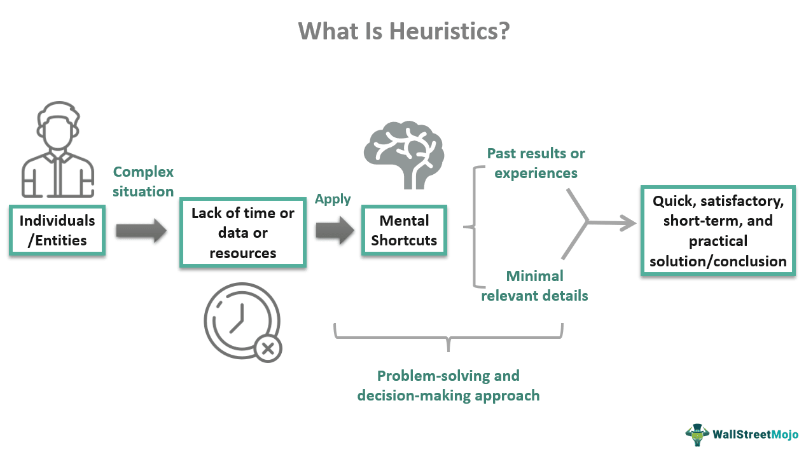

Herbert A. Simon, a Nobel Laureate and American economist, proposed the concept in the 1950s. He claimed that humans try to make rational decisions but are ultimately impacted by cognitive heuristics. However, the technique gained traction following Israeli psychologist Daniel Kahneman’s book “Thinking, Fast and Slow.” He hypothesized that these biases have an impact on how people think and make decisions.

Heuristics may be the most effective method for resolving problems, whether they are personal or professional. These short-term results provide ample time to make decisions that will solve difficulties permanently. The strategy has been found effective, if not accurate, as a short-term technique of dealing with problems or making correct decisions. Nevertheless, it has also been regarded as a method of reducing effort.

Many theories call it an approach indicative of cognitive laziness. Those who do not want to put much mental effort opt for this method for making judgments or solving problems. For some psychologists, the technique can cause cognitive biases. The findings or choices reached in previous cases based on cognitive abilities become the basis for conclusions or decisions for others with better-thinking levels.

The heuristics definition has become more prominent with the advent of technology, making all types of data available online. People can conduct research, examine, and evaluate data from multiple sources to reach conclusions and make decisions quickly and efficiently.

***Now you can Master Financial Modeling with Wallstreetmojo’s premium courses at special prices***

**Best Financial Modeling Courses by Wallstreetmojo**

**Financial Modeling Course**

* McDonalds Step by Step Modeling from Scratch  
* 12+ Hours of Video  
* Certificate

**RATING**4.91/5

[**Learn More**](https://www.wallstreetmojo.com/financial-modeling-course/)

**Financial Modeling & Valuation**

* McDonalds Step by Step Modeling from Scratch  
* Valuations  
* 25+ Hours of Video  
* Certificate of Completion

**RATING**5/5

[**Learn More**](https://www.wallstreetmojo.com/financial-modeling-and-valuation/)

**Valuation Course**

* Valuations (DCF, DDM, Comparable Comps)  
* 12+ Hours of Video  
* Certificate

**RATING**4.89/5

[**Learn More**](https://www.wallstreetmojo.com/valuation-course/)

**Importance Of Heuristics**

Heuristics are infamous for producing cognitive biases due to data limitations, which cause people and corporations to make poor decisions. Understanding the notion is therefore critical to avoid such a predicament and participate in more adaptive activities. It is worth noting that mental shortcuts, i.e., readily and widely available information, aid in making quick decisions in difficult circumstances or finding appropriate solutions to complex problems with limited time and resources.

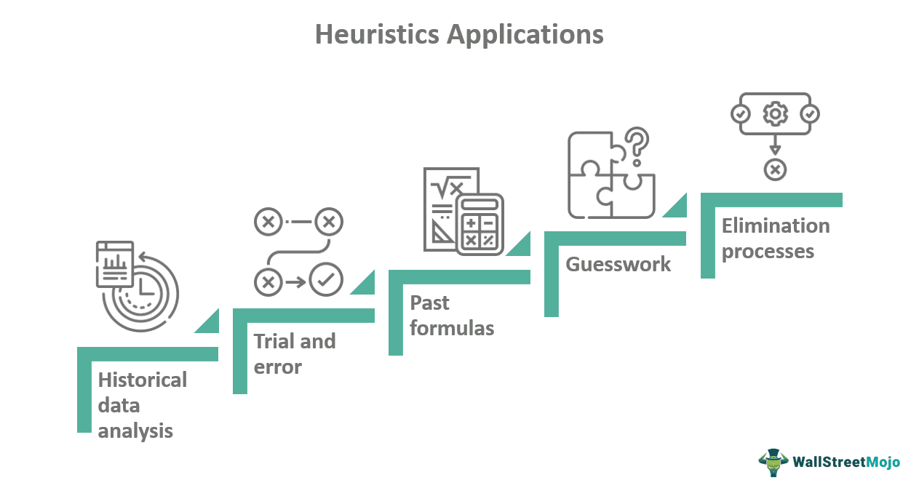

The approach applies in various methods, including historical data analysis, trial and error, past formulas, guesswork, and elimination processes.

**Types Of Heuristics Methods**

Here are the various sorts of heuristics based on the sources, contexts, and problems from which one derives the solutions or decisions:

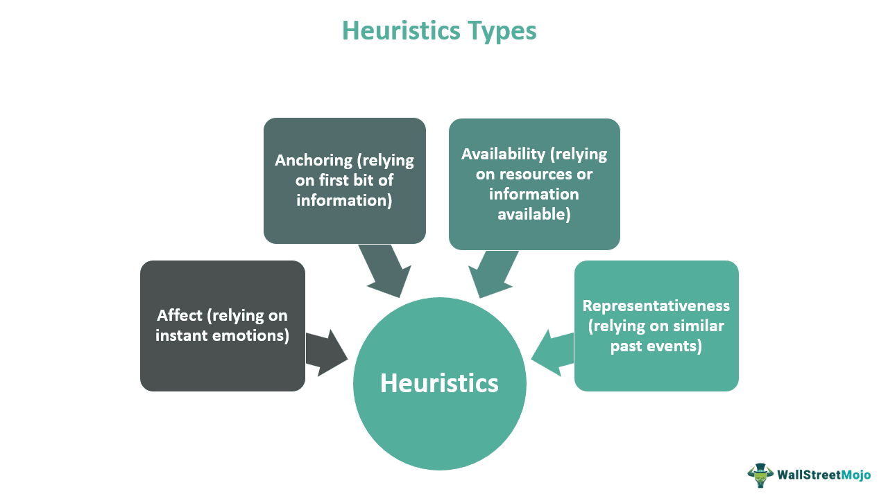

**Affect**

It emphasizes the instant emotions generated in individuals in response to a stimulus. It could be any positive or negative feeling they experience at a particular moment and in a specific situation. In short, this strategy signifies how the emotions or reactionary feelings triggered by previous experiences can influence a decision. This emotionally-driven approach, sometimes known as gut feeling, is common in situations that require evaluating the benefits and risks of something in a short time.

For example, when readers come across an article that promotes a product or service, clicking affiliate links will redirect them to the store’s website. There may be people who either want to buy something or look at the offerings. On the other hand, some visitors may read the article in the hopes of learning something new, but they quickly abandon the site if it appears to be promotional.

**Anchoring**

In this approach, individuals or entities make judgments based on the very first set of information they get called “anchor”. Since the decision is usually made in a hurry, it may be inaccurate. The impulsive decision-makers forget or ignore other factors, making not-so-good choices.

For example, an instant message about winning the latest automobile in exchange for a particular sum of money seems intriguing. People, however, pay just to be stuck in a deceptive bargain out of sheer excitement.

**Availability**

It is a process in which persons or entities recall previous related instances and evaluate their effectiveness in resolving problems. It is due to the most significant sources to refer to for reaching valid conclusions are the readily available ones. However, they are more likely to make poor decisions or come up with incorrect solutions to issues because of this process.

For example, someone wants to invest in [**cryptocurrencies**](https://www.wallstreetmojo.com/cryptocurrency-top/) but is unsure which one to buy. So, they can look into the historical performance of the most popular digital coins on the market. Following that, they can make investment decisions depending on which has been the most successful.

**Representativeness**

This technique makes individuals or entities evaluate the likelihood of a solution to a problem or conclusion in a situation based on a similar past event that acts as representative data. It, thus, provides a reasonable probability of selecting the most effective alternative under uncertainty.

For example, a company is going through a [**financial crisis**](https://www.wallstreetmojo.com/financial-crisis/). So it can review how other organizations in comparable situations have recovered. It will aid in determining which methods or techniques to employ to achieve effective results.

**Heuristics Examples**

Let us consider the following examples to understand the concept better:

**Example #1**

In the first heuristics example, we take the case of a mother named Maria. Maria appeared to be terrified of the daily news reports of child abductions in the neighborhood. She became fearful and began locking her children inside. Maria became more cautious and vigilant as a result of the availability heuristic. So she devised a strategy to avoid her children becoming the next to be kidnapped from the neighborhood.

**Example #2**

The availability heuristics decision making plays a crucial [**role**](https://www.forbes.com/sites/forbestechcouncil/2021/06/14/human-cognitive-bias-and-its-role-in-ai/?sh=d055fdb27b90) in artificial intelligence (AI). It encourages cognitive bias or rationalization, leading to the logical interpretation of the resources or data available. Even though this approach offers an effective means of making a rational decision, some issues may still be hard to avoid.

Memory leakage, here, is a notable example that adopts this technique for problem-solving or decision-making. However, it ends up using obsolete information. The unconscious nature of biases makes them hard to detect in AI decisions that might lead to failures at a later stage.

**Frequently Asked Questions (FAQs)**

**What does heuristics mean?**

Heuristics is a decision-making strategy in which entities make decisions based on the fewest details available and past experiences. While the results are not always accurate or rational, they are sufficient to meet the immediate needs while awaiting valid findings or decisions.

**What are the types of heuristics?**

There are four types of heuristics –   
• Affect (decisions made based on instant emotions)  
• Anchoring (decisions made based on the first bit of information)  
• Availability (decisions made based on resources or information available around)   
• Representativeness (decisions made based on similar past events)

**How does the heuristics approach help?**

Heuristics can cause cognitive biases due to limitations of time, data, and resources. It may lead to people and businesses making poor decisions. However, understanding the concept can help avoid such a situation. Furthermore, mental shortcuts assist in making quick conclusions in challenging situations or find acceptable solutions to complex facts for the short term.