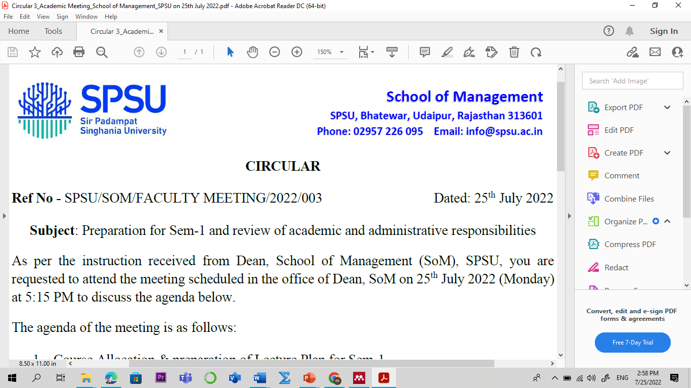
Subject: Innovative Financial Services
Branch: BBA Semester : VI
Course Code: BMF-3107 L-T-P-C : 3-0-0-3 w.e.f: 4 Jan 2023
S. No. | Topics | Contact  Hours  (Lectures)
Module 01: Introduction to Traditional Financial Services
 | Indian financial system: introduction and historical evolution of IFS |  | 01
 | Financial Services: Concept, Objectives/Functions |  | 01
 | Financial Service Market |  | 01
 | Growth of Financial Services in India |  | 01
 | Problems in Financial Services Sector |  | 01
 | Banking and Non-Banking Companies |  | 01
 | Banking and Non-Banking Companies, Regulatory Framework |  | 01
 | Factoring and Forfaiting: Introduction |  | 01
 | Types of Factoring, Theoretical Framework |  | 01
 | Advantages and Disadvantages of Factoring |  | 01
 | Factoring in India, Factoring v/s Forfaiting |  | 01
 | Bill Discounting: Introduction, Factoring V/s Bill |  | 01
Module 2: Issue Management and Securitization
 | Issue Management and Intermediaries: Introduction |  | 01
 | Merchant Bankers/ Lead Managers |  | 01
 | Overview and types of Merchants Bankers |  | 01
 | Underwriters, Bankers to an Issue |  | 01
 | Brokers to an Issue Stock Broking: |  | 01
 | Introduction, Stockbrokers, Sub Brokers, |  | 01
 | Stock Trading, Securitization overview |  | 01
 | Securitization v/s Factoring, |  | 01
Module 03: Financial Services and its Mechanism
 | Lease and Hire-Purchase: Meaning, |  | 01
 | Types of Leases - Finance Lease, Operating Lease |  | 01
23 | Advantages and Disadvantages of Leasing, Leasing in India, Legal Aspects of Leasing. |  | 01
24 | Definition of Hire Purchase, Hire Purchase and Installment Sale Characteristics |  | 01
25 | Advantages of Hire Purchase, Problems of Hire Purchase |  | 01
Module 04: Housing Finance and Consumer Finance
26 | Housing Finance: Introduction |  | 01
27 | Housing Finance in India – Growth Factors |  | 01
28 | Housing Finance Institutions in India, Fair Trade Practice Code |  | 01
29 | Consumer Finance: Introduction |  | 01
30 | Sources, Types of Products, Consumer Finance Practice  in India |  | 01
31 | Marketing and Insurance of Consumer Finance, Consumer Credit Scoring, |  | 01
Module 05: Plastic Money and Credit Rating
32 | Types of Plastic Cards- Credit card-Debit Card- Smart card- Add-on Cards |  | 01
33 | Performance of Credit Cards and Debit Cards |  | 01
34 | Prevention of Frauds and Misuse, Consumer Protection |  | 01
35 | Smart Cards- Features, Types, Security Features and Financial Applications |  | 01
36 | Credit Rating: Meaning, Origin, Features, Advantages of Rating, |  | 01
www.swayam.gov.in/www.nptel.ac.in-
Will pursue course Financial Market from Jan 2023 (if available on portal)
For Students:
- There are one mid-term examination, second midterm and one final examination.
- There should be many Quizzes to evaluate the performance of every student.
- There will be regular presentation on any topic of syllabus.
- Group assignment and group presentation in every term.
- Think-pair-share (TPS): discussion with students about relevance and learning of the video.
a. Think (4 min): state present scenario and future prospect of these topics individually.
b. Pair (3 min): Students will present his/her points to the class and final answer is concluded by the teacher (Summarization).

Evolution Criteria for the students:

- Mid-term Examination I – 20 marks
- End-term Examination – 100 marks
Text/ Reference Books
1. Financial Management, IM Pandey, Vikas Publishing House Ltd.
2. Financial Services, Khan M.Y., McGraw Hill Education.
3. Financial Services, Dr.S.Gurusamy, Financial Services, Vijay Nicole Imprints.
4. Financial Market and Services, E, Gordon and K. Natrajan, Himalaya Publishing
House.

