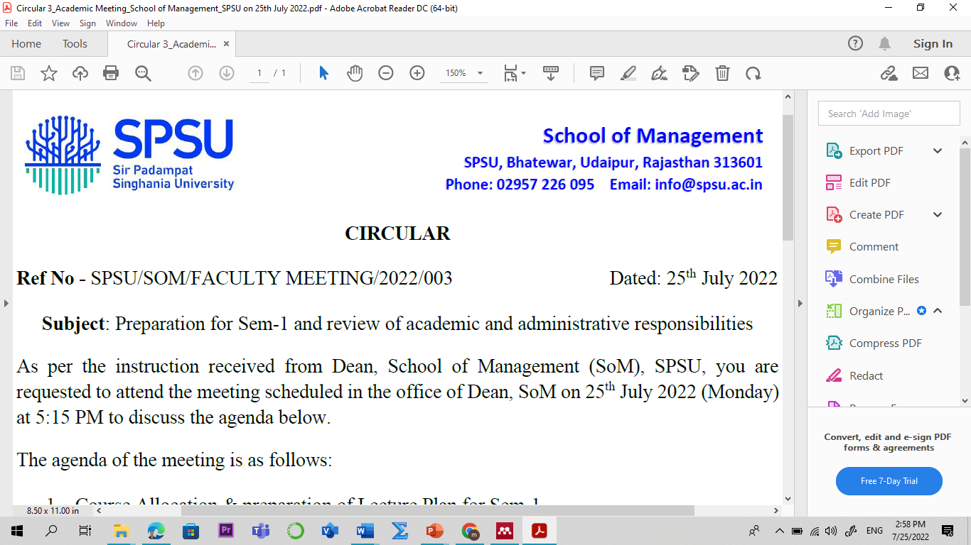
Subject: Financial Institutions & Market
Branch : BBA Semester : IV
Course Code: BMF-2105 L-T-P-C : 3-0-0-3 w.e.f: 04 Jan 2023
S. No. | Topics | Contact  Hours  (Lectures)
Module 01: Financial System
1 | Indian financial system: introduction and historical evolution of IFS |  | 01
2 | Different components of the financial system |  | 01
3 | Functions of financial system |  | 01
4 | Concept of financial markets |  | 01
5 | Role of government in financial development |  | 01
6 | Phases of Indian financial system since independence |  | 01
7 | Financial sector reforms 1991 till financial sector Legislative Reforms |  | 01
8 | Financial Institutions (Banking & Non- Banking) |  | 01
Module 02: Microfinance and Financial Regulators
9 | Financial Markets (Organized and Unorganized) Financial Assets/Instruments. |  | 01
10 | Microfinance - Conceptual Framework – Origin, Definitions |  | 01
11 | Advantages, Barriers, Microfinance Models in India. |  | 01
12 | Changing role of RBI in the financial sector |  | 01
13 | Global crisis and RBI, Ministry of Corporate Affairs, SEBI IRDAI. |  | 01
14 | Financial Institutions- Role, Classification, Role of Commercial banks |  | 01
15 | IFCI, IDBI, ICICI, SFC |  | 01
16 | Investment institutions in India (LIC, GIC) NBFC services provided by NBFC. |  | 01
17 | Specialized Financial Institutions – EXIM, NABARD, SIDBI, NHB, SIDC |  | 01
18 | SME, Rating agency of India Ltd, IIFCL, IWRFC |  | 01
Module 03: Financial Markets
20 | Indian Money Market – Meaning, Features, |  | 01
21 | Functions, Importance, Defects, Participants, Components (Organized and Unorganized) |  | 01
22 | Indian Capital Market - Meaning, Features |  | 01
23 | Functions, Importance, Participants, Instruments of capital market |  | 01
24 | Reforms in Primary and Secondary Market |  | 01
25 | Stock Indices, NSE, BSE, ADR and GDR |  | 01
Module 04: Insurance and Mutual funds
26 | Introduction of Commodity and Derivative Markets |  | 01
27 | Insurance in India |  | 01
28 | Need and types of insurance |  | 01
29 | Mutual funds: meaning, types, features |  | 01
30 | Financial System Design-Meaning, Lecture by Industry Experts |  | 01
Module 05: Managing Financial Systems Design
31 | Stakeholder Lender Conflict |  | 01
32 | Manager Stockholder conflict, Conflict Resolution |  | 01
33 | Bank oriented systems and Market oriented systems |  | 01
34 | advantages and drawbacks of financial system |  | 01
35 | Dimensions of well- functioning financial systems |  | 01
36 | Case studies, Problem-solving class/recapitulation. |  | 01
 | Total |  | 36
www.swayam.gov.in/www.nptel.ac.in-
Will pursue course Financial Market from Jan 2023 (if available on portal)
For Students:
- There are one mid-term examination, second midterm and one final examination.
- There should be many Quizzes to evaluate the performance of every student.
- There will be regular presentation on any topic of syllabus.
- Group assignment and group presentation in every term.
- Think-pair-share (TPS): discussion with students about relevance and learning of the video.
- Think (4 min): state present scenario and future prospect of these topics individually.
- Pair (3 min): Students will present his/her points to the class and final answer is concluded by the teacher (Summarization).

Evolution Criteria for the students:

- Mid-term Examination I – 20 marks
- End-term Examination – 100 marks
Text/ Reference Books
1. Financial Management, IM Pandey, Vikas Publishing House Ltd.
2. Financial Services, Khan M.Y., McGraw Hill Education.
3. Financial Services, Dr.S.Gurusamy, Financial Services, Vijay Nicole Imprints.
4. Financial Market and Services, E, Gordon and K. Natrajan, Himalaya Publishing
House.

