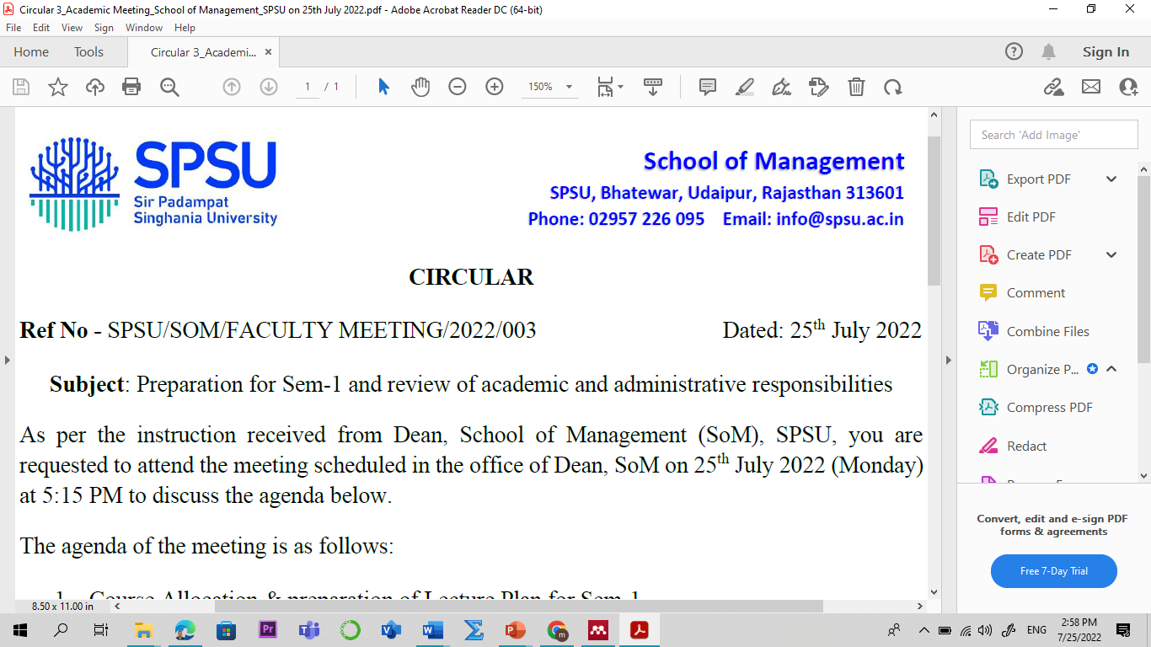
Subject : Banking & Insurance - I
Branch: B.Com Semester : VI
Course Code: BC-3010 L-T-P-C : 4-0-0-4 w.e.f: 4 Jan 2023
SN | Topics | Contact  Hours  (Lectures)
Module 01: Nationalization of Bank, RBI and NBFC
1 | Overview of banking system in India
2 | Definition of bank, banker & banking, concept | 01
3 | Growth of banking in India | 01
4 | Nationalization of banks in India | 01
5 | Reserve Bank of India, role, and its functions | 01
6 | Wealth Management in banking, | 01
7 | Emerging trends in banking | 01
8 | Structure of banking system | 01
9 | Classification of Commercial banks in India | 01
10 | Functions of Commercial banks | 01
11 | Financial & Non-financial Intermediaries | 01
Module 02: Bank Marketing, Principle of Lending
12 | Profitability & Efficiency in Indian banks | 01
13 | Bank Marketing & Positioning bank Services in the market, | 01
14 | Opportunities & challenges in bank marketing | 01
15 | Principles of lending – various credit products | 01
16 | Credit appraisal techniques and Credit monitoring | 01
17 | Meaning of NPA, types of various assets | 01
18 | Causes and NPA management in banks | 01
19 | Remedies and trends of NPA in Indian banking system | 01
Module 03: Economic Reforms in Banking and CSR
20 | Impact of globalization on Indian banking | 01
21 | Economic reforms & Efficiency of banking in India | 01
22 | Corporate Social Responsibility in banks | 01
23 | Work Culture in Indian banking, IT & Core Banking in banks | 01
24 | Global banking scenario | 01
25 | Types of risk and Risk Management in banks | 01
Module 04: Banking Operation
26 | Introduction to banking operations | 01
27 | Concept of E banking, procedure, advantages | 01
28 | Case study/recapitulation | 01
29 | New-age banking system in India | 01
30 | Fintech and its application | 01
31 | Human capital management in banks, | 01
32 | Quality circles in banks | 01
33 | Liabilities & Assets in banks, Payment & Settlement system | 01
Module 05: Introduction to Insurance
34 | Introduction to Insurance, concept | 01
35 | Need of insurance in India | 01
36 | Case study/research paper | 01
37 | Types of Insurance and utility | 01
38 | Principles of insurance | 01
39 | Functions of insurance in present context | 01
40 | Case study/research paper on insurance | 01
41 | Legal framework of insurance, | 01
42 | Distribution in bancassurance | 01
43 | Development of Insurance in India | 01
44 | Risk Management in Insurance | 01
45 | Case studies | 01
46 | Lecture by Industry Experts | 01
47 | Problem-solving class/recapitulation. | 01
48 | Presentation by the students/ interaction, case analysis/ group discussion. | 01
www.swayam.gov.in/www.nptel.ac.in-
Will pursue course Fundamentals of Banking and Insurance from Jan 2023 (if available on portal)
Flipped Classroom Activity: Topic: wealth management, non performing assets, insurance and risk management.
Flipped Classroom activity 1(FC-1)
Outside Class activity:
The video resources provided to the students for the flipped classroom activity.
S.No | Video resource | Topics covered
1 | https://www.youtube.com/watch?v=PjDClozqNAM | Wealth Management
2 | https://www.youtube.com/watch?v=JSgW-Q7zRIE | NPA of Banks
3 | https://www.youtube.com/watch?v=kz8zMwXBToA | Types of Insurance
4 | https://www.youtube.com/watch?v=Cp_XEhexcDw | Risk Management
In class Activity:
1. Discuss the outline and share video.
2. Student will come to know about wealth management, non performing assets, insurance and risk management with groups of 5 students.
3. Final analysis by teacher and solving other questions based on aforesaid topic with groups of 5 students.

4. Think-pair-share (TPS): discussion with students about relevance and learning of the video.
a. Think (4 min): state present scenario and future prospect of these topics individually.
b. Pair (3 min): Students will present his/her points to the class and final answer is concluded by the teacher (Summarization).

Evolution Criteria for the students:

- Mid-term Examination I – 20 marks
- End-term Examination – 100 marks
Texts / Reference Books
- Agarwal, O.P., Banking and Insurance, Himalaya Publishing House, New Delhi.
- Satyadevi, C., Financial Services Banking and Insurance ,S. Chand, New Delhi.
- Suneja, H.R., Practical and Law of Banking, Himalaya Publishing House, New Delhi.
- Chabra, T.N., Elements of Banking Law, Dhanpat Rai and Sons, Delhi.
- Arthur, C. and C. William Jr., Risk Management and Insurance, McGraw Hill Publication.
- Saxena, G.S; Legal Aspects of Banking Operations, Sultan Chand and Sons, Delhi.
- Varshney, P.N., Banking Law and Practice, Sultan Chand and Sons, Delhi.

