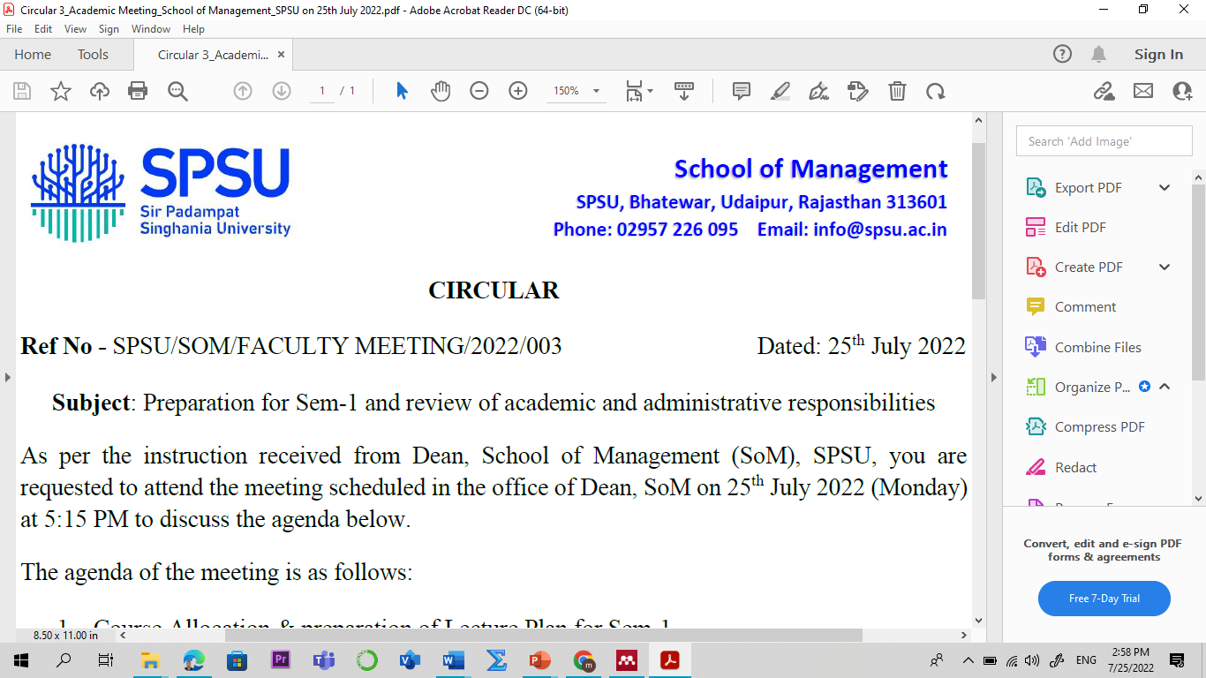

Lecture Plan

Program: B Tech

Name of the Course: Financial Literacy L-P-T-C
Credit: 02 0-0-2-0
Sem: IV (B.Tech, CC, CS and AI-ML) Academic Year: 2025-26
Faculty Member: Manish Dadhich, PhD Code: MDM2401
Contact No.: 9828142616 E-mail: manish.dadhich@spsu.ac.in

Introduction /Course Description:
This course is designed to equip students with essential knowledge and skills to manage personal finances effectively. It covers fundamental concepts such as budgeting, saving, investing, credit management, and understanding financial products like loans, insurance, and retirement plans. Students will learn to analyze financial decisions, understand the implications of debt, and navigate the complexities of financial markets. By fostering critical thinking and informed decision-making, the course empowers individuals to achieve financial stability, set financial goals, and build a secure future.

Course Objective:
To provide knowledge about the objectives, scope, and how financial literacy has evolved over a period.
- Understand financial literacy basics, financial institutions, investment principles, and budgeting.
- Learn about banking services, types of accounts, loans, and modern banking methods like e-banking.
- Explore post office savings schemes and financial services, including PPF and money transfers.
- Understand insurance policies, housing loans, and government schemes.
- Gain knowledge of personal tax structure, exemptions, deductions, and e-filing processes.

Course Outcomes (COs) & Bloom's Taxonomy:

Course Outcomes | Bloom's Taxonomy
CO1: Understand financial literacy concepts, budgeting, and investment principles. | - Remembering (K1)
CO2: Utilize banking services, loans, and cashless banking methods effectively. | - Remembering (K1)  - Knowledge (K2)
CO3: Apply post office financial services for personal financial planning. | - Remembering (K2)  - Knowledge (K3)
CO4: Select suitable insurance policies, housing loans, and government schemes. | - Apply (K3)  - Analyze (K4)
CO5: Plan personal taxes, understand exemptions, and complete e-filing. | - Apply (K3)  - Analyze (K4)
*Level of Learning- Use the number from 1 to 5 for indicating the level. Level 1- Remember & Understand, Level 2- Apply, Level 3- Analyse, Level 4- Evaluate, Level 5- Create. Mention the highest level that will be attained in the particular Course Outcome.
Course Outcome (CO) - Program Outcome (PO)/ Program Specific Outcome (PSO) Mapping
Sem | Course | CO-PO/PSO Mapping | PO1 | PO2 | PO3 | PO4 | PO5 | PO6 | PO7 | PO8 | PSO1 | PSO2 | PSO3
 | Financial | CO1 |  |  | 1 |  | 1
 | Literacy
 |  | CO2 | 1 |  |  |  |  |  |  | 2
I
 |  | CO3 |  | 1 |  |  |  | 1 |  |  | 2
 |  | CO4 |  | 2 |  | 1 | 1 |  |  | 1 |  | 2
 | (MDM2401)
 |  | CO5 |  | 3 |  | 2 | 2 |  |  |  |  | 3
Note: 1 for “Low”, 2 for “Medium” and 3 for “High”

Pedagogy
The course adopts a learner-centered approach, combining theoretical instruction with practical application. Interactive lectures and discussions provide foundational knowledge, while case studies and real-life examples enhance understanding. Hands-on activities, guest lecture such as budgeting exercises, tax planning, and the analysis of financial products, foster critical thinking and decision-making skills. Digital tools and e-resources are integrated to familiarize students with modern banking and e-filing processes. Assessments, including quizzes, assignments, and group projects, ensure comprehensive learning and practical application of financial literacy concepts.

Employability Skills Measuring Tools:
- Financial Knowledge Assessments
- Portfolio Development
- Financial Planning Projects

Suggested Readings:
Textbook/ Reference Books:
- Financial Literacy for people newly inducted into the Financial System. Reserve Bank of India, 2022, https://www.rbi.org.in/financialeducation/
- Financial Literacy Initiative undertaken by RBI, https://ncfe.org.in/stakeholders-initiatives/rbi/
- Financial Education Booklet, Securities and Exchange Board of India (SEBI), https://investor.sebi.gov.in/fem-workshop-material.html

Important Websites:
- Reserve Bank of India (RBI): https://www.rbi.org.in
- Securities and Exchange Board of India (SEBI): https://www.sebi.gov.in
- National Stock Exchange (NSE): https://www.nseindia.com
- Income Tax Department of India: https://www.incometaxindia.gov.in
- India Post: https://www.indiapost.gov.in
- Association of Mutual Funds in India (AMFI): https://www.amfiindia.com Investing.com: https://www.investing.com

Scheme of Evaluation

Assessment
Continuous Internal Assessment
Assessment Task | Frequency * Marks = Total Marks (100)
Quiz | 3*20 = 60
Assignments (Class Assignment /Home Assignments)/Case Study/ Case Discussions/ Project Work. | 1*20 = 20
Assignments (Class Assignment /Home Assignments) | 1*20 = 20

Detailed Lecture Plan:

Session No | Topics | Reading/Reference | Learning Outcome & Course Outcome (CO)
UNIT-I: Introduction
1 | Financial Literacy: Meaning and Importance | Financial Education Booklet, SEBI, https://investor.sebi.gov.in/fem-workshop-material.html, page 1-10 | Understand the concept and significance of financial literacy. (CO1, K1)
2 | Components of Financial Literacy | Financial Education Booklet, SEBI, page 11-15, Further: https://manishdadhich.gnomio.com | Identify key components of financial literacy. (CO1, K1)
3 | Financial Institutions: Meaning and Types | Financial Education Booklet, SEBI, page 16-20, Further: https://manishdadhich.gnomio.com | Distinguish between banking and non-banking financial institutions. (CO1, K2)
4 | Banking and Non-Banking Financial Institutions, | Financial Education Booklet, SEBI, page 20-29, Further: https://manishdadhich.gnomio.com | Understand the role of post offices in financial services. (CO1, K2)
5 | Investment: Meaning and Principles | Financial Education Booklet, SEBI, page 30-40, Further: https://manishdadhich.gnomio.com | Learn the principles and basics of investment. (CO1, K2)
6 | Investment vs. Gambling | Financial Education Booklet, SEBI, page 41-45, Further: https://manishdadhich.gnomio.com | Differentiate between investment and gambling. (CO1, K2)
7 | Risk and Return | Financial Education Booklet, SEBI, Further: https://manishdadhich.gnomio.com | Understand the relationship between risk and return in investments. (CO1, K2)
8 | Investment Avenues, Financial Planning and Budgets | Financial Education Booklet, SEBI, Further: https://manishdadhich.gnomio.com | Explore various investment avenues available. (CO1, K2)
9 | Introduction, Budget Deficit and Surplus | Financial Education Booklet, SEBI, Further: https://manishdadhich.gnomio.com | Understand the basics of financial planning and budgets. (CO1, K2)
UNIT-II: Banking
10 | Meaning and Types of Banks | Financial Literacy, https://www.rbi.org.in/financialeducation/, page 2-12, Further: https://manishdadhich.gnomio.com | Understand the structure and types of banks. (CO2, K1)
11 | Services Offered by Banks | Financial Literacy, https://www.rbi.org.in/financialeducation/, page 2-12, Further: https://manishdadhich.gnomio.com | Learn about various banking services. (CO2, K2)
12 | Types of Bank Deposit Accounts | Financial Literacy, https://www.rbi.org.in/financialeducation/, page 2-12, Further: https://manishdadhich.gnomio.com | Distinguish between types of deposit accounts. (CO2, K2)
13 | Opening Bank Accounts and KYC Norms | Financial Literacy, https://www.rbi.org.in/financialeducation/, page 2-12, Further: https://manishdadhich.gnomio.com | Understand formalities for account opening and KYC requirements. (CO2, K3)
14 | Loans: Short-term, Medium-term, Long-term | Financial Literacy, https://www.rbi.org.in/financialeducation/, page 2-12, Further: https://manishdadhich.gnomio.com | Learn about different types of loans and their uses. (CO2, K2)
15 | Cashless Banking and E-Banking | Financial Literacy, https://www.rbi.org.in/financialeducation/, page 2-12, Further: https://manishdadhich.gnomio.com | Explore modern banking methods like e-banking and cashless transactions. (CO2, K3)
16 | Banking Complaints and Grievance Redressal | Textbook, Chapter 6 Further: https://manishdadhich.gnomio.com | Learn to address banking complaints and grievance mechanisms. (CO2, K2)
UNIT-III: Financial Services from Post Office
17 | Post Office Savings Schemes: Overview | Financial Literacy, https://www.rbi.org.in/financialeducation/, page 2-12, Further: https://manishdadhich.gnomio.com | Understand the various savings schemes offered by post offices. (CO3, K2)
18 | Term Deposits, Recurring Deposits, Monthly Income Schemes | Financial Literacy, https://www.rbi.org.in/financialeducation/, page 2-12, Further: https://manishdadhich.gnomio.com | Learn about term deposits and recurring deposit options. (CO3, K2)
19 | NPS, NSC, and PPF | Financial Literacy, https://www.rbi.org.in/financialeducation/, page 2-12, Further: https://manishdadhich.gnomio.com | Explore the benefits of KVP, NSC, and PPF schemes. (CO3, K2)
20 | Sukanya Samriddhi Yojana and Senior Citizen Savings Scheme | Financial Literacy, https://www.rbi.org.in/financialeducation/, page 2-12, Further: https://manishdadhich.gnomio.com | Understand the features and benefits of these specific schemes. (CO3, K2)
21 | Indian Post Payments Bank | Financial Literacy, https://www.rbi.org.in/financialeducation/, page 2-12, Further: https://manishdadhich.gnomio.com | Understand the features post payment banks. (CO3, K2)
UNIT-IV: Insurance Services
22 | Life Insurance: Meaning and Policies | Financial Literacy, https://www.rbi.org.in/financialeducation/, page 2-12, Further: https://manishdadhich.gnomio.com | Learn the basics of life insurance policies and their benefits. (CO4, K1)
23 | Term Insurance vs. Endowment Policies | Financial Literacy, https://www.rbi.org.in/financialeducation/, page 2-12, Further: https://manishdadhich.gnomio.com | Compare term insurance and endowment policies. (CO4, K2)
24 | General Insurance: Property and Health Insurance | Financial Literacy, https://www.rbi.org.in/financialeducation/, page 2-12, Further: https://manishdadhich.gnomio.com | Understand general insurance types and their importance. (CO4, K2)
25 | Housing Loans and types | Financial Literacy, https://www.rbi.org.in/financialeducation/, page 2-12, Further: https://manishdadhich.gnomio.com | Learn about housing loans and government housing schemes. (CO4, K3)
26 | Pradhanmantri Awas Yojana: Rural and Urban. | https://pmay-urban.gov.in/ Further: https://manishdadhich.gnomio.com | Learn about housing loans and government housing schemes. (CO4, K3)
UNIT-V: Tax
27 | Introduction to Personal Tax Structure in India | https://taxsummaries.pwc.com/india/individual/taxes-on-personal-income#:~:text=Taxation%20of%20individuals%20in%20India,tax%20year%20and%20past%20years. | Understand the basics of the Indian personal tax system. (CO5, K1)
28 | Exemptions and Deductions for Individuals | https://taxsummaries.pwc.com/india/individual/taxes-on-personal-income#:~:text=Taxation%20of%20individuals%20in%20India,tax%20year%20and%20past%20years. | Learn about exemptions and deductions to optimize tax planning. (CO5, K2)
29 | E-Filing Process | Online Resource: https://www.incometaxindiaefiling.gov.in | Gain hands-on experience in e-filing personal taxes. (CO5, K3)
30 | Recapitulation/Seminar/ presentation | - | -

Students' Interaction Time: Friday (04:30 PM – 05:30 PM)
Thursday (04:30 PM – 05:30 PM)

