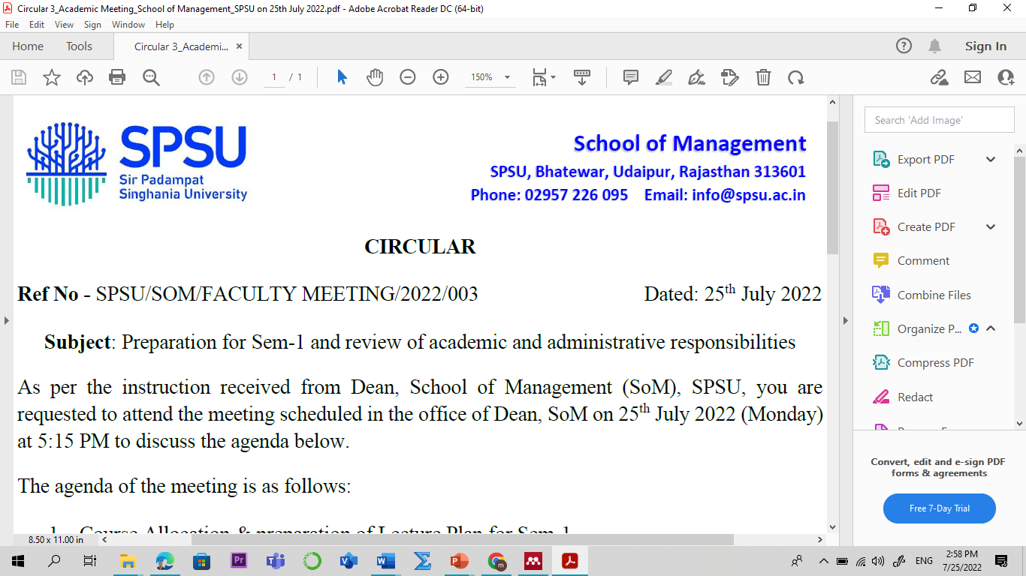

Lecture Plan

Program: MBA

Name of the Course: Financial Management L-P-T-C
Credit: 03 3-0-0-3
Sem: I Academic Year: 2025-26
Faculty Member: Manish Dadhich, PhD Code: MGM4203
Contact No.: 9828142616 E-mail: manish.dadhich@spsu.ac.in

Introduction /Course Description:

Financial Management is a fundamental discipline for effective business operations and strategic decision-making. This course provides a comprehensive overview of financial principles, including financial analysis, investment strategies, capital structure, and risk management. Through interactive learning modules and practical exercises, students will gain the skills to interpret financial data, evaluate investment opportunities, optimize capital usage, manage working capital effectively, and navigate ethical and global financial challenges. Ideal for business students and professionals alike, this course equips participants with the tools and knowledge to drive financial stability and growth in any organization.
Course Objective:
To provide knowledge about the objectives, scope, and how financial Management has evolved over a period of time.
- Understand the objectives and functions of financial Management and regulatory systems.
- Develop the ability to estimate and manage working capital components like inventory, receivables, and cash for efficient operations.
- Apply capital budgeting techniques to evaluate investment opportunities and make strategic long-term financial decisions.
- Analyze various sources of finance and design optimal capital structures using theories of capital structure and financial planning tools.
- Examine the impact of leverage on a firm’s cost of capital and evaluate dividend decision models to optimize shareholder value.

Course Outcomes (COs) & Bloom's Taxonomy:

Course Outcomes | Bloom's Taxonomy
CO1: To develop students' knowledge and understanding of financial Management and investment decision-making. | - Remembering (K1)  - Knowledge (K2)
CO2: To explain the components and importance of working capital management. | - Remembering (K1)  - Knowledge (K2)
CO3: To apply and comprehend capital budgeting techniques to evaluate investment opportunities. | - Remembering (K2)  - Knowledge (K3)
CO4: To analyze sources of Finance and apply capitalization theory. | - Apply (K3)  - Analyze (K4)
CO5: To analyze capital structure planning, leverage and dividend policies for financial decisions. | - Apply (K3)  - Analyze (K4)
*Level of Learning- Use the number from 1 to 5 for indicating the level. Level 1- Remember & Understand, Level 2- Apply, Level 3- Analyse, Level 4- Evaluate, Level 5- Create. Mention the highest level that will be attained in the particular Course Outcome.
Course Outcome (CO) - Program Outcome (PO)/ Program Specific Outcome (PSO) Mapping
Sem | Course | CO-PO/PSO Mapping | PO1 | PO2 | PO3 | PO4 | PO5 | PO6 | PO7 | PO8 | PSO1 | PSO2 | PSO3
 | Financial Management | CO1 |  |  | 1 | 1 | 1
 | Management
 |  | CO2 | 1 |  | 1 |  | 2 |  |  | 2
I
 |  | CO3 | 1 |  | 2 | 1 |  | 1 |  |  | 2
 |  | CO4 |  | 2 |  | 1 | 1 |  |  | 1 |  | 2
 | (MGM4203)
 |  | CO5 |  | 3 |  | 4 | 4 |  |  |  | 3
Note: 1 for “Low”, 2 for “Medium” and 3 for “High”

Pedagogy
The pedagogy of this course emphasizes a blend of theoretical understanding and practical application to ensure comprehensive learning. Through interactive lectures, case studies, and real-world examples, students will engage deeply with financial management concepts. Practical exercises like financial statement analysis and investment simulations will allow students to apply theoretical knowledge to real-life scenarios. Group discussions and peer collaboration foster critical thinking and enhance problem-solving skills. Ethical dilemmas and global perspectives are integrated into the curriculum to prepare students for navigating diverse financial environments responsibly. Continuous assessment and feedback ensure students grasp key concepts effectively, equipping them with the skills and confidence to excel in financial decision-making roles.

Employability Skills Measuring Tools:
- Critical Thinking and Problem Solving
- Managerial competitive skill (assignment on contemporary issues).
- Portfolio Assessment

Suggested Readings:
Textbook/ Reference Books:
- Pandey I. M. Financial Management. Vikas Publishing, 11th Edition. 2023.
- Rustagi R.P. Fundamentals of Financial Management. Taxman, 14th Edition. 2021.
- Kishore, Ravi M. Financial Management. Taxman’s, 8th Edition, 2022.
- Khan, M.Y., & Jain, P.K. Financial Management: Text, Problems and Cases Mc Graw Hill Publication, 8th Edition. 2021.
- Maheshwari S.N. Financial Management: Principles and Practice Sultan Chand and Sons, 5th Edition. 2019.

Important Websites:
- Investopedia: www.investopedia.com
- Financial Times: www.ft.com
- Bloomberg: www.bloomberg.com
- Yahoo Finance: finance.yahoo.com
- Morningstar: www.morningstar.com
- SEC EDGAR: www.sec.gov/edgar.shtml
- Wall Street Journal: www.wsj.com
- Financial Management Association International: www.fma.org
- CFA Institute: www.cfainstitute.org
- Harvard Business Review - Finance: hbr.org/topic/financeESG Investing and Analysis (cfainstitute.org)

Scheme of Evaluation

Assessment |  | Weightage (in %)
Continuous Internal Assessment |  | 40
Assessment Task | Frequency * Marks = Total Marks (100) | Weightage for individual Component
Mid-Term Examination – I and II | 2*20 = 40 | 16
Quiz | 3*10 = 30 | 12
Assignments (Class Assignment /Home Assignments)/Case Study/ Case Discussions/ Project Work. | 1*10 = 10 | 4
Assignments (Class Assignment /Home Assignments) | 1*10 = 10 | 4
Attendance | 10 | 4
External Assessment |  | 60
End Term Examination | 1*60 | 60

Detailed Lecture Plan:

Session No | Topics | Reading/Reference | Learning Outcome & Course Outcome (CO)
UNIT-I: Introduction to Financial Management
1 | Overview of Financial Management | Textbook, Chapter 1, pp. 1-4 (Financial Management:  by V Sharan, Pearson) | Remember and understand financial Management.  (CO1, K1, K2)
2 | Meaning, definition, and nature of financial Management | Textbook, Chapter 1, pp. 5-8. Further: https://manishdadhich.gnomio.com | Comprehend the meaning, definition, and nature of financial Management.  (CO1, K1 & K2)
3 | Introduction to finance functions in the present context. | Textbook, Chapter 1, pp. 9-11. Further: https://manishdadhich.gnomio.com | Understand finance functions in the present context.  (CO1, K2)
4 | Objectives of financial Management- profitability vs. shareholder wealth maximization | Textbook, Chapter 1, pp. 11-13. Further: https://manishdadhich.gnomio.com | Comprehend objectives of financial Management- profitability vs. shareholder wealth maximization.  (CO1, K1)
5 | Indian Financial system- Functions of the financial system | Book, Chapter 1, Investment Management, Prof. sandeep kour tandon, Directorate of Distance Education  University of Jammu, Further: https://manishdadhich.gnomio.com | Know the Indian financial system and its functions.  (CO1, K2)
6 | Financial Assets; Financial markets; Financial intermediaries | Book, Chapter 1, Investment Management, Prof. sandeep kour tandon, University of Jammu, Further: https://manishdadhich.gnomio.com | Understand Financial Assets, Financial markets, Financial intermediaries.  (CO1, K2)
7 | Regulatory system | Book, Chapter 2, Investment Management, Prof. sandeep kour tandon, University of Jammu, Further: https://manishdadhich.gnomio.com | Understand the financial regulatory system in India.  (CO1, K2)
8 | Financial Analysis performance analysis using Ratio. | Book, Chapter 3, Investment Management, Prof. sandeep kour tandon, University of Jammu, Further: https://manishdadhich.gnomio.com | Understand financial Analysis performance analysis using ratio.  (CO1, K2)
9 | Quiz 1: Financial Management, objective and financial system | Further: https://manishdadhich.gnomio.com | Understand the concept of financial Management, and new-age objectives.  (CO1, K2)
UNIT-II: Working Capital Management
10 | Understanding of various concepts of working capital. | Textbook, Chapter 8, pp. 139-141. Further: https://manishdadhich.gnomio.com | Understand and analyze various concepts of working capital.  (CO5, K2)
11 | Approaches to the financing of current assets. | Textbook, Chapter 8, pp. 142-143. Further: https://manishdadhich.gnomio.com | Acquaint and analyze various approaches to the financing of current assets.  (CO5, K3)
12 | Management of different components of working capital. | Textbook, Chapter 8, pp. 144-146. Further: https://manishdadhich.gnomio.com | Analyze and review Management of different components of working capital.  (CO5, K3, K3)
13 | Management of Cash, types and purpose. | Textbook, Chapter 9, pp. 155-165. Further: https://manishdadhich.gnomio.com | Understand and analyze the Management of cash, its types, and its purpose.  (CO5, K2, K3)
14 | Overview of receivables management and its relevance. | Textbook, Chapter 10, pp. 175-184. Further: https://manishdadhich.gnomio.com | Analyze receivables management and its relevance.  (CO5, K2, K3)
15 | Types of inventory management techniques and their limitations. | Textbook, Chapter 11, pp. 196-200. Further: https://manishdadhich.gnomio.com | Analyze inventory management and its importance.  (CO5, K2, K3)
16 | Meaning and importance of financial planning | Textbook, Chapter 13, pp. 260. Further: https://manishdadhich.gnomio.com | Understand the meaning and importance of financial planning.  (CO5, K2)
17 | Approaches to financial planning | Textbook, Chapter 13, pp. 260. Further: https://manishdadhich.gnomio.com | Apply and analyze approaches to financial planning.  (CO5, K2)
18 | Analysis of Income Statement and Balance Sheet Computation of external financing requirements. | https://www.investopedia.com/terms/f/financial-statement-analysis.asp https://manishdadhich.gnomio.com | Analyze financial statements and their external requirements.  (CO5, K2)
19 | Quiz 2: Working Capital Management and financial planning. | https://manishdadhich.gnomio.com | Understand and evaluate the understanding of Working Capital Management and financial planning.  (CO5, K2)
UNIT-III: Capital Budgeting
20 | Investment decisions using capital budgeting. | Textbook, Chapter 5, pp. 75-80. Further: https://manishdadhich.gnomio.com | Discuss investment decisions using capital budgeting.  (CO2, K1, K2)
21 | Payback, NPV approach, feasibility analysis with sensitivities, | Textbook, Chapter 5, pp. 80-90. Further: https://manishdadhich.gnomio.com | Analyze and appraise payback, NPV approach.  (CO2, K1, K2)
22 | IRR and ARR methods, practical applications. | Textbook, Chapter 5, pp. 90-98. Further: https://manishdadhich.gnomio.com | Analyze IRR, ARR methods and their practical applications.  (CO2, K1, K3)
23 | Practical applications on NPV, IRR and ARR | Textbook, Chapter 5, pp. 90-98. Further: https://manishdadhich.gnomio.com | Analyze IRR, ARR methods and their practical applications.  (CO2, K2, K3)
24 | Understand the significance of capital budgeting in the real-world scenario. | Textbook, Chapter 5, pp. 101. Further: https://manishdadhich.gnomio.com | Understand the significance of capital budgeting in the real-world scenario.  (CO2, K1, K3)
25 | Quiz-3 and analysis | Further: https://manishdadhich.gnomio.com | Understand and analyze capital budgeting, TVM and applications.  (CO2, K3, K4)
UNIT-IV: Sources of Finance, Capitalization theory
26 | Sources of Finance, short term and long term, Case study: ICICI prudential retirement plan | Textbook: Chapter 2, pp.24-27. Further: https://manishdadhich.gnomio.com | Understand the concept of time value of money.  (CO1, K2)
27 | Theory of capital structure and its relevance | Textbook, Chapter 7, pp. 151. Further: https://manishdadhich.gnomio.com | Acquaint with Theory of capital structure.  (CO2, K3, K4)
28 | Overview of Net income approach, Practical problem | Textbook, Chapter 5, pp. 161. Further: https://manishdadhich.gnomio.com | Understand the concept of Net income approach  (CO2, K3, K4)
29 | Overview of Net operating income approach, Practical problem | Textbook, Chapter 5, pp. 165. Further: https://manishdadhich.gnomio.com | Acquaint Net operating income approach.  (CO2, K3, K4)
30 | MM approach; Traditional approach, Practical problem | Textbook, Chapter 5, pp. 170. Further: https://manishdadhich.gnomio.com | Know MM approach, Traditional approach.  (CO2, K3, K4)
31 | Capital Structure Planning and Designing. | Textbook, Chapter 5, pp. 174. Further: https://manishdadhich.gnomio.com | Acquaint with Capital Structure Planning and Designing.  (CO2, K3, K4)
32 | EBIT and EPS/MPS approach, Factors affecting capital structure. | Textbook, Chapter 6, pp. 184. Further: https://manishdadhich.gnomio.com | EBIT and EPS/MPS approach, Factors affecting capital structure.  (CO2, K3, K4)
UNIT-V: Capital Structure Planning and Leverage Analysis
33 | Meaning, nature and importance of Cost of capital. | Textbook, Chapter 7, pp. 124-128. Further: https://manishdadhich.gnomio.com | Acquaint with the meaning, nature, and importance of the cost of capital.  (CO3, K1, K2)
34 | Types of Cost of capital. Analysis of WACC. | Textbook, Chapter 7, pp. 128-132. Further: https://manishdadhich.gnomio.com | Understand various types of cost of capital.  (CO3, K1, K2)
35 | Overview of Kd, Ke, Kd and Kr | Further: https://manishdadhich.gnomio.com | Understand and appraise the cost of capital.  (CO3, K1, K2)
36 | Determinants of capital structure. | Textbook, Chapter 14, pp. 235-240. Further: https://manishdadhich.gnomio.com | Understand the vital determinants of capital structure.  (CO2, K2)
37 | Capital structure theories. | Textbook, Chapter 14, pp. 240-250. Further: https://manishdadhich.gnomio.com | Understand various theories of capital structure.  (CO2, K2)
38 | Introduction to Dividend Policy | Textbook, Chapter 17, pp. 301-304. Further: https://manishdadhich.gnomio.com | Understand the concept and relevance of dividend decisions.  (CO4, K2, K3)
39 | Types of dividends and factors | Textbook, Chapter 17, pp. 305-310. Further: https://manishdadhich.gnomio.com | Analyze various types of dividends and their impact on profitability.  (CO4, K3, K4)
40 | Dividend theory- Walter Model | Textbook, Chapter 17, pp. 310-315. Further: https://manishdadhich.gnomio.com | Review and analyze dividend theory- Walter Model.  (CO5, K3, K4)
41 | Dividend theory- Gordon Model, MM Hypothesis and its relevance | Textbook, Chapter 17, pp. 315-320. Further: https://manishdadhich.gnomio.com | Analyze and review dividend theory- Gordon Model  (CO5, K3, K4)
42 | Leverage Analysis, types and implications | Textbook, Chapter 17, pp. 321-322. Further: https://manishdadhich.gnomio.com | Analyze and review various types of leverage and its relevance.  (CO5, K3, K4)
43 | Operating, Financial and mixed leverage | Further: https://manishdadhich.gnomio.com | Analyze and appraise various leverages to magnify the profit.  (CO5, K3, K4)
44 | Recapitulation/Seminar/ presentation | Further: https://manishdadhich.gnomio.com | -
45 | Recapitulation/Seminar/ presentation | Further: https://manishdadhich.gnomio.com | -

Students' Interaction Time: Friday (04:30 PM – 05:30 PM)
Thursday (04:30 PM – 05:30 PM)

