**Product Life-Cycle Theory of International Trade**

The product life-cycle theory was developed by Raymond Vernon in the mid-1960s. The theory presents an insightful analysis as to why in the twentieth century a large number of new products in the world were developed by the US firms and sold first in the US market.

Vernon pointed out that many manufactured foods, like automobiles, televisions, instant cameras, photocopiers, personal computers, semi-conductor chips, etc. go through a continuum or cycle that consists of introduction, growth, maturity, and decline stages. The location of production will shift to serve markets according to the stage of cycle a product is therein.

**Stage 1: Introduction:**

Most **innovations** take place where there is a nearby observed need and market for them. A Japanese company will develop a new product for Japanese market and a US company for the US market. The introductory phase is characterised by high expenditures (on market research, market testing, cost of launch, etc.) and possibly by financial losses.

Young, better educated and more affluent sections of society are always attracted by novelties. The early production occurs in home location for the reason that manufactures want to be near to a home market to get consumer feedback and also to save on transport cost.

Technology is the tool to produce new products or to produce old products in new ways. Experimentation and improvement in design and manufacturing requires scientific and engineering inputs along with venture capital. Thus, production is possible only in industrialised countries.

**Stage 2: Growth:**

Over the time, market grows and enters the second stage called ‘growth’. Overseas demand grows. Competitors enter the market. Increase in demand may lead to foreign production in industrialised countries only, where the demand has gone up. At this stage production outside innovator-country would be sold in the producing country only (say Japan is the producing country and the US is the innovator).

This is so because the demand is high in Japanese market, the product will be molded according Japanese liking and the cost of production due to start up is likely to be high. There is incentive to improve production process at this stage, but due to variations in the product at home and abroad, the process still remains labor-intensive (but less than the first stage).

**Stage 3: Maturity:**

As the market in advanced countries mature, product and the process get standardised and price becomes the important competitive strategy. Due to intense competition, the production bases start moving down. Exporter-nations, thus, become importers. Capital intensity increases. The need for skilled labor is replaced by using low-skilled and semi-skilled labor. In the case of Weikfield India, a company owned by Malhotras, earlier used to import custards powder from the UK and Australia, now export to the US and Canada.

**Stage 4: Decline:**

With the saturation of market, the product enters the ‘decline’ stage. The production bases shift entirely too low-cost nations, like Asian industrializing economies. Over the life-cycle, production has moved from innovator-country to other industrialised countries to developing countries. The innovating-country becomes the importer. The pressure on high-income countries is to turn toward innovation of new products which starts the cycle over again.

**[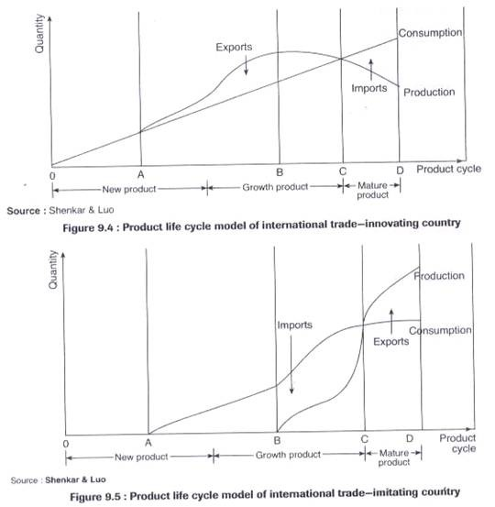](http://www.shareyouressays.com/wp-content/uploads/hindi/What-is-the-Importance-of-Product-Life-C_E55D/clip_image002.jpg)**