**Competitive**[**environment**](https://ceopedia.org/index.php/Environment)

**Competitive**[**environment**](https://ceopedia.org/index.php/Environment) of [organization](https://ceopedia.org/index.php/Organization) is made up of all competitive or cooperative relationships. Organizations may facilitate the positive or negative (harming) activities towards each another. The competitive environment thus includes suppliers, customers, competitors, associations and chambers of [industry](https://ceopedia.org/index.php/Industry), research institutes, [clusters](https://ceopedia.org/index.php/Cluster), etc.

**Competitive Strategies:** The purpose of the analysis of the competitive environment is:

* Estimate the attractiveness of the sector for companies that already operate in it, and for the new entrants or investors,
* Determine the prospects of individual sectors, [opportunities and threats](https://ceopedia.org/index.php/Opportunities_and_threats)
* Definition of new, attractive sectors for the [company](https://ceopedia.org/index.php/Company) in which it could invest.

**Michael Porter’s Five Forces Analyses**

In 1979, Michael Porter, a Harvard economist specializing in industrial organization, wrote a Harvard Business Review article entitled "How Competitive Forces Shape Strategy." It's still the best source on the subject of economic market competition. Not many economics articles remain current for four decades, and most that do were written by Nobel Prize winners.

Porter recognized that organizations likely keep a close watch on their rivals, but he encouraged them to look beyond the actions of their competitors and examine what other factors could impact the business environment. He identified five forces that make up the competitive environment, and which can erode your profitability. These are:

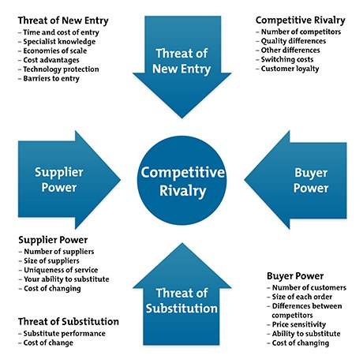

1. **Competitive Rivalry.** This looks at the number and strength of your competitors. How many rivals do you have? Who are they, and how does the quality of their products and services compare with yours?

Where rivalry is intense, companies can attract customers with aggressive price cuts and high-impact marketing campaigns. Also, in markets with lots of rivals, your suppliers and buyers can go elsewhere if they feel that they're not getting a good deal from you.

On the other hand, where competitive rivalry is minimal, and no one else is doing what you do, then you'll likely have tremendous strength and healthy profits.

1. **Supplier Power.** This is determined by how easy it is for your suppliers to increase their prices. How many potential suppliers do you have? How unique is the product or service that they provide, and how expensive would it be to switch from one supplier to another?

The more you have to choose from, the easier it will be to switch to a cheaper alternative. But the fewer suppliers there are, and the more you need their help, the stronger their position and their ability to charge you more. That can impact your profit.

1. **Buyer Power.** Here, you ask yourself how easy it is for buyers to drive your prices down. How many buyers are there, and how big are their orders? How much would it cost them to switch from your products and services to those of a rival? Are your buyers strong enough to dictate terms to you?

When you deal with only a few savvy customers, they have more power, but your power increases if you have many customers.

1. **Threat of Substitution.** This refers to the likelihood of your customers finding a different way of doing what you do. For example, if you supply a unique software product that automates an important process, people may substitute it by doing the process manually or by outsourcing it. A substitution that is easy and cheap to make can weaken your position and threaten your profitability.
2. **Threat of New Entry.** Your position can be affected by people's ability to enter your market. So, think about how easily this could be done. How easy is it to get a foothold in your industry or market? How much would it cost, and how tightly is your sector regulated?