**Sun-rise Sectors of Indian Economy**

Introduction

India is the fastest growing large economy in the world, with an enormous population, favourable demographics and high catch-up potential due to low initial GDP per head.

As per the World Bank data, in 2017, India became the sixth largest economy with a GDP of USD 2.59 trillion, relegating France to the seventh position.

India is likely to surpass the United Kingdom in the world's largest economy rankings in 2019, according to a report by global consultancy firm PwC.

[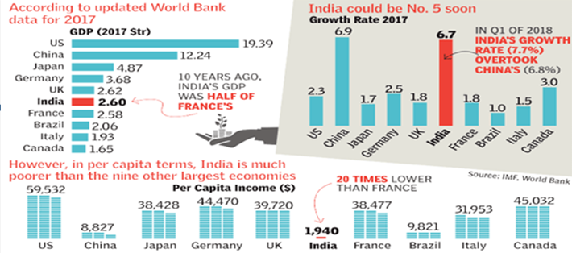](https://www.drishtiias.com/images/uploads/1578483675_image49.png)

1. According to World Economic Outlook report of IMF, India's economy is expected to grow by 7.5 per cent in the 2019-20 fiscal year, keeping an upward trajectory as the rest of the world slumps.
2. According to report "India's economy is poised to pick up in 2019, benefiting from lower oil prices and a slower pace of monetary tightening than previously expected, as inflation pressures ease," the report said.
3. As per Central Statistics Office (CSO), Ministry of Statistics and Programme Implementation (MOSPI), the growth in GDP during 2018-19 is estimated at 7.2 percent as compared to the growth rate of 6.7 per cent in 2017-18.

Economic Sectors

* Economic activities result in the production of goods and services while sectors are the group of economic activities classified on the basis of some criteria.
* The Indian economy can be classified into various sectors on the basis of ownership, working conditions and the nature of the activities.
* All economic activity was in the primary sector during early civilisation. After the surplus production of food, people’s need for other products increased which led to the development of the secondary sector.
* The growth of secondary sector spread its influence during the industrial revolution in the nineteenth century.
* A support system was needed to facilitate the industrial activity. Certain sectors like transport and finance played an important role in supporting the industrial activity.

[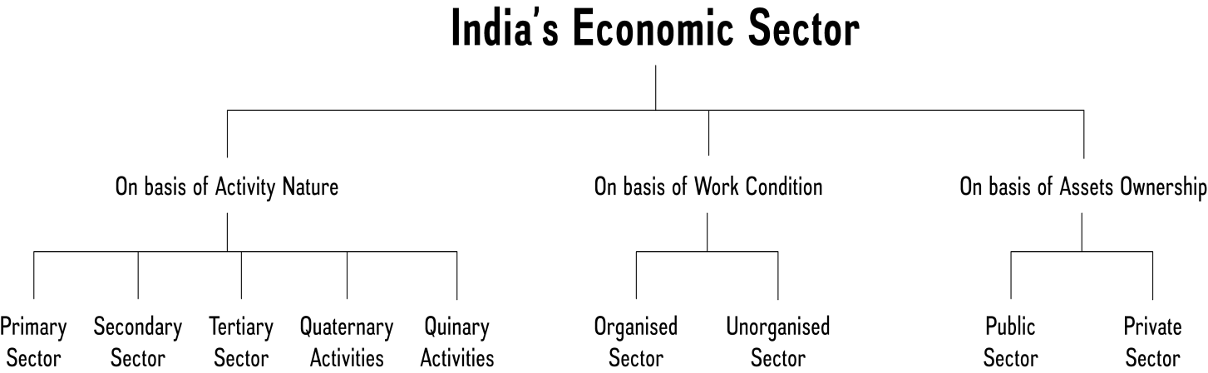](https://www.drishtiias.com/images/uploads/1578483780_image15.png)

**Primary Sector**

In Primary sector of economy, activities are undertaken by directly using natural resources. Agriculture, Mining, Fishing, Forestry, Dairy etc. are some examples of this sector. It is called so because it forms the base for all other products. Since most of the natural products we get are from agriculture, dairy, forestry, fishing, it is also called Agriculture and allied sector. People engaged in primary activities are called red-collar workers due to the outdoor nature of their work.

**Secondary Sector**

It includes the industries where finished products are made from natural materials produced in the primary sector. Industrial production, cotton fabric, sugar cane production etc. activities comes under this sector.

Hence its the part of a country's economy that manufactures goods, rather than producing raw materials Since this sector is associated with different kinds of industries, it is also called industrial sector.

People engaged in secondary activities are called blue collar workers.

**Examples of manufacturing sector:**

Small workshops producing pots, artisan production.

Mills producing textiles,

Factories producing steel, chemicals, plastic, car.

Food production such as brewing plants, and food processing.

Oil refinery.

Core Industries

Eight Core Industries are Electricity, steel, refinery products, crude oil, coal, cement, natural gas and fertilizers. The Index of Eight Core Industries is a monthly production index, which is also considered as a lead indicator of the monthly industrial performance. The Index of Eight Core Industries is compiled based on the monthly production information received from the Source Agencies.

**Tertiary Sector/Service Sector**

This sector’s activities help in the development of the primary and secondary sectors. By itself, economic activities in tertiary sector do not produce a goods but they are an aid or a support for the production.

Goods transported by trucks or trains, banking, insurance, finance etc. come under the sector. It provides the value addition to a product same as secondary sector.

This sector jobs are called white collar jobs.

**Pink Collar Worker**

Pink-collar worker is one who is employed in a job that is traditionally considered to be women's work. The term pink-collar worker was used to distinguish female-orientated jobs from the blue-collar worker, a worker in manual labor, and the white-collar worker, a professional or educated worker in office positions.

A pink collar worker need not require as much professional training as white-collar professions. They do not get equal pay or prestige.

A pink collar worker is usually a woman. Men rarely work in pink collar jobs. Some examples of pink collar occupations are baby sitter, florist, day care worker, nurses etc.

Lately, the pink collar worker is educated or trained. Pink collar workers are educated through training seminars or classes and they have to continue to strive for advancement in their careers.

Today, women have more opportunities in traditionally male white-collar jobs and men work in traditionally female pink-collar jobs.

**Sunrise Industry**

Sunrise industry is a term used for a sector that is just in its infancy but shows promise of a rapid boom.The industry is typically characterized by high growth rates, high degree of innovation and generally has plenty of public awareness about the sector and investors get attracted to its long-term growth prospects.

On the other hand Sunrise industry rapid emergence may threaten a competing industry sector that is already in decline. Because of its dim long-term prospects, such an industry is referred to as a sunset industry.

**Existing Indian sectors that can be termed as Sunrise sectors and likely to hold us in good stead in the future in terms of employment generation and business growth are:**

**Information Technology**

**Telecom Sector**

**Healthcare**

**Infrastructure Sector**

**Retail Sector**

**Food Processing Industries**

**Fisheries**

**Why did India shift from primary sector to services sector and not secondary sector?**

The natural economic movement of a country goes from agrarian economy to an industrial economy to a service economy but India has leapfrogged from an agrarian economy to a service economy.

One remarkable feature of India’s recent growth is diversification into services, with the services sector dominating GDP. India’s success in software and IT-enables serviced (ITeS) exports, has made it a significant services exporter with its share in world services exports rising from 0.6 per cent in 1990 to 3.3 per cent in 2013.

human resources, Fluency in English and availability of cheap labour are other reasons for rapid growth of service sector in the country. On the other hand low growth in Secondary sector can be attributed to:

The license Raj

**Restrictions on foreign investment**

Lack of measures to promote private industry

Power Deficit

Stringent Labour laws

Lack of skilled labour

Delays in Land Acquisition and environmental clearances

Import of cheap manufactured goods etc.

Though India ranks low in terms of per capita income, its share of services in GDP is approaching the global average. Interestingly, however, the contribution of services to employment was significantly lower than the world average.

The manufacturing sector tends to be labour intensive, hence renewed emphasis on the manufacturing through programmes like ‘Make in India’ will serve to correct this anomaly and raise employment in proportion with growth in GDP.

**Quaternary Activities**

These are specialized tertiary activities in the ‘Knowledge Sector’ which demands a separate classification.

The quaternary sector is the intellectual aspect of the economy. It is the process which enables entrepreneurs to innovate and improve the quality of services offered in the economy.

Personnel working in office buildings, elementary schools and university classrooms, hospitals and doctors’ offices, theatres, accounting and brokerage firms all belong to this category of services.

Like other tertiary functions, quaternary activities can also be outsourced.

**Quinary Activities**

The quinary sector is the part of the economy where the top-level decisions are made. This includes the government which passes legislation. It also comprises the top decision-makers in industry, commerce and also the education sector.

These are services that focus on the creation, re-arrangement and interpretation of new and existing ideas; data interpretation and the use and evaluation of new technologies.

Profession under this category often referred as 'gold collar' professions, they represent another subdivision of the tertiary sector representing special and highly paid skills of senior business executives, government officials, research scientists, financial and legal consultants, etc.

**Organised Sector**

In this sector, employment terms are fixed and regular, and the employees get assured work and social security.

It can also be defined as a sector, which is registered with the government and a number of acts apply to the enterprises. Schools and hospitals are covered under the organised sector.

Workers in the organised sector enjoy security of employment. They are expected to work only a fixed number of hours. If they work more, they have to be paid overtime by the employer.

**Unorganised Sector**

An unorganised worker is a home-based worker or a self-employed worker or a wage worker in the unorganized sector and includes a worker in the organized sector who is not covered by any of the Acts pertaining to welfare Schemes as mentioned in Schedule-II of Unorganized Workers Social Security Act, 2008.

In this sector wage-paid labour is largely non-unionised due to casual and seasonal nature of employment and scattered location of enterprises.

The sector is marked by low incomes, unstable and irregular employment, and lack of protection either from legislation or trade unions.

**The Public Sector**

In the sector, government owns most of the assets and it is the part of the economy concerned with providing various governmental services.

The purpose of the public sector is not just to earn profits. Governments raise money through taxes and other ways to meet expenses on the services rendered by it.

**Classification of Central Public Sector Enterprises (CPSEs)**

**CPSEs are classified into 3 categories- Maharatna, Navratna and Miniratna. Presently, there are 7 Maharatna, 16 Navratna and 71 Miniratna CPSEs.**

**Maharatna Scheme was introduced for Central Public Sector Enterprises (CPSEs), with effect from 19th May, 2010, in order to empower mega CPSEs to expand their operations and emerge as global giants.**

**Presently there are seven ‘Maharatna’ CPSEs, viz. (i) Bharat Heavy Electricals Limited, (ii) Coal India Limited, (iii) GAIL (India) Limited, (iv) Indian Oil Corporation Limited, (v) NTPC Limited, (vi) Oil & Natural Gas Corporation Limited and (vii)Steel Authority of India Limited.**

**CPSEs fulfilling the following criteria are eligible to be considered for grant of Maharatna status:**

**Having Navratna status.**

1. Listed on Indian stock exchange with minimum prescribed public shareholding under SEBI regulations.
2. Average annual turnover of more than Rs. 25,000 crore, during the last 3 years.
3. Average annual net worth of more than Rs. 15,000 crore, during the last 3 years.
4. Average annual net profit after tax of more than Rs. 5,000 crore, during the last 3 years.
5. Should have significant global presence/international operations.