**What are the constituents of financial service market?**

Constituents of financial service market mainly consist of money market and capital market. Thus, it provides the free flow of [capital](https://www.investopedia.com/terms/c/capital.asp) and [liquidity](https://www.investopedia.com/terms/l/liquidity.asp) in the marketplace. Accordingly, such constituents of financial service market are classified on the basis of nature of transactions-

**a) Money market**

It refers to the short term financial market that facilitates trading of near money assets for short period. Further, the classification of this market-

i) **Organisational structure**–

**1. Bill market:** Firstly, in this market for purchase and sale of different trade bills.

**2. Acceptance houses**: Secondly, under this market, trade bills accept trade bills for purchase and sale.

**3. Discount houses**: Thirdly, these are the financial institutions which facilitates discounting of commercial bills and trade bills.

**4. Dealers and brokers:** Finally, it deals with trade bills to facilitate acceptance and discount of bills.

ii) I**nstitutional structure**–

1) **Central bank:**The role of central bank are-

-firstly, it regulates of money market.

-secondly, the central bank provides refinancing facilities to other institutions engaged in money market.

-finally, RBI purchase and sale of treasury bills etc.

2**. Commercial banks**: Further, it deals with commercial papers, certificate of deposits, treasury bills etc. in the money market.

3. **Non-banking financial institutions**: Additionally, it facilitates purchase and sale of money market instruments.

4.**Dealers and brokers**: Further, it performs activities to bring together the buyers and sellers of money market.

**b) Capital market**

It refers to the market that facilitates trading of financial assets for long period. Securities and Exchange Board of India (SEBI) regulates the market. The classification of this market are-

**1. Primary market or new issue market:** Firstly, it is the capital market for purchase and sale of fresh securities. Eg. Initial Public Offer (IPO).

2. **Secondary market or stock exchange:** Secondly, it is the capital market for trading second hand securities.

3**. Gilt edge market**: Finally, this market facilitates trading of Government and Semi- Government securities.

**Growth of Financial Sector in India**

The growth of financial sector in India at present is nearly 8.5% per year. The rise in the growth rate suggests the growth of the economy. The financial policies and the monetary policies are able to sustain a stable growth rate.

The reforms pertaining to the monetary policies and the macro economic policies over the last few years has influenced the Indian economy to the core. The major step towards opening up of the financial market further was the nullification of the regulations restricting the growth of the financial sector in India. To maintain such a growth for a long term the inflation has to come down further.

The financial sector in India had an overall growth of 15%, which has exhibited stability over the last few years although several other markets across the Asian region were going through a turmoil. The development of the system pertaining to the financial sector was the key to the growth of the same. With the opening of the financial market variety of products and services were introduced to suit the need of the customer. The Reserve Bank of India (RBI) played a dynamic role in the growth of the financial sector of India.

The growth of financial sector in India was due to the development in sectors

**1. Growth of the banking sector in India**

The banking system in India is the most extensive. The total asset value of the entire banking sector in India is nearly US$ 270 billion. The total deposits is nearly US$ 220 billion. Banking sector in India has been transformed completely. Presently the latest inclusions such as Internet banking and Core banking have made banking operations more user friendly and easy.

**2. Growth of the Capital Market in India**

The ratio of the transaction was increased with the share ratio and deposit system. The removal of the pliable but ill-used forward trading mechanism. The introduction of infotech systems in the National Stock Exchange (NSE) in order to cater to the various investors in different locations.

**3. Growth in the Insurance sector in India**

With the opening of the market, foreign and private Indian players are keen to convert untapped market potential into opportunities by providing tailor-made products. The insurance market is filled up with new players which has led to the introduction of several innovative insurance-based products, value add-ons, and services. Many foreign companies have also entered the arena such as Tokio Marine, Aviva, Allianz, Lombard General, AMP, New York Life, Standard Life, AIG, and Sun Life. The competition among the companies has led to aggressive marketing, and distribution techniques. The active part of the Insurance Regulatory and Development Authority (IRDA) as a regulatory body has provided to the development of the sector.

**4. Growth of the Venture Capital market in India**

The venture capital sector in India is one of the most active in the financial sector inspite of the hindrances by the external set up. Presently in India there are around 34 national and 2 international SEBI registered venture capital funds.

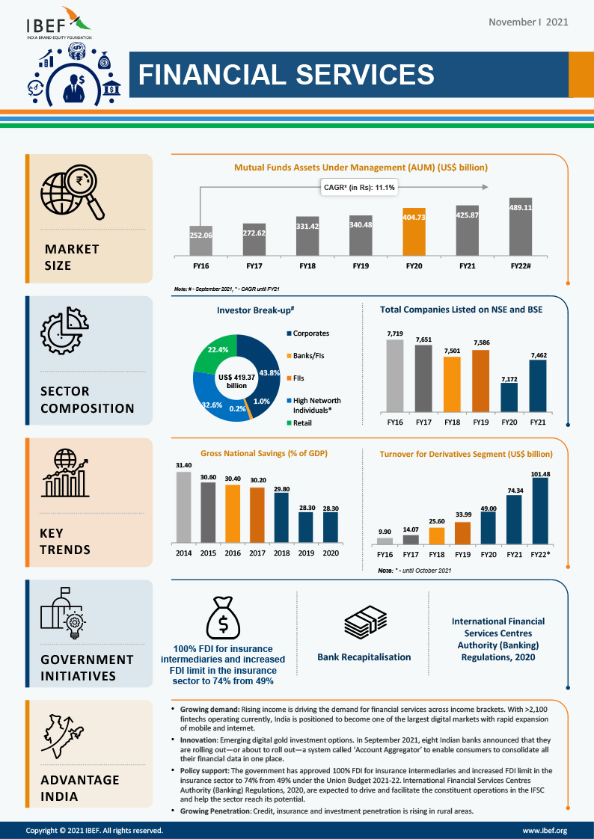

**Financial Services Industry Challenges & Opportunities In 2022**

Financial service firms are facing many challenges today. Most of it has to do with the rapid changes in technology. While the vast majority of financial firms have embraced the technology revolution, there are still many challenges these companies have to face.

**1. Eliminating Data Breaches**

Financial service firms are prime targets for cybercrime. Because of the sensitive data they carry, they are more likely to be targeted. In fact, financial service firms were hit 300 times more than other businesses. In 2018 financial service firms were hit 819 times, an increase from 69 incidents reported in 2017. The total number of cyber-attacks won’t be known until well into 2022, but there have already been many data breaches this year. On March 22-23, a hacker gained access to Capital One’s consumer and small business credit card applications from as early as 2005. According to Capital One, approximately 140,000 social security numbers and 80,000 linked bank account numbers were exposed in the U.S. Also, about 1 million Canadian social insurance numbers were breached.

**2. Keeping Up with Regulations**

Regulations in the financial service industry continue to increase. Banks are spending a large part of their income on making sure they’re compliant. They have to make sure there are systems to keep up with ever-changing regulations and industry standards. Traditional banks have to constantly evaluate and improve their operations to keep up with fast-changing consumer and shareholder expectations, technology, and industry regulations. According to KPMG, there are 10 key regulatory challenges financial service firms will face in 2022. They include:

Geopolitical change: Companies must expect business change and disruption.

Divergent regulation: Must anticipate continued differences in state, federal, and global regulations among protectionist and localized public policy agendas in the U.S. and overseas.

Data protection and governance: Protect your data at all costs

Operational resilience: Plan for the unexpected. It will happen

Credit quality: Firms must apply what they’ve learned from past credit cycles

Capital and liquidity shifts: Even though there may be an easing of regulatory capital and liquidity requirements, firms should not weaken risk management.

Compliance agility: Must have a solution for agile and streamlined compliance.

Financial crime: It’s OK to be innovative but don’t do too much at the cost of increased risk for financial crime.

Customer trust: Firms must maintain the trust of the customers

Ethical conduct: Do the right thing no matter what you have or not.

Financial service companies need to create a strategy to innovate and stay in compliance.

**3. Exceeding Consumer Expectations**

Consumers continue to expect a lot from their financial institutions. Many want more personalized services from their financial providers. According to the 2019 Accenture Global Financial Services Consumer Study, one in two consumers wants personalized banking advice based on their personal circumstances. They want an analysis of their spending habits and advice on how to handle money. 64% of the participants are interested in insurance premiums tied to their behavior, such as having a good driving record.

**4. Surpassing the Competition**

Competition within the financial services industry is still robust. As mentioned earlier, consumers want more personalized service. They also want more automated services with easier access to them. Institutions that provide all these services will dominate their share of the market. Today, consumers are less concerned with brand loyalty and identity. They want what they want. Institutions that provide those services will keep their customers.

**5. Keeping Up with Technology**

Business growth is very important for financial firms, but they must spend money updating their technology to grow. According to a report from Protiviti, financial service firms must continue to invest in technology such as robotics and other workflow automation tools to increase their efficiency and reduce the costs associated with operational, risk management, and compliance. Firms must also modernize their technology platforms and data storage to enable big data solutions such as AI-supported digital customer support assistants. Financial firms must also consider consolidating platforms and provide a more efficient, customer-friendly experience across internet, mobile and physical locations.

**6. Incorporating AI into Their Firms**

According to a study from Deloitte, major financial service firms are achieving a 19% growth in revenue. Deloitte found that 30% of financial service firms they describe as frontrunners are more adept at utilizing AI, helping them increase revenue faster than their competitors. These frontrunner firms are also twelve times more likely to notice the importance of AI to their businesses than late adopters. Frontrunners are quicker to recognize the importance of AI and are motivated to implement it. At the same time, other firms may recognize the importance of AI but are more hesitant to use it.

**7. Organizing Big Data**

Big data is a necessity but also an obstacle for financial service firms. Big data is getting bigger because a lot of data is being created by several sources. This new data is structured and unstructured, and these legacy data systems can’t handle the volume of data coming in. The various types of data coming in is one of the biggest challenges facing financial service companies. According to a study from EMC, there will be 44 zettabytes of digital data by 2022. That’s 44 trillion gigabytes. The challenge for financial service companies is to sort through all their data and determine what is useful and what isn’t.

**8. Effective Financial Digital Marketing Strategy**

The effective use of digital channels to drive leads and customers are two of the primary digital transformation challenges the financial industry faces. Many financing companies and banks are having difficulty being efficient, effective, and measuring the impact of their marketing channels such as paid media, enterprise SEO, Local SEO, content strategy, or social media. In our opinion, one of the primary challenges these companies have is their digital experience, website design, and presentation of their brand.