## What Is a SWOT Analysis?

A SWOT analysis is a technique used to determine and define your Strengths, Weaknesses, Opportunities, and Threats – SWOT.

SWOT analyses can be applied to an entire company or organization, or individual projects within a single department. Most commonly, SWOT analyses are used at the organizational level to determine how closely a business is aligned with its growth trajectories and success benchmarks, but they can also be used to ascertain how well a particular project – such as [an online advertising campaign](https://www.wordstream.com/blog/ws/2017/07/05/online-advertising-costs) – is performing according to initial projections.

## Breaking Down the SWOT Analysis Process

We know that SWOT stands for Strengths, Weaknesses, Opportunities, and Threats – but what does each of these elements mean? Let’s take a look at each element individually.

If you’ve ever worked in a corporate office environment, you may have come across the term “SWOT analysis.” This has nothing to do with evaluating militarized law enforcement response units, and everything to do with taking a long, hard look at your company.

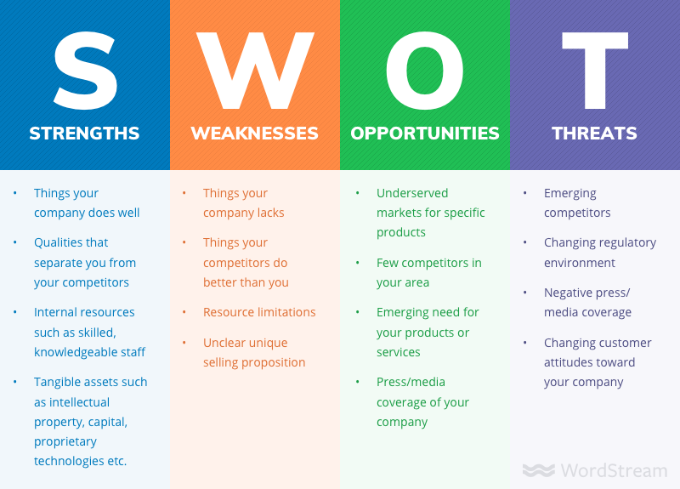

**A PESTEL analysis**

A PESTEL analysis is a framework or tool used by marketers to analyse and monitor the macro-environmental (external marketing environment) factors that have an impact on an organisation. The result of which is used to identify threats and weaknesses which is used in a [**SWOT analysis**](https://www.professionalacademy.com/news/marketing-theories-swot-analysis).

PESTEL stands for:

* **P – Political**
* **E – Economic**
* **S – Social**
* **T – Technological**
* **E – Environmental**
* **L – Legal**

Lets look at each of these macro-environmental factors in turn.

All the external environmental factors (PESTEL factors)

**Political Factors**

These are all about how and to what degree a government intervenes in the economy. This can include – government policy, political stability or instability in overseas markets, foreign trade policy, tax policy, labour law, environmental law, trade restrictions and so on.

It is clear from the list above that political factors often have an impact on organisations and how they do business. Organisations need to be able to respond to the current and anticipated future legislation, and adjust their marketing policy accordingly.

**Economic Factors**

Economic factors have a significant impact on how an organisation does business and also how profitable they are. Factors include – economic growth, interest rates, exchange rates, inflation, disposable income of consumers and businesses and so on.

These factors can be further broken down into macro-economical and micro-economical factors. Macro-economical  factors deal with the management of demand in any given economy. Governments use interest rate control, taxation policy and government expenditure as their main mechanisms they use for this.

Micro-economic factors are all about the way people spend their incomes. This has a large impact on B2C organisations in particular.

**Social Factors**

Also known as socio-cultural factors, are the areas that involve the shared belief and attitudes of the population. These factors include – population growth, age distribution, health consciousness, career attitudes and so on. These factors are of particular interest as they have a direct effect on how marketers understand customers and what drives them.

**Technological Factors**

We all know how fast the technological landscape changes and how this impacts the way we market our products. Technological factors affect marketing and the management thereof in three distinct ways:

* New ways of producing goods and services
* New ways of distributing goods and services
* New ways of communicating with target markets

**Environmental Factors**

These factors have only really come to the forefront in the last fifteen years or so. They have become important due to the increasing scarcity of raw materials, polution targets, doing business as an ethical and sustainable company, carbon footprint targets set by governments (this is a good example were one factor could be classes as political and environmental at the same time). These are just some of the issues marketers are facing within this factor. More and more consumers are demanding that the products they buy are sourced ethically, and if possible from a sustainable source.

**Legal Factors**

Legal factors include - health and safety, equal opportunities, advertising standards, consumer rights and laws, product labelling and product safety. It is clear that companies need to know what is and what is not legal in order to trade successfully. If an organisation trades globally this becomes a very tricky area to get right as each country has its own set of rules and regulations.

After you have completed a PESTEL analysis you should be able to use this to help you identify the strengths and weaknesses for a [**SWOT analysis**](https://www.professionalacademy.com/news/marketing-theories-swot-analysis).